INDIRA GANDHI NATIONAL OPEN UNIVERSITY

PROJECT REPORT OF

BCSP-064

ON

SCHOOL MANAGEMENT SYSTEM

By

Gauri Thakur (2003682335)

UNDER GUIDANCE

OF

Mr. Sabhya Verma

Submitted to the Shyamlal College (0769) in

Partial fulfilment of the Requirements for the degree of

BachelorOf

Computer Applications



Indira Gandhi National Open University

MaidanGarhi

New Delhi-110068

Table of Content

|  |  |  |
| --- | --- | --- |
| S.NO. | CONTENT | PAGE NO. |
| 1. | Index | **1** |
| 2. | SYNOPSIS | **2-24** |
| 3. | PROJECT REPORT | **25-198** |

**Synopsis**

**Table of Content**

|  |  |  |
| --- | --- | --- |
| **S.NO.** | **CONTENT** | **PAGE NO.** |
| **1.** | **Title of the Project** | 4 |
| **2.** | **Introduction and Objectives of the Project** | 5-7 |
| **3.** | **Project Category** | 8 |
| **4.** | **Analysis** | 9-13 |
| **5.** | **A complete structure** | 14-21 |
| **6.** | **Tools / Platform, Hardware and Software Requirement specifications** | 22 |
| **7.** | **Are you doing this project for any Industry/Client?** | 23 |
| **8.** | **Future scope and further**  **enhancement of the project.** | 23 |
| **9.** | **Bibliography** | 24 |

## TITLE OF PROJECT



***SCHOOL MANAGEMENT SYSTEM***

1. **INTRODUCTION OF PROJECT AND IT’S OBJECTIVES**

**1.1 Abstract of the system**

Web based school managements systems are designed to manage and store project information that are used in web-based applications. The project is titled “school management system”. This package once developed will help the school/institute to manage various details pertaining to its students.

This will help accounts department in maintaining the details related to the fee & basic details like their security deposits, conveyance and etc., it will also help management or we can say administration

department in maintaining student’s basic details as well as keeping a check on fees details. This package is basically developed for the authorities of the school/ institute to make their task easier or we can say this package automate their task like maintaining student’s personal details, marinating cash details, printing of receipts. This package helps the administrative & accounts

## INTRODUCTION

The title of the project is “School Management system”. This project will handle whole the activities of the school. SMS has most of the facilities that a modern school requires to computerize its day-to-day jobs. It provides facilities to keep the records of student, fees, teaching and non-teaching staff with all their required details along with all required transaction handling. It has facilities to generate various types of reports, which are required by the management during normal business operations to operate the business effectively.

## OBJECTIVES

This project is based on the RDBMS technology the main objective of this project is to computerize the manual system & reduce the time consumption. In other words, we can say that our project has the following objectives: -

* Make all the system computerize
* Reduce time consumption
* Reduce error scope
* All system managements are automated
* Centralized database management
* Easy operations for operator of the system
* No paper work requirement

## PROJECT CATEGORY

This project as title “**School management system**” is comes under the **Relational Database Management System (RDBMS).** This application is developed with the help of Eclipse, VS Code and MySQL. This application can also be run on the network environment so it can be said as network application.

### **ANALYSIS**

### **DATA FLOW DIAGRAMS (DFD)**

The DFD was first developed by Larry Constance as a way of expressing system in a graphical form. A DFD, also known as Bubble Chart, has a purpose of clarifying system requirement and identifying major transformation that will become the programs in the system design.

## DFD SYMBOLS

1. A SQUARE defines a source or destination of system data
2. An ARROW identifies data flow or data in motion. It is a pipeline through which information flow.
3. A CIRCLE or a BUBBLE (Some people use an over bubble) represents a process transforms in coming data flow into outgoing data flow.
4. An OPEN RECTANGLE is a data store or data at rest or a temporary rest repository of data.

Note that a DFD describe what data flow (logical) rather than they are processed, so it does not depend on hardware, software and data structure or file organization.

# **PROCESSING OF SMS**

**Level 0 DFD**

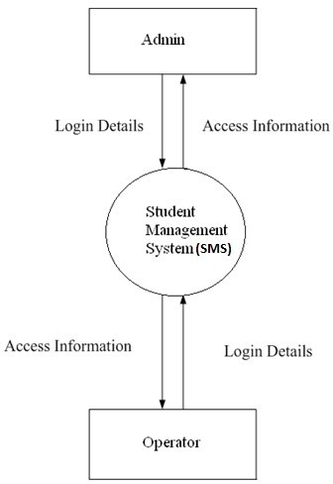

**Level 1 DFD**

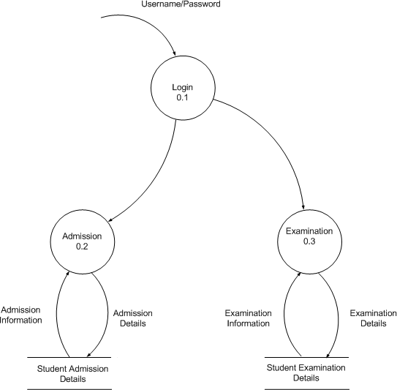

**Level 2 DFD**

## Student:

**School Management System**

**Admission**

**Student**

## Teacher:

**School Management System**

**Teacher DB**

**Teacher**

# **5.SYSTEM DESIGN**

* System Design is the solution to the creation of a new system. This is the important aspect made up of several steps. The complete, efficient and successful system should provide the following in succession: -
* From where should we start
* where we have to go
  + where we should stop
* if the project is to be successful, we will need answer this question. The answer of these questions is schema manner and is known as system design. A systematic manner will be followed so as to achieve beneficial result at the end. It involves starting with a vague idea and ultimately developing it up into a useful system. The design phase is transition from a user oriented to a document oriented to the programmers. Software report can be broken into a series of steps starting with the basic ideas and ending with the finished project
* The steps for the successful project are as follows: -
* We should define problem completely and the goals should be known before our destination
* In the next step, we should specify inputs and outputs of our interest
* Then the structure of various database should be designed which will be used during the programming
* Next, we should design our programs of user-friendly nature and always provide a way to the user to read back the origin if he/she find any complex problem at any stage
* We should know the function of each and every program which will leads us to or helps us to read at the specified goal.
* Then we write these individual programs which later on joining solve our problem
* Next step involves then testing of these programs and correction – if necessary

At last, linking all the programs in a well- specified manner and combining in the form of a menu, submenu etc. will be our defined problem. Out of these defined steps, few of the major steps will respect to Project.

## DATABASE DESIGN

* Database Design in most important in any project. We are using the following table to store
* the information related to staff of school
  1. **STAFF**

|  |  |  |
| --- | --- | --- |
| **Field Name** | **Constraints** | **Type** |
| **EMPNO** | **A.I/P. K** | **NUMBER (5)** |
| **EMPNAME** | **Not Null** | **VARCAHR (30)** |
| **ADDRESS** | **Not Null** | **VARCAHR (30)** |
| **CITY** | **Not Null** | **VARCAHR (15)** |
| **PIN** | **Not Null** | **VARCAHR (6)** |
| **STATE** | **Not Null** | **VARCAHR (15)** |
| **PHONE** | **Not Null** | **VARCAHR (15)** |
| **MOBILE** | **Not Null** | **VARCAHR (13)** |
| **EMAIL** | **Not Null** | **VARCAHR (30)** |
| **GENDER** | **Not Null** | **VARCAHR (1)** |
| **M_STATUS** | **Not Null** | **VARCAHR (15)** |
| **DOB** | **Not Null** | **DATE** |
| **DOJ** | **Not Null** | **DATE** |
| **DEPT** | **Not Null** | **VARCAHR (30)** |
| **NATURE_OF_JOB** | **Not Null** | **VARCAHR (10)** |
| **BASIC_PAY** | **Not Null** | **NUMBER (10.2)** |

**2.STUDENT**

|  |  |  |
| --- | --- | --- |
| **Field Name** | **Constraints** | **Type** |
| **REGNO** | **A.I/P. K** | **NUMBER (5)** |
| **ROLLNO** | **A. I** | **NUMBER (5)** |
| **CLASS** | **NOT NULL** | **VARCHAR (4)** |
| **NAME** | **NOT NULL** | **VARCHAR (25)** |
| **FNAME** | **NOT NULL** | **VARCHAR (25)** |
| **MNAME** | **NOT NULL** | **VARCHAR (25)** |
| **DOB** | **NOT NULL** | **DATE** |
| **DOR** | **NOT NULL** | **DATE** |
| **ADDRESS** | **NOT NULL** | **VARCHAR (30)** |
| **CITY** | **NOT NULL** | **VARCHAR (15)** |
| **STATE** | **NOT NULL** | **VARCHAR (15)** |
| **PIN** | **NOT NULL** | **VARCHAR (6)** |
| **PHONE** | **NOT NULL** | **VARCHAR (15)** |

**3.FEE**

|  |  |  |
| --- | --- | --- |
| **Field Name** | **Constraints** | **Type** |
| **REGNO** | **F. K** | **NUMBER (5)** |
| **ROLLNO** | **F. K** | **NUMBER (5)** |
| **CLASS** | **NOT NULL** | **VARCHAR (4)** |
| **FEEDEP** | **NOT NULL** | **NUMBER (5)** |
| **DEPDATE** | **NOT NULL** | **DATE** |
| **FINE** | **NOT NULL** | **NUMBER (3)** |

**4.RESULTS**

|  |  |  |
| --- | --- | --- |
| **Field Name** | **Constraints** | **Type** |
| **REGNO** | **F. K** | **NUMBER (5)** |
| **SUBJECT_NAME** | **NOT NULL** | **VARCHAR (15)** |
| **MAX_MARKS** | **NOT NULL** | **NUMBER (3)** |
| **PASS_MARKS** | **NOT NULL** | **NUMBER (3)** |
| **MARKS_OBT** | **NOT NULL** | **NUMBER (3)** |

## MODULES USED IN THE PROJECT

This project includes the following modules for development of the project. These are as follows: -

1. **LANDING PAGE MODULE**

This is first Page that displays the welcome screen for the user and also shows the Information of our school or staff etc.

### **LOGIN MODULE**

This module will contain a form that accepts the username and password when user enter a valid user name and Password then he/she can operate the application.

### **MAIN FORM**

This form is a menu-based form that displays the menu for operation of the application. It Includes various options for staff, student, fees and report related option.

### **STUDENT FORM**

This form provides the option to add, modify, delete or find the information of a student who Seeks the admission in the school.

### **STAFF FORM**

This form provides the option to add, delete, search and delete the information of staff (either Teaching or non-teaching) that is working in the school.

### **FEE MODULE**

This module provides the option to the user of the system to add, delete, modify and search the Information of the fee deposited by the student.

### **RESULT MODULE**

This module displays the result of students with other details

### **REPORT MODULE**

With the help of this option from menu user of the system can see or take the print out of report card.

### **CONTACT US MODULE**

With the help of this option from menu user of the system can contact us or take the contact details of our school.

## NAME OF REPORTS

Following are the reports names that are generated by the Project for the management of school or Staff members of the school.

1. Details of teaching staff
2. Details of non-teaching staff
3. Class wise detail of students
4. Date wise detail of students based on date of admission
5. Detail of student according to name wise
6. Teacher report based on the Date of joining
   1. **TOOLS, SOFTWARE & HARDWARE REQUIREMENTS**

We have a wide range of options of languages. From these options we can choose appropriate platform/ tools and languages for development of the project. Some of these are as follows: -

**Project Category**: Web-Based Application

**SOFTWARE REQUIREMENTS:**

**IDE:** Eclipse, VS Code.

**Front End:** HTML, CSS, JavaScript, jQuery, bootstrap.

**Back End:** Servlet and JSP

**RDBMS:** MySQL 8.0 or Higher

**Browser:** Chrome, Firefox etc. (latest version)

**Operating System:** Windows 7 and above, Linux etc.

**HARDWARE REQUIREMENTS:**

**Processor:** Intel Pentium, Core duo or more

**RAM:** 2GB or more

**Cache:** 512 KB

**Hard-disk:** 50 GB hard disk recommended Monitor, Keyboard & mouse.

* 1. **Are you doing this project for any Industry/Client?**

**Ans. NO.**

* 1. **FUTURE SCOPE OF THE PROJECT**

Nothing is perfect in this world. So, we are also no exception. Although, we have tried our best to present the information effectively, yet, there can be further enhancement in the Application.

We have taken care of all the critical aspects, which need to take care of during development of the Project.

Like the things this project also has some limitations and can further be enhances by someone, because there are certain drawbacks that do not permit the system to be 100% accurate.

* 1. BIBLIOGRAPHY

**Websites**

* <https://www.mysqltutorial.org/>
* <https://www.tutorialspoint.com/>
* <https://javatpoint.com/>
* [https://W3schools.com/](https://w3schools.com/)
* <https://edureka.co/>

**Books**

* **HTML & CSS: Design and Build Web Sites**
* **Head First SQL: Your Brain on SQL**
* **SQL Bible, 2nd Edition (Paperback)**

**Project Report**

Table of Content

|  |  |  |
| --- | --- | --- |
| S.NO. | CONTENT | PAGE NO. |
| 1. | Title of project | 28 |
| 2. | Introduction of the Project | 29-30 |
| 3. | Objective of the Project | 31 |
| 4. | Tools/Environment Used | 32 |
| 5. | Analysis Documents | 33-52 |
| 6. | Design Document | 53-55 |
| 7. | Program Code | 56-157 |
| 8. | Testing | 158-164 |
| 9. | Input and Output Screens | 165-191 |
| 10. | Implementation of Security | 192-195 |
| 11. | Limitation of the Project | 196 |
| 12. | Future Application of the Project | 197 |
| 13. | Bibliography | 198 |

1. Title of Project

***SCHOOL MANAGEMENT SYSTEM***



2. Introduction of the Project

**2.1Abstract of the system**

Web based school managements systems are designed to manage and store project information that are used in web-based applications. The project is titled “school management system”. This package once developed will help the school/ institute to manage various details pertaining to its students.

This will help accounts department in maintaining the details related to the fee & basic details like their security deposits, conveyance and etc., it will also help management or we can say administration

department in maintaining student’s basic details as well as keeping a check on fees details. This package is basically developed for the authorities of the school/ institute to make their task easier or we can say this package automate their task like maintaining students’ personal details. This package helps the administrative & accounts

## 2.2 INTRODUCTION

The title of the project is “School Management system”. This project will handle whole the activities of the school. SMS has most of the facilities that a modern school requires to computerize its day-to-day jobs. It provides facilities to keep the records of student, fees, teaching and non-teaching staff with all their required details along with all required transaction handling. It has facilities to generate various types of reports, which are required by the management during normal business operations to operate the business effectively.

## 3.OBJECTIVES

This project is based on the RDBMS technology the main objective of this project is to computerize the manual system & reduce the time consumption. In other words, we can say that our project has the following objectives: -

* Make all the system computerize
  + Reduce time consumption
  + Reduce error scope
  + All system managements are automated
  + Centralized database management
  + Easy operations for operator of the system
  + No paper work requirement

**4. TOOLS / ENVIRONMENT USED**

We have a wide range of options of languages. From these options we can choose appropriate platform/ tools and languages for development of the project. Some of these are as follows: -

Project Category: Web-Based Application

**SOFTWARE REQUIREMENTS:**

**IDE:** VS Code, Eclipse

**Front End:** HTML, CSS, JavaScript , jQuery

**Back End:**  Servlet

**RDBMS:** MySQL 8.0 or Higher

**Browser:** Chrome, Firefox etc. (latest version)

**Operating System:** Windows 7 and above, Linux etc.

**HARDWARE REQUIREMENTS:**

**Processor:** Intel Pentium, Core duo or more

**RAM:** 2GB or more

**Cache:** 512 KB

**Hard-disk:** 50 GB hard disk recommended

Monitor, Keyboard & mouse.

**5.Analysis document**

# **Introduction**

The following subsections are an overview of the entire Software Requirements Specification (SRS) document.

### **Purpose**

This document provides the technical description of all software requirements of SCHOOL MANAGEMENT SYSTEM. The document will not only define the product functions, user characteristics, constraints, and specific requirements of the system, but also serve as a basis for the Software Design Document that is prepared according to IEEE Std.

The objective of the software is to maintain information pertaining to the students with the purpose of: -

* Planned approach towards working
* Accuracy
* Reliability
* No Redundancy
* Immediate retrieval of information
* Immediate storage of information
* Easy to Operate

### **Scope**

“SCHOOL MANAGEMENT SYSTEM” is a project with a mission of viewing and manipulating student information of IIMSR in a Web- based environment. Thus, the overall system will consist of a School Database System and Web Interface.

The School Database System will supply the fundamental database structure of the entire system whereas Web Interface will provide a secure Web interface between the users and the database.

The Software aims to create a “paperless office” rather than using a traditional record keeping system.

Although this project is presently being designed specifically for Integral Institute of Medical Sciences and Research but there exists the possibility in future to upgrade it to general level.

The software will not only help the following levels of user in viewing the information but also each user can alongside update changes within their respective access limits.

* Administrative Level
* User Level
* Management of Institute
* Faculty
* Student

#### **Definition**

Paperless Office: refers to an integrated working environment where all the data and documentation is represented in electronic format.

Student Personal Information: refers to personal records of individual student’s bio-data along with his performance throughout the course.

Traditional Record Keeping System: refers to a manual system where all records are kept on papers by manual in-charge.

### **References**

MCS-014 IGNOU Blocks

### **Overview**

This document is prepared in accordance with the IEEE Standard, IEEE Recommended Practice for Software Requirements Specifications.

It also provides product perspectives, product functions, user characteristics, general constraints, and assumptions and dependencies of the system.

it will contain functional and performance requirements, design constraints, attributes and external interface requirements for the Software.

# **Overall Description**

This section describes the general factors that affect software and its requirements. In order to be easily understandable, this part of SRS provides a background for the requirements.

### **Product Perspective**

This software is a totally self-contained system. Also, it is not dependent of any larger system.

### **System Interfaces**

Since this School Management System is a standalone system, there is no system interface with any other system.

### **User Interfaces**

The interfaces will involve check boxes, combo boxes, text boxes, and radio buttons. The combo boxes and the radio buttons will be used to prevent users from entering wrong type of information. They will also enable fast data entry. Text boxes will be controlled for avoiding invalid and inconsistent data.

Users can use “Tab” key to move cursor on screen items easily.

There will be two types of messages for constructive advice to the users: error and confirmation messages. There will be four types of error messages for application control: input, output, process and database/Web server error messages.

There will be several types of users, and each user will access the screens according to their types after entering their id and passwords. Standard screen format (fixed colors, fonts, background, the page layout, etc.) will be used throughout the interfaces.

The language of the user interfaces will be English

### **Hardware Interfaces**

Processor **:** 1 GHz Processor

RAM **:** 1 GB (minimum recommended)

Hard Disk **:** 20 GB (minimum recommended)

Monitor **:** 11” inch DISPLAY or more

Keyboard **:** 108 key normal

### **Software Interfaces**

On the client side the required software product is Internet Explorer supporting at least HTML version 3.2, java enabled, and any operating system that can run the browsers.

The project will use following software

Front End **:** Html, CSS, bootstrap, jQuery

Back End **:** Servlet , JSP

Database : MySQL 8.0

Web Server **:** Apache Tomcat 9.0 or higher

Documentation Tool : Microsoft Office

### **Communication Interfaces**

The default communication protocol for data transmission between server and the client is Transmission Control Protocol/ Internet Protocol (TCP/IP). At the upper-level Hyper Text Transfer Protocol (HTTP, default port=80) will be used for communication between the web server and client.

### **Memory Constraints**

The client computer, which runs the web browser, should have enough physical memory to run this program.

### Product Functions

* Track Students
* Keep record of Staff
  1. Keep record of student’s achievement User Characteristics

Administrator – The dean will hold full access to view as well as manipulate anywhere in the software and the information.

User- The other user like staff or faculty can view only their individual report and analyze their own performance based on that.

**Assumptions**

Every user will be having the appropriate hardware and software configuration as per the necessary requirement.

**Specific Requirements**

### **Functional Requirements-**

The software is meant to generate a student id which will provide unique identity to individual students. It is through this student id that each student’s data can accessed on this platform. The requirements under School Management System are to maintain information relevant to the following fields:

* **Students Profile**- The full information of each and every student must be maintained in System along with the facility to regularly update it from time to time at regular intervals which will be easily possible through each student’s Enrolment number.
* **Providing statistical reports-** It is meant to analyse each student performance on the individual level as well as among the group.

**Software Product Features**

The software feature is to provide easy accessibility to student details on IIMSR to the management of the institute. But it requires authentication of user through login id and password at various different levels for safety of the system.

### **Performance Requirements**

The performance of the software will be as smooth as possible with special consideration on the following parameters-

* + Planned approach towards working
  + Accuracy
  + Reliability
  + No Redundancy
  + Immediate retrieval of information
  + Immediate storage of information
  + Easy to Operate

### Design Constraints

* GUI is only in English.
* Login and password are used for identification of user and there is no facility for guest.

#### **Reliability**

The system has to operate in a reliable manner with no scope for any flaws. This is to ensure efficient working and processing of information.

#### **Availability**

The site should be available all the time without any issues. A backup must be available for recovery issues so that the existing is not lost in case of any issue.

#### **Security**

The system has an authorization mechanism for users to identify their personal profiles. Therefore, different users will have different authorization levels to access the data. Data integrity for critical variables will also be checked.

#### **Maintainability**

The system can meet the changing requirements easily, since the infrastructure of the system would not need major changes. The requirements of the software while evolving will be met by just adding new sub-functions. Therefore, the maintainability of the system would not be a complex issue.

#### **Portability**

All of the code which will be deployed at the web server will be written in servlets and using MySQL for database storage. So, the software will remain portable.

Level 0 DFD



Level 1 DFD



## Level 2 DFD

## Student:

**School Management System**

**Admission**

**Student**

## Teacher:

**School Management System**

**School Management System**

**TeacherDB**

**Teacher**

**ER Diagram Examination**

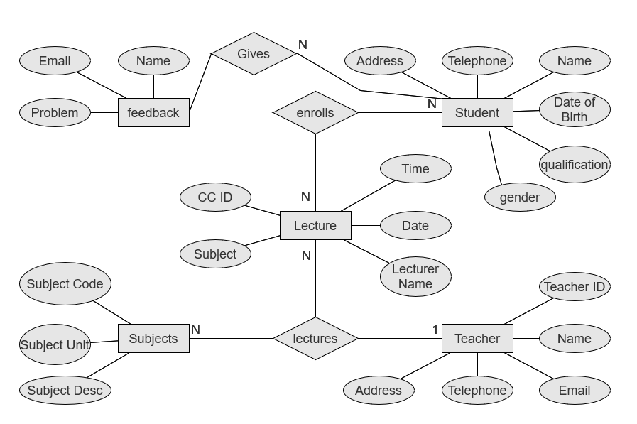

#### PLANNING AND SCHEDULING

**PROJECT CONTROL SYSTEMS**

The purpose of controlling a project is to monitor the progress of the activities against the plans, to ensure that the goals are being approached and eventually achieved. Other aspects of control are to detect, as soon as possible, when deviations from the plan are occurring so that corrective action may be taken. Most project control techniques are based on breaking down the goal of the project into several Intermediate goals. Each Intermediate goal can turn be broken further. This process can be repeated until each goal can turn be broken further. This process can be repeated until each goal is small enough to be understood. We can plan for each goal individually its resource requirements, assignments of responsibility, scheduling, etc.

Two general scheduling techniques are GANTT charts and PERT Charts as discussed below.

#### GANTT CHART:

A bar chart is perhaps the simplest form of formal project management. The bar chart also known as GANTT CHART is used almost exclusively for scheduling purpose and therefore controls only the time dimension of projects. Gantt chart is a project control technique that can be used for several purposes, including scheduling, budgeting and resource planning. A Gantt chart is a bar chart, with each bar representing an activity. The bars are drawn against a time line. The length of each bar is proportional to the length of time planned for the activity. Gantt chart can take different forms depending on their Intended use. They are best for resource scheduling. Gantt charts are useful for resource planning and scheduling. Gantt chart they show the tasks and their duration clearly. However, they do not show Inter task dependencies plainly.

#### PERT CHART:

Unlike the bar chart, PERT can be both cost and a time management system PERT is organized by events and activities or tasks. PERT has several advantages over bar charts and is likely to be used with more complex projects. One advantage of PERT is that it is a scheduling device that also shows graphically which tasks must be completed before others are begun. PERT enable the calculation of a Critical path. Each path and cost associated with each task along a path is calculated, and the path that requires the greatest amount of elapsed time is the Critical path. Calculation of the critical path enables project manager to monitor this series of tasks more closely. PERT controls time and cost during the project the project and also facilities finding the right balance between completing a project on time and completing it within budget. PERT recognizes that projects are complex that some tasks must be completed before other can be started and that the appropriate way to manage a project is to be defined and control each task. Because projects often fall behind schedule, PERT is designed to facilitate getting back schedule. PERT is based in part on the premise that subjective estimates of the total completion time for a project are usually greatly inferior to the sum of subjective estimates for each task. The PERT chart gives a graphical representation of this information.

#### Advantages of PERT

It forces the manager to plan.

It shows an Interrelationship among the tasks in the project, in particular, clearly identifies the critical path of the project, thus helping to focus on it.

It exposes all possible parallelism in the activities and thus helps in allocating resources.

It allows scheduling and simulation of alternative schedule. It enables the manager to monitor and control the project.

Despite these advantages, PERT is just a tool, and its use does not automatically guarantee the success of the project. Gantt chart can be derived automatically from PERT charts.

The charts are shown in figure A (Gantt chart) and B (PERT Chart).

#### GANTT CHART

Design

8. Tests by User

7. Training

6. Documentation

5. Security

4. Testing

*3 Coding*

*2.3 Data Dictionary*

*2.2 ER-Diagram*

*2.1Creating DFD*

2. SRS And Design

1. Gathering Information and Requirement Analysis

**Month 6**

**Month 5**

**Month 4**

**Month 3**

**Month 2**

**Month 1**

**Work Tasks**

**PERT CHART**

SRS and Design

Testing (Alpha Testing)

Conversation

User Requirement

And Analysis

Testing (Beta Testing)

Programming

2

4

8

10

11

20 40

20

Training

20

User Test

20

1 Write

Manual

7

9

5

15

15

12

5

15

3 5

5

Dummy

Activity

6

Buy Hardware

Installation

**6.Design Document**

School Management System (SMS) is a web-based application that tracks current student’s academic information. It maintains academic information for ready access by office staff, students, their faculty advisors, and committee members. Instead of tedious paper work, students will be able to submit required information electronically, and the departments will be able to evaluate the submissions with a much quicker turnaround.

The School Management System has been modularized into following modules.

**LOGIN MODULE:**

The purpose of this module is to provide entry to the system or website. Based on the type of login, the user is provided with various facilities and functionalities. The main function of this module is to allow the user to use SMS. This module provides two types of logins —Admin login and Student login. School Management System

**ADMINISTRATOR MODULE:**

In this module when the administrator will enter his/her username and password, then he/she will enter in to the administrator page and this page consists of two following sub modules.

**Student Addition/ Updation / Deletion:** In SMS each Student is added, updated or deleted according to its branch.

**Notice/Attendance/Result Generation:** In SMS information about notice, attendance and Internal result is generated.

**STUDENT MODULE:**

In this module when a user enters his student id and password, then he can visit all the following pages.

**Profile View:** When the student clicks on this link he/she will get his/her information like student id, student name, password, father name, date of birth, nationality, city, address, country, phone number, mobile number, email. If he/she wants then he/she can change the profile.

**Notice View:** When the student clicks on this link, he can see latest notices released by the administrator.

**The Student Helpdesk:** This helpdesk is staffed by faculty who are there to help you. You may contact on (faculty phone no.).

**DATABASE DESIGN**

* Database Design in most important in any project. We are using the following table to store
* the information related to staff or Student etc.

1. **Studentdetails**

|  |  |  |  |
| --- | --- | --- | --- |
| **StudentDetails** | | | |
| Student_Id | Varchar | Pk/AI | NULL |
| Student_Rollno | Varchar | unique/AI | NULL |
| Student_Email | Varchar | unique | notnull |
| Date_of_joining | date |  | NULL |
| Student_Name | Varchar |  | NULL |
| Student_fathername | Varchar |  | NULL |
| Student_DOB | Varchar |  | NULL |
| Student_mobile | Varchar |  | NULL |
| Student_photo | Varchar |  | NULL |
| Student_username | Varchar |  | NULL |
| Student_Password | Varchar |  | NULL |

**2.UserDetails**

|  |  |  |  |
| --- | --- | --- | --- |
| **LoginDetails** | | | |
| username | Varchar | pk/AI |  |
| email | Varchar | unique | not null |
| password | Varchar |  |  |

**3.Feedback**

|  |  |  |  |
| --- | --- | --- | --- |
| **Feedback** | | | |
| Contact_Id | Varchar | PK/ai | not null |
| student_name | Varchar |  | NULL |
| email | Varchar |  | NULL |
| problem | text |  | NULL |

**4.TeacherDetails**

|  |  |  |  |
| --- | --- | --- | --- |
| **TeacherDetails** | | | |
| Teacher_id | Varchar | Pk/AI | NULL |
| Teacher_name | Varchar |  | NULL |
| Teacher_Email | Varchar |  | NULL |
| Teacher_qualification | Varchar |  | NULL |
| Teacher_joining | Varchar |  | NULL |
| Teacher_DOB | Varchar |  | NULL |
| Teacher_photo | Varchar |  | NULL |

**5.Courses**

|  |  |  |  |
| --- | --- | --- | --- |
| **COURSE** | | | |
| COURSE_ID | Varchar | Pk/AI | NULL |
| COURSE_name | Varchar |  | NULL |
| COURSE_time | Varchar |  | NULL |
| COURSE_type | Varchar |  | NULL |
| Course_level | Varchar |  | NULL |
| course_description | Varchar |  | NULL |

**5.Allusers**

|  |  |  |  |
| --- | --- | --- | --- |
| **COURSE** | | | |
| username | Varchar | Pk/AI | NULL |
| role | Varchar |  | NULL |
| password | Varchar |  | NULL |
| contactid | Varchar |  | NULL |

**7.Program code**

**Directory Structure**

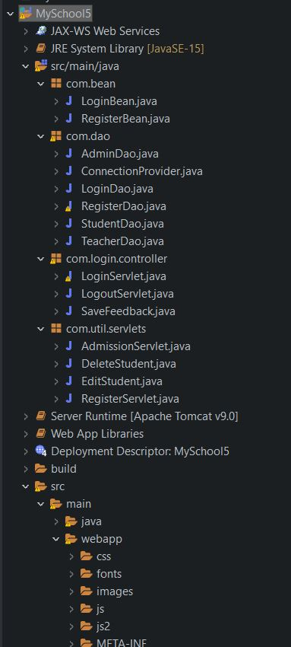

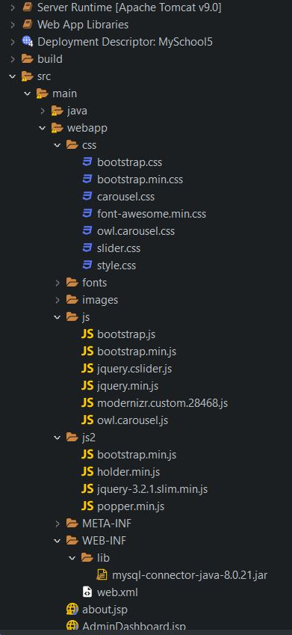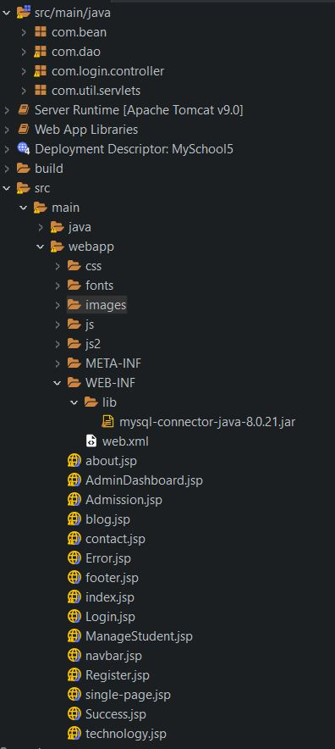

**LoginBean.java**

package com.bean;

public class **LoginBean** {

    private String userName;

    private String password;

    private String role;

    public String **getUserName**() {

    return userName;

    }

    public void **setUserName**(String userName) {

    this.userName = userName;

    }

    public String **getPassword**() {

    return password;

    }

    public void **setPassword**(String password) {

    this.password = password;

    }

    public String **getRole**() {

        return role;

    }

    public void **setRole**(String role) {

        this.role = role;

    }

}

**RegisterBean.java**

package **com**.**bean**;

public class **RegisterBean**

{

**String** name,password,email,gender,city,country,username,role;

**String** dob,Qualification;

     int id;

**String** contact;

        public **String** **getName**() {

            return name;

        }

        public void **setName**(**String** name) {

            this.name = name;

        }

        public **String** **getUserName**() {

            return username;

        }

        public void **setUserName**(**String** username) {

            this.username =username;

        }

        public **String** **getPassword**() {

            return password;

        }

        public void **setPassword**(**String** password) {

            this.password = password;

        }

        public **String** **getEmail**() {

            return email;

        }

        public void **setEmail**(**String** email) {

            this.email = email;

        }

        public **String** **getContact**() {

            return contact;

        }

        public void **setContact**(**String** contact) {

            this.contact = contact;

        }

        public int **getId**() {

            return id;

        }

        public void **setId**(int id) {

            this.id = id;

        }

        public **String** **getGender**() {

            return gender;

        }

        public void **setGender**(**String** gender) {

            this.gender = gender;

        }

        public **String** **getCity**() {

            return city;

        }

        public void **setCity**(**String** city) {

            this.city = city;

        }

        public **String** **getCountry**() {

            return country;

        }

        public void **setCountry**(**String** country) {

            this.country = country;

        }

        public **String** **getDob**() {

            return dob;

        }

        public void **setDob**(**String** dob) {

            this.dob = dob;

        }

        public **String** **getQualification**() {

            return Qualification;

        }

        public void **setQualification**(**String** qualification) {

            Qualification = qualification;

        }

        public **String** **getRole**() {

            return role;

        }

        public void **setRole**(**String** role) {

            this.role = role;

        }

}

**ConnectionProvider.java**

package **com**.**dao**;

import **java**.**sql**.*;

public class **ConnectionProvider**

{

 static **Connection** con = null;

 public static **Connection** **getConnection**()

 {

     try

     {

**Class**.**forName**("com.mysql.cj.jdbc.Driver");

        con = **DriverManager**.**getConnection**("jdbc:mysql://localhost:3306/myschool","root","1234");

     }catch(**Exception** e)

     {

         e.**printStackTrace**();

     }

     return con;

 }

}

**LoginDao.java**

package **com**.**dao**;

import **java**.**sql**.**Connection**;

import **java**.**sql**.**ResultSet**;

import **java**.**sql**.**SQLException**;

import **java**.**sql**.**Statement**;

import **com**.**bean**.**LoginBean**;

public class **LoginDao** {

public **String** **authenticateUser**(**LoginBean** loginBean)

{

**String** userName = loginBean.**getUserName**();

**String** password = loginBean.**getPassword**();

**Connection** con = null;

**Statement** statement = null;

**ResultSet** resultSet = null;

**String** userNameDB = "";

**String** passwordDB = "";

**String** roleDB = "";

    try

    {

        con = **ConnectionProvider**.**getConnection**();

        statement = con.**createStatement**();

        resultSet = statement.**executeQuery**("select username,password,role from userDetails");

        while(resultSet.**next**())

        {

            userNameDB = resultSet.**getString**("username");

            passwordDB = resultSet.**getString**("password");

            roleDB = resultSet.**getString**("role");

            if((userName.**equals**(userNameDB) )&& password.**equals**(passwordDB) && roleDB.**equals**("Admin"))

            return "Admin_Role";

            else if(userName.**equals**(userNameDB) && password.**equals**(passwordDB) && roleDB.**equals**("Teacher"))

            return "Teacher_Role";

            else if(userName.**equals**(userNameDB) && password.**equals**(passwordDB) && roleDB.**equals**("Student"))

            return "Student_Role";

        }

    }

    catch(**SQLException** e)

    {

        e.**printStackTrace**();

    }

    return "Invalid user credentials";

}

}

**RegisterDao.java**

package **com**.**dao**;

    import **java**.**sql**.**Connection**;

    import **java**.**sql**.**PreparedStatement**;

    import **java**.**sql**.**ResultSet**;

    import **java**.**sql**.**SQLException**;

import **com**.**bean**.**LoginBean**;

    public class **RegisterDao** {

        public static **String** **checkLogin**(**String** email, **String** password) throws **SQLException**,**ClassNotFoundException**,**NullPointerException**

        {

**Connection** connection =**ConnectionProvider**.**getConnection**();

**String** sql = "SELECT * FROM UserDetails";

**PreparedStatement** statement = connection.**prepareStatement**(sql);

**ResultSet** result = statement.**executeQuery**();

            if (result.**next**()) {

                if((email.**equals**(result.**getString**("username")) || email.**equals**(result.**getString**("email")) ) && password.**equals**(result.**getString**("password")))

                {

                    return email;

                }

            }

            connection.**close**();

            return "invalid";

        }

        public static int **saveFeedback**(**String** name,**String** email,**String** subject) throws **SQLException**

        {

**Connection** connection =**ConnectionProvider**.**getConnection**();

**String** sql = "insert into feedback(name,email,problem) values(?,?,?);";

**PreparedStatement** statement = connection.**prepareStatement**(sql);

            statement.**setString**(1, name);

            statement.**setString**(2, email);

            statement.**setString**(3, subject);

            int status=0;

            status= statement.**executeUpdate**();

**System**.out.**println**(status);

            return status;

        }

    }

**StudentDao.java**

package **com**.**dao**;

import **java**.**util**.*;

import **com**.**bean**.**RegisterBean**;

import **java**.**sql**.*;

public class **StudentDao** {

    public static int **save**(**RegisterBean** e){

        int status=0;

        try{

**Connection** con=**ConnectionProvider**.**getConnection**();

**PreparedStatement** ps2=con.**prepareStatement**("insert into Userdetails(username,password) values(?,?)");

            ps2.**setString**(1, e.**getUserName**());

            ps2.**setString**(2, e.**getPassword**());

**System**.out.**println**("hii "+e.**getUserName**()+" "+e.**getPassword**()+" "+e.**getEmail**());

            ps2.**executeUpdate**();

**PreparedStatement** ps=con.**prepareStatement**("insert into StudentDetails(username,student_email,Student_name,student_qualification,student_dob,student_mobile,gender,city,country) values (?,?,?,?,?,?,?,?,?)");

            ps.**setString**(1,e.**getUserName**());

            ps.**setString**(2,e.**getEmail**());

            ps.**setString**(3,e.**getName**());

            ps.**setString**(4,e.**getQualification**());

            ps.**setString**(5, e.**getDob**());

            ps.**setString**(6, e.**getContact**());

            ps.**setString**(7, e.**getGender**());

            ps.**setString**(8, e.**getCity**());

            ps.**setString**(9, e.**getCountry**());

            status=ps.**executeUpdate**();

            con.**close**();

        }catch(**Exception** ex){ex.**printStackTrace**();}

        return status;

    }

    public static int **update**(**RegisterBean** e){

        int status=0;

        try{

**Connection** con=**ConnectionProvider**.**getConnection**();

**PreparedStatement** ps=con.**prepareStatement**("update StudentDetails set city=?,country=?,Student_name=?,student_qualification=?,student_dob=?,student_mobile=?,gender=?,city=?,student_email=? where username=?");

            ps.**setString**(1,e.**getCity**());

            ps.**setString**(2,e.**getCountry**());

            ps.**setString**(3,e.**getName**());

            ps.**setString**(4,e.**getQualification**());

            ps.**setString**(5, e.**getDob**());

            ps.**setString**(6, e.**getContact**());

            ps.**setString**(7, e.**getGender**());

            ps.**setString**(8, e.**getCity**());

            ps.**setString**(9, e.**getEmail**());

            ps.**setString**(10, e.**getUserName**());

            status=ps.**executeUpdate**();

            con.**close**();

        }catch(**Exception** ex){ex.**printStackTrace**();}

        return status;

    }

    public static int **delete**(**String** username){

        int status=0;

        try{

**Connection** con=**ConnectionProvider**.**getConnection**();

**PreparedStatement** ps=con.**prepareStatement**("delete from StudentDetails where username=?");

            ps.**setString**(1,username);

            status=ps.**executeUpdate**();

            con.**close**();

        }catch(**Exception** e){e.**printStackTrace**();}

        return status;

    }

    public static **RegisterBean** **getEmployeeByUsername**(**String** username){

**RegisterBean** e=new **RegisterBean**();

        try{

**Connection** con=**ConnectionProvider**.**getConnection**();

**PreparedStatement** ps=con.**prepareStatement**("select * from studentdetails where username=?");

            ps.**setString**(1,username);

**ResultSet** rs=ps.**executeQuery**();

            if(rs.**next**()){

                e.**setName**(rs.**getString**("student_name"));

                e.**setEmail**(rs.**getString**("student_email"));

                e.**setCountry**(rs.**getString**("country"));

                e.**setCity**(rs.**getString**("city"));

                e.**setContact**(rs.**getString**("student_mobile"));

                e.**setDob**(rs.**getString**("Student_dob"));

                e.**setGender**(rs.**getString**("gender"));

                e.**setQualification**(rs.**getString**("Student_qualification"));

                e.**setUserName**(rs.**getString**("username"));

            }

**PreparedStatement** ps2=con.**prepareStatement**("select * Userdetails where username=?");

            ps2.**setString**(1, username);

**ResultSet** rs2=ps.**executeQuery**();

            e.**setPassword**(rs2.**getString**("password"));

            e.**setRole**(rs.**getString**("role"));

            con.**close**();

        }catch(**Exception** ex){ex.**printStackTrace**();}

        return e;

    }

    public static **List**<**RegisterBean**> **getAllRegisterBean**(){

**List**<**RegisterBean**> list=new **ArrayList**<**RegisterBean**>();

        try{

**Connection** con=**ConnectionProvider**.**getConnection**();

**PreparedStatement** ps=con.**prepareStatement**("select * from Studentdetails inner join Userdetails using('username');");

**ResultSet** rs=ps.**executeQuery**();

            while(rs.**next**()){

**RegisterBean** e=new **RegisterBean**();

                e.**setName**(rs.**getString**("student_name"));

                e.**setEmail**(rs.**getString**("student_email"));

                e.**setCountry**(rs.**getString**("country"));

                e.**setCity**(rs.**getString**("city"));

                e.**setContact**(rs.**getString**("student_mobile"));

                e.**setDob**(rs.**getString**("Student_dob"));

                e.**setGender**(rs.**getString**("gender"));

                e.**setQualification**(rs.**getString**("Student_qualification"));

                e.**setUserName**(rs.**getString**("username"));

                e.**setPassword**(rs.**getString**("password"));

                e.**setRole**(rs.**getString**("role"));

                list.**add**(e);

            }

            con.**close**();

        }catch(**Exception** e){e.**printStackTrace**();}

        return list;

    }

    }

**TeacherDao.java**

package **com**.**dao**;

import **java**.**util**.*;

import **com**.**bean**.**RegisterBean**;

import **java**.**sql**.*;

public class **TeacherDao** {

    public static int **save**(**RegisterBean** e){

        int status=0;

        try{

**Connection** con=**ConnectionProvider**.**getConnection**();

**PreparedStatement** ps2=con.**prepareStatement**("insert into Userdetails(username,password,role) values(?,?,?)");

            ps2.**setString**(1, e.**getUserName**());

            ps2.**setString**(2, e.**getPassword**());

            ps2.**setString**(3,"Teacher");

            ps2.**executeUpdate**();

**PreparedStatement** ps=con.**prepareStatement**("insert into TeacherDetails(username,student_email,Student_name,student_qualification,student_dob,student_mobile,gender,city,country) values (?,?,?,?,?,?,?,?,?)");

            ps.**setString**(1,e.**getUserName**());

            ps.**setString**(2,e.**getEmail**());

            ps.**setString**(3,e.**getName**());

            ps.**setString**(4,e.**getQualification**());

            ps.**setString**(5, e.**getDob**());

            ps.**setString**(6, e.**getContact**());

            ps.**setString**(7, e.**getGender**());

            ps.**setString**(8, e.**getCity**());

            ps.**setString**(9, e.**getCountry**());

            status=ps.**executeUpdate**();

            con.**close**();

        }catch(**Exception** ex){ex.**printStackTrace**();}

        return status;

    }

    public static int **update**(**RegisterBean** e){

        int status=0;

        try{

**Connection** con=**ConnectionProvider**.**getConnection**();

**PreparedStatement** ps2=con.**prepareStatement**("update Userdetails set username=?,password=? values(?,?)");

            ps2.**setString**(1, e.**getUserName**());

            ps2.**setString**(2, e.**getPassword**());

            ps2.**executeUpdate**();

**PreparedStatement** ps=con.**prepareStatement**("update StudentDetails set city=?,country=?,Student_name=?,student_qualification=?,student_dob=?,student_mobile=?,gender=?,city=?, where username=?");

            ps.**setString**(1,e.**getCity**());

            ps.**setString**(2,e.**getCountry**());

            ps.**setString**(3,e.**getName**());

            ps.**setString**(4,e.**getQualification**());

            ps.**setString**(5, e.**getDob**());

            ps.**setString**(6, e.**getContact**());

            ps.**setString**(7, e.**getGender**());

            status=ps.**executeUpdate**();

            con.**close**();

        }catch(**Exception** ex){ex.**printStackTrace**();}

        return status;

    }

    public static int **delete**(**String** username){

        int status=0;

        try{

**Connection** con=**ConnectionProvider**.**getConnection**();

**PreparedStatement** ps=con.**prepareStatement**("delete from userDetails where username=?");

            ps.**setString**(1,username);

            status=ps.**executeUpdate**();

            con.**close**();

        }catch(**Exception** e){e.**printStackTrace**();}

        return status;

    }

    public static **RegisterBean** **getEmployeeByUsername**(**String** username){

**RegisterBean** e=new **RegisterBean**();

        try{

**Connection** con=**ConnectionProvider**.**getConnection**();

**PreparedStatement** ps=con.**prepareStatement**("select * from studentdetails where username=?");

            ps.**setString**(1,username);

**ResultSet** rs=ps.**executeQuery**();

            if(rs.**next**()){

                e.**setName**(rs.**getString**("student_name"));

                e.**setEmail**(rs.**getString**("student_email"));

                e.**setCountry**(rs.**getString**("country"));

                e.**setCity**(rs.**getString**("city"));

                e.**setContact**(rs.**getString**("student_mobile"));

                e.**setDob**(rs.**getString**("Student_dob"));

                e.**setGender**(rs.**getString**("gender"));

                e.**setQualification**(rs.**getString**("Student_qualification"));

                e.**setUserName**(rs.**getString**("username"));

            }

**PreparedStatement** ps2=con.**prepareStatement**("select * Userdetails where username=?");

            ps2.**setString**(1, username);

**ResultSet** rs2=ps.**executeQuery**();

            e.**setPassword**(rs2.**getString**("password"));

            e.**setRole**(rs.**getString**("role"));

            con.**close**();

        }catch(**Exception** ex){ex.**printStackTrace**();}

        return e;

    }

    public static **List**<**RegisterBean**> **getAllRegisterBean**(){

**List**<**RegisterBean**> list=new **ArrayList**<**RegisterBean**>();

        try{

**Connection** con=**ConnectionProvider**.**getConnection**();

**PreparedStatement** ps=con.**prepareStatement**("select * from Studentdetails inner join Userdetails using('username');");

**ResultSet** rs=ps.**executeQuery**();

            while(rs.**next**()){

**RegisterBean** e=new **RegisterBean**();

                e.**setName**(rs.**getString**("student_name"));

                e.**setEmail**(rs.**getString**("student_email"));

                e.**setCountry**(rs.**getString**("country"));

                e.**setCity**(rs.**getString**("city"));

                e.**setContact**(rs.**getString**("student_mobile"));

                e.**setDob**(rs.**getString**("Student_dob"));

                e.**setGender**(rs.**getString**("gender"));

                e.**setQualification**(rs.**getString**("Student_qualification"));

                e.**setUserName**(rs.**getString**("username"));

                e.**setPassword**(rs.**getString**("password"));

                e.**setRole**(rs.**getString**("role"));

                list.**add**(e);

            }

            con.**close**();

        }catch(**Exception** e){e.**printStackTrace**();}

        return list;

    }

    }

**LoginServlet.java**

package **com**.**login**.**controller**;

import **java**.**io**.**IOException**;

import **java**.**sql**.**SQLException**;

import **javax**.**servlet**.**RequestDispatcher**;

import **javax**.**servlet**.**ServletException**;

import **javax**.**servlet**.**annotation**.**WebServlet**;

import **javax**.**servlet**.**http**.**HttpServlet**;

import **javax**.**servlet**.**http**.**HttpServletRequest**;

import **javax**.**servlet**.**http**.**HttpServletResponse**;

import **javax**.**servlet**.**http**.**HttpSession**;

import **com**.**bean**.**LoginBean**;

import **com**.**dao**.**RegisterDao**;

@**WebServlet**("/LoginServlet")

public class **LoginServlet** extends **HttpServlet** {

    private static final long serialVersionUID = 1L;

    public **LoginServlet**() {

        super();

    }

    protected void **doPost**(**HttpServletRequest** request, **HttpServletResponse** response)

            throws **ServletException**, **IOException** {

**String** email = request.**getParameter**("email");

**String** password = request.**getParameter**("password");

        try {

**String** user = **RegisterDao**.**checkLogin**(email, password);

**String** destPage = "Login.jsp";

            if (user != null) {

**HttpSession** session = request.**getSession**();

                session.**setAttribute**("user", user);

                session.**setAttribute**("Role", "Admin");

                destPage = "AdminDashboard.jsp";

            } else {

**String** message = "Invalid email/password";

                request.**setAttribute**("errMessage", message);

            }

**RequestDispatcher** dispatcher = request.**getRequestDispatcher**(destPage);

            dispatcher.**forward**(request, response);

        } catch (**SQLException** | **ClassNotFoundException** ex) {

            throw new **ServletException**(ex);

        }

    }

}

**LogoutServlet.java**

package **com**.**login**.**controller**;

import **java**.**io**.**IOException**;

import **javax**.**servlet**.**RequestDispatcher**;

import **javax**.**servlet**.**ServletException**;

import **javax**.**servlet**.**annotation**.**WebServlet**;

import **javax**.**servlet**.**http**.**HttpServlet**;

import **javax**.**servlet**.**http**.**HttpServletRequest**;

import **javax**.**servlet**.**http**.**HttpServletResponse**;

import **javax**.**servlet**.**http**.**HttpSession**;

@**WebServlet**("/LogoutServlet")

public class **LogoutServlet** extends **HttpServlet**

{

    private static final long serialVersionUID = 1L;

    protected void **doGet**(**HttpServletRequest** request, **HttpServletResponse** response) throws **ServletException**, **IOException**

    {

**HttpSession** session = request.**getSession**(false); *//Fetch session object*

        if(session!=null) *//If session is not null*

        {

            session.**invalidate**(); *//removes all session attributes bound to the session*

            request.**setAttribute**("errMessage", "You have logged out successfully");

**RequestDispatcher** requestDispatcher = request.**getRequestDispatcher**("./Login.jsp");

            requestDispatcher.**forward**(request, response);

        }

    }

}

**SaveFeedback.java**

package **com**.**login**.**controller**;

import **java**.**io**.**IOException**;

import **java**.**sql**.**SQLException**;

import **javax**.**servlet**.**RequestDispatcher**;

import **javax**.**servlet**.**ServletException**;

import **javax**.**servlet**.**annotation**.**WebServlet**;

import **javax**.**servlet**.**http**.**HttpServlet**;

import **javax**.**servlet**.**http**.**HttpServletRequest**;

import **javax**.**servlet**.**http**.**HttpServletResponse**;

import **com**.**dao**.**RegisterDao**;

@**WebServlet**("/SaveFeedback")

public class **SaveFeedback** extends **HttpServlet** {

    private static final long serialVersionUID = 1L;

    public **SaveFeedback**() {

        super();

    }

    protected void **doPost**(**HttpServletRequest** request, **HttpServletResponse** response) throws **ServletException**, **IOException** {

**String** name=request.**getParameter**("name");

**String** email=request.**getParameter**("email");

**String** query=request.**getParameter**("text");

        int status=0;

        try {

            status = **RegisterDao**.**saveFeedback**(name,email,query);

        } catch (**SQLException** e) {

            e.**printStackTrace**();

        }

        if(status!=0)

        {

**RequestDispatcher** dispatcher = request.**getRequestDispatcher**("Success.jsp");

            dispatcher.**forward**(request, response);

        }

        else

        {

**RequestDispatcher** dispatcher = request.**getRequestDispatcher**("Error.jsp");

            dispatcher.**forward**(request, response);

        }

    }

}

**RegisterServlet.java**

package **com**.**util**.**servlets**;

import **java**.**io**.**IOException**;

import **java**.**sql**.**Connection**;

import **java**.**sql**.**PreparedStatement**;

import **javax**.**servlet**.**ServletException**;

import **javax**.**servlet**.**annotation**.**WebServlet**;

import **javax**.**servlet**.**http**.**HttpServlet**;

import **javax**.**servlet**.**http**.**HttpServletRequest**;

import **javax**.**servlet**.**http**.**HttpServletResponse**;

import **com**.**dao**.**ConnectionProvider**;

@**WebServlet**("/RegisterServlet")

public class **RegisterServlet** extends **HttpServlet** {

    private static final long serialVersionUID = 1L;

    public **RegisterServlet**() {

        super();

    }

    protected void **doPost**(**HttpServletRequest** request, **HttpServletResponse** response) throws **ServletException**, **IOException** {

        if(!request.**getParameter**("confirm_password").**equals**(request.**getParameter**("password")))

        {

            request.**getRequestDispatcher**("Error.jsp").**forward**(request, response);

        }

    int flag=0;

     try {

**Connection** con = **ConnectionProvider**.**getConnection**();

**PreparedStatement** ps = con.**prepareStatement**("insert into UserDetails (username,email,password)  values(?,?,?)");

         ps.**setString**(1,request.**getParameter**("username"));

         ps.**setString**(2,request.**getParameter**("email"));

         ps.**setString**(3, request.**getParameter**("password"));

         flag = ps.**executeUpdate**();

         if(flag!=0){

             request.**getRequestDispatcher**("Success.jsp").**forward**(request, response);

        }

        else

        {

             request.**getRequestDispatcher**("Error.jsp").**forward**(request, response);

        }

     }

     catch(**Exception** se)

     {

           se.**printStackTrace**();

**System**.out.**print**(se);

     }

    }

}

**AdmissionServlet.java**

package **com**.**util**.**servlets**;

import **java**.**io**.**IOException**;

import **javax**.**servlet**.**ServletException**;

import **javax**.**servlet**.**annotation**.**WebServlet**;

import **javax**.**servlet**.**http**.**HttpServlet**;

import **javax**.**servlet**.**http**.**HttpServletRequest**;

import **javax**.**servlet**.**http**.**HttpServletResponse**;

import **com**.**bean**.**RegisterBean**;

import **com**.**dao**.**StudentDao**;

import **com**.**dao**.**TeacherDao**;

@**WebServlet**("/AdmissionServlet")

public class **AdmissionServlet** extends **HttpServlet** {

    private static final long serialVersionUID = 1L;

    public **AdmissionServlet**() {

        super();

    }

**RegisterBean** user=new **RegisterBean**();

    protected void **doPost**(**HttpServletRequest** request, **HttpServletResponse** response) throws **ServletException**, **IOException** {

    int flag=0;

    user.**setName**(request.**getParameter**("name"));

    user.**setUserName**(request.**getParameter**("username"));

    user.**setPassword**(request.**getParameter**("password"));

    user.**setEmail**(request.**getParameter**("email"));

    user.**setGender**(request.**getParameter**("gender"));

    user.**setDob**(request.**getParameter**("dob"));

    user.**setCity**(request.**getParameter**("city"));

    user.**setCountry**(request.**getParameter**("country"));

    user.**setQualification**(request.**getParameter**("qualification"));

    user.**setContact**(request.**getParameter**("mobile"));

**String** role="Student";

    if(role.**equals**("Student"))

    {

        flag=**StudentDao**.**save**(user);

**System**.out.**println**("flag="+flag);

    }

    else if(role.**equals**("Teacher"))

    {

        flag=**TeacherDao**.**save**(user);

    }

    else

    {

        request.**getRequestDispatcher**("Register.jsp").**forward**(request, response);

    }

    if(flag!=0){

        request.**getRequestDispatcher**("Success.jsp").**forward**(request, response);

    }

    else

    {

        request.**getRequestDispatcher**("Error.jsp").**forward**(request, response);

    }

    }

}

**DeleteStudent.java**

package **com**.**util**.**servlets**;

import **java**.**io**.**IOException**;

import **javax**.**servlet**.**ServletException**;

import **javax**.**servlet**.**annotation**.**WebServlet**;

import **javax**.**servlet**.**http**.**HttpServlet**;

import **javax**.**servlet**.**http**.**HttpServletRequest**;

import **javax**.**servlet**.**http**.**HttpServletResponse**;

import **com**.**dao**.**StudentDao**;

@**WebServlet**("/DeleteStudent")

public class **DeleteStudent** extends **HttpServlet** {

    private static final long serialVersionUID = 1L;

    protected void **doGet**(**HttpServletRequest** request, **HttpServletResponse** response) throws **ServletException**, **IOException** {

**StudentDao**.**delete**(request.**getParameter**("username"));

    request.**getRequestDispatcher**("ManageStudent.jsp").**forward**(request, response);

    }

    protected void **doPost**(**HttpServletRequest** request, **HttpServletResponse** response) throws **ServletException**, **IOException** {

**doGet**(request, response);

    }

}

**EditStudent.java**

package **com**.**util**.**servlets**;

import **java**.**io**.**IOException**;

import **javax**.**servlet**.**ServletException**;

import **javax**.**servlet**.**annotation**.**WebServlet**;

import **javax**.**servlet**.**http**.**HttpServlet**;

import **javax**.**servlet**.**http**.**HttpServletRequest**;

import **javax**.**servlet**.**http**.**HttpServletResponse**;

import **com**.**bean**.**RegisterBean**;

import **com**.**dao**.**StudentDao**;

@**WebServlet**("/EditStudent")

public class **EditStudent** extends **HttpServlet** {

    private static final long serialVersionUID = 1L;

    protected void **doGet**(**HttpServletRequest** request, **HttpServletResponse** response) throws **ServletException**, **IOException** {

**String** username = request.**getParameter**("username");

**String** name = request.**getParameter**("name");

**String** email = request.**getParameter**("email");

**String** qualification = request.**getParameter**("qualification");

**String** city = request.**getParameter**("city");

**String** gender = request.**getParameter**("gender");

**String** contact = request.**getParameter**("mobile");

**String** dob = request.**getParameter**("dob");

**RegisterBean** user=new **RegisterBean**();

     user.**setUserName**(username);

     user.**setName**(name);

     user.**setEmail**(email);

     user.**setQualification**(qualification);

     user.**setCity**(city);

     user.**setGender**(gender);

     user.**setContact**(contact);

     user.**setCountry**("India");

     user.**setDob**(dob);

     int status = **StudentDao**.**update**(user);

        if(status>0)

        {

            request.**getRequestDispatcher**("ManageStudent.jsp").**forward**(request, response);

        }

        else

        {

            request.**getRequestDispatcher**("Error.jsp").**forward**(request, response);

        }

    }

    protected void **doPost**(**HttpServletRequest** request, **HttpServletResponse** response) throws **ServletException**, **IOException** {

**doGet**(request, response);

    }

}

**Index.jsp**

<%@ page language="java" contentType="text/html; charset=utf-8"

    pageEncoding="utf-8"%>

<!DOCTYPE *HTML*>

<html>

<head>

<title>School Management System</title>

*<!-- Bootstrap -->*

<link *href*="css/bootstrap.min.css" *rel*='stylesheet' *type*='text/css' />

<link *href*="css/bootstrap.css" *rel*='stylesheet' *type*='text/css' />

<meta *name*="viewport" *content*="width=device-width, initial-scale=1">

<script *type*="application/x-javascript">

**addEventListener**("load", function() { **setTimeout**(hideURLbar, 0); }, false); function **hideURLbar**(){ window.**scrollTo**(0,1); }

</script>

<link *href*="css/style.css" *rel*="stylesheet" *type*="text/css" *media*="all" />

<link *rel*="stylesheet"

*href*="https://cdnjs.cloudflare.com/ajax/libs/font-awesome/5.15.3/css/all.min.css"

*integrity*="sha512-iBBXm8fW90+nuLcSKlbmrPcLa0OT92xO1BIsZ+ywDWZCvqsWgccV3gFoRBv0z+8dLJgyAHIhR35VZc2oM/gI1w=="

*crossorigin*="anonymous" *referrerpolicy*="no-referrer" />

*<!-- start plugins -->*

<script *type*="text/javascript" *src*="js/jquery.min.js"></script>

<script *type*="text/javascript" *src*="js/bootstrap.js"></script>

<script *type*="text/javascript" *src*="js/bootstrap.min.js"></script>

*<!-- start slider -->*

<link *href*="css/slider.css" *rel*="stylesheet" *type*="text/css" *media*="all" />

<script *type*="text/javascript" *src*="js/modernizr.custom.28468.js"></script>

<script *type*="text/javascript" *src*="js/jquery.cslider.js"></script>

<script *type*="text/javascript">

**$**(function() {

**$**('#da-slider').**cslider**({

            autoplay : true,

            bgincrement : 450

        });

    });

</script>

*<!-- Owl Carousel Assets -->*

<link *href*="css/owl.carousel.css" *rel*="stylesheet">

<style *type*="text/css">

#login {

    height: 50px;

    margin-right: 30px;

    padding: 10px;

    font-size: 200%;

    background-color: #211e1d;

    color: white;

    border-radius: 5px;

}

#register {

    height: 50px;

    padding: 10px;

    font-size: 200%;

    background-color: #211e1d;

    color: white;

    border-radius: 5px;

}

</style>

<script *src*="js/owl.carousel.js"></script>

<script>

**$**(document).**ready**(function() {

**$**("#owl-demo").**owlCarousel**({

            items : 4,

            lazyLoad : true,

            autoPlay : true,

            navigation : true,

            navigationText : [ "", "" ],

            rewindNav : false,

            scrollPerPage : false,

            pagination : false,

            paginationNumbers : false,

        });

    });

</script>

*<!-- //Owl Carousel Assets -->*

*<!----font-Awesome----->*

<link *rel*="stylesheet" *href*="css/font-awesome.min.css">

<link *rel*="stylesheet"

*href*="https://cdnjs.cloudflare.com/ajax/libs/font-awesome/5.15.3/css/all.min.css"

*integrity*="sha512-iBBXm8fW90+nuLcSKlbmrPcLa0OT92xO1BIsZ+ywDWZCvqsWgccV3gFoRBv0z+8dLJgyAHIhR35VZc2oM/gI1w=="

*crossorigin*="anonymous" *referrerpolicy*="no-referrer" />

*<!----font-Awesome----->*

</head>

<body>

    <%

        if(request.getAttribute("error") != null)

        {

            out.print(request.getAttribute("error"));

        }

    %>

        <%@ include file="navbar.jsp" %>

    <div *class*="slider_bg">

*<!-- start slider -->*

        <div *class*="container">

            <div *id*="da-slider" *class*="da-slider text-center">

                <div *class*="da-slide">

                    <h2>education portal</h2>

                    <p>

                        Inculcating the joy of learning and enriching the students with

                        academic knowledge, our Website has been constantly providing

                        activity based learning opportunity to it's learners, becoming the

                        most innovative in Delhi.<span *class*="hide_text"> A blend

                            of learning and fun is something which is offered by the

                            institute, achieving excellence in all the fields for more than

                            25 glorious years.</span>

                    </p>

                    <h3 *class*="da-link">

                        <a *href*="single-page.jsp" *class*="fa-btn btn-1 btn-1e">view

                            more</a>

                    </h3>

                </div>

                <div *class*="da-slide">

                    <h2>online educations</h2>

                    <p>

                        Advances in technology now allow students to study entirely online

                        while still socializing with classmates, watching lectures and

                        participating in subject-specific discussions.<span

*class*="hide_text">Offered by some of the world's

                            top-ranked institutions, online learning offers you all the perks

                            of attending your dream university, with the added convenience of

                            a learning experience tailored to your schedule.</span>

                    </p>

                    <h3 *class*="da-link">

                        <a *href*="single-page.jsp" *class*="fa-btn btn-1 btn-1e">view

                            more</a>

                    </h3>

                </div>

                <div *class*="da-slide">

                    <h2>Our Staff</h2>

                    <p>

                        Tremendous methodologies of Teaching Learning programmes to

                        provide children with ample opportunities Fun Learning Process to

                        provide the students with wings<span *class*="hide_text">we

                            try several ways of bringing a little joy to all of our students.

                            Each child is as unique as his/her unique thumbprint. The real

                            challenge for any education system is to understand the strengths

                            and turn the weaknesses into assets in an individual.</span>

                    </p>

                    <h3 *class*="da-link">

                        <a *href*="single-page.jsp" *class*="fa-btn btn-1 btn-1e">view

                            more</a>

                    </h3>

                </div>

                <div *class*="da-slide">

                    <h2>Study Materials</h2>

                    <p>

                        our eStudy Materials help the teacher , parents ,student and

                        others to get updated with regular.<span *class*="hide_text">eaching

                            the students of today, who belong to a generation which excels in

                            the usage of gadgets and touch screens is not an easy job,

                            however, owing to COVID-19 pandemic when the onus of teaching

                            such learners through online platform fell upon a generation not

                            very conversant with gizmos, i</span>

                    </p>

                    <h3 *class*="da-link">

                        <a *href*="single-page.jsp" *class*="fa-btn btn-1 btn-1e">view

                            more</a>

                    </h3>

                </div>

            </div>

        </div>

    </div>

*<!-- end slider -->*

    <div *class*="main_bg">

*<!-- start main -->*

        <div *class*="container">

            <div *class*="main row">

                <div *class*="col-md-3 images_1_of_4 text-center">

                    <span *class*="bg"><i *class*="fas fa-users"></i></span>

                    <h4>

                        <a *href*="#">Students</a>

                    </h4>

                    <p *class*="para">there are a lot of students got registered with

                        us and We believe sanctity of all religions</p>

                    <a *href*="single-page.jsp" *class*="fa-btn btn-1 btn-1e">read

                        more</a>

                </div>

                <div *class*="col-md-3 images_1_of_4 bg1 text-center">

                    <span *class*="bg"><i *class*="fas fa-user-graduate"></i></span>

                    <h4>

                        <a *href*="#">Graduates</a>

                    </h4>

                    <p *class*="para">There are a lot of batches which gets excellent

                        skills and gets certified by our institution.</p>

                    <a *href*="single-page.jsp" *class*="fa-btn btn-1 btn-1e">read

                        more</a>

                </div>

                <div *class*="col-md-3 images_1_of_4 bg1 text-center">

                    <span *class*="bg"><i *class*="fas fa-chalkboard-teacher"></i></span>

                    <h4>

                        <a *href*="#">Virtual ClassRoom</a>

                    </h4>

                    <p *class*="para">Our classes held online with the most

                        experienced faculties.</p>

                    <a *href*="single-page.jsp" *class*="fa-btn btn-1 btn-1e">read

                        more</a>

                </div>

                <div *class*="col-md-3 images_1_of_4 bg1 text-center">

                    <span *class*="bg"><i *class*="fas fa-graduation-cap"></i> </span>

                    <h4>

                        <a *href*="#">Placements</a>

                    </h4>

                    <p *class*="para">we provides the Placements to the top students

                        in may reputed companies and institutes.</p>

                    <a *href*="single-page.jsp" *class*="fa-btn btn-1 btn-1e">read

                        more</a>

                </div>

            </div>

        </div>

    </div>

*<!-- end main -->*

    <div *class*="main_btm">

*<!-- start main_btm -->*

        <div *class*="container">

            <div *class*="main row">

                <div *class*="col-md-6 content_left">

                    <img *src*="images/pic1.jpg" *alt*="" *class*="img-responsive">

                </div>

                <div *class*="col-md-6 content_right">

                    <h4>

                        A parent's first concern is their child's education in the best

                        possible way. <br>

                        <span>How to enroll your child to a class ? </span>

                    </h4>

                    <p *class*="para">We are determined to be among the top 10

                        Schools Website in Delhi, and our gems of Class X help us achieve

                        that goal of being the Top Ranker by scoring 90+ Marks every Year.

                        Our Class XII Board Result for session 2015-2018 is Above 90%. The

                        IIT result for the session 2017-18:</p>

                    <a *href*="Admission.jsp" *class*="fa-btn btn-1 btn-1e">Admission

                        Now !</a>

                </div>

            </div>

            <h2 *style*="text-align: center;">- Alumni Testimonials -</h2>

*<!----start-img-cursual---->*

            <div *id*="owl-demo" *class*="owl-carousel text-center">

                <div *class*="item">

                    <div *class*="cau_left">

                        <img *class*="lazyOwl" *data-src*="images/c5.jpeg"

*alt*="Lazy Owl Image">

                    </div>

                    <div *class*="cau_left">

                        <h4>

                            <a *href*="#">Aman Tiwari</a>

                        </h4>

                        <p>I spent 5 years at Brandon Hall. I absolutely enjoyed every

                            experience while in school. My teachers made the learning

                            experience valuable and my coaches made sports memorable and fun.

                        </p>

                    </div>

                </div>

                <div *class*="item">

                    <div *class*="cau_left">

                        <img *class*="lazyOwl" *data-src*="images/c3.jpeg"

*alt*="Lazy Owl Image">

                    </div>

                    <div *class*="cau_left">

                        <h4>

                            <a *href*="#">Jay Kumar</a>

                        </h4>

                        <p>The school is on a nature reserve which makes the learning

                            environment a peaceful and beautiful place to learn and study.</p>

                    </div>

                </div>

                <div *class*="item">

                    <div *class*="cau_left">

                        <img *class*="lazyOwl" *data-src*="images/c4.jpeg"

*alt*="Lazy Owl Image">

                    </div>

                    <div *class*="cau_left">

                        <h4>

                            <a *href*="#">Sanjoy Mathur</a>

                        </h4>

                        <p>Each and every teacher I had not only taught me in a small

                            class setting in ways I understood, but they also all taught us

                            morals and how to be upstanding citizens.</p>

                    </div>

                </div>

                <div *class*="item">

                    <div *class*="cau_left">

                        <img *class*="lazyOwl" *data-src*="images/c2.jpeg"

*alt*="Lazy Owl Image">

                    </div>

                    <div *class*="cau_left">

                        <h4>

                            <a *href*="#">Atul Kushwaha</a>

                        </h4>

                        <p>As an alumni of the school, I can well assure prospective

                            families that their child will be in the best hands with the

                            teachers and staff.</p>

                    </div>

                </div>

                <div *class*="item">

                    <div *class*="cau_left">

                        <img *class*="lazyOwl" *data-src*="images/c1.jpeg"

*alt*="Lazy Owl Image">

                    </div>

                    <div *class*="cau_left">

                        <h4>

                            <a *href*="#">Chandrajeet Singh</a>

                        </h4>

                        <p>I was a student at eSchool from 2012-2014. I formed so

                            many amazing relationships with the faculty, staff and my fellow

                            classmates.</p>

                    </div>

                </div>

                <div *class*="item">

                    <div *class*="cau_left">

                        <img *class*="lazyOwl" *data-src*="images/c6.jpeg"

*alt*="Lazy Owl Image">

                    </div>

                    <div *class*="cau_left">

                        <h4>

                            <a *href*="#">Meeta</a>

                        </h4>

                        <p>I enrolled at eSchool in 2013 and was a student there for

                            4 1/2 years. The reasons I am grateful for attending eSchool are

                            endless and helped shape who I am today.</p>

                    </div>

                </div>

                <div *class*="item">

                    <div *class*="cau_left">

                        <img *class*="lazyOwl" *data-src*="images/c1.jpeg"

*alt*="Lazy Owl Image">

                    </div>

                    <div *class*="cau_left">

                        <h4>

                            <a *href*="#">Chandrajeet Singh</a>

                        </h4>

                        <p>On the other hand, we denounce with righteous indignation

                            and dislike men who are so beguiled pleasure of the moment,</p>

                    </div>

                </div>

                <div *class*="item">

                    <div *class*="cau_left">

                        <img *class*="lazyOwl" *data-src*="images/c2.jpeg"

*alt*="Lazy Owl Image">

                    </div>

                    <div *class*="cau_left">

                        <h4>

                            <a *href*="#">Atul</a>

                        </h4>

                        <p>Lorem ipsum dolor amet,consectetur adipisicing elit, sed do

                            eiusmod tempor incididunt dolore magna aliqua.</p>

                    </div>

                </div>

                <div *class*="item">

                    <div *class*="cau_left">

                        <img *class*="lazyOwl" *data-src*="images/c3.jpeg"

*alt*="Lazy Owl Image">

                    </div>

                    <div *class*="cau_left">

                        <h4>

                            <a *href*="#">Jay Kumar</a>

                        </h4>

                        <p>Sed ut perspiciatis unde omnis iste natus error sit

                            voluptatem accusantium doloremque laudantium,</p>

                    </div>

                </div>

                <div *class*="item">

                    <div *class*="cau_left">

                        <img *class*="lazyOwl" *data-src*="images/c1.jpeg"

*alt*="Lazy Owl Image">

                    </div>

                    <div *class*="cau_left">

                        <h4>

                            <a *href*="#">Chandrajeet Singh</a>

                        </h4>

                        <p>On the other hand, we denounce with righteous indignation

                            and dislike men who are so beguiled pleasure of the moment,</p>

                    </div>

                </div>

                <div *class*="item">

                    <div *class*="cau_left">

                        <img *class*="lazyOwl" *data-src*="images/c4.jpeg"

*alt*="Lazy Owl Image">

                    </div>

                    <div *class*="cau_left">

                        <h4>

                            <a *href*="#">Sanjoy Mathur</a>

                        </h4>

                        <p>Sed ut perspiciatis unde omnis iste natus error sit

                            voluptatem accusantium doloremque laudantium,</p>

                    </div>

                </div>

            </div>

*<!----//End-img-cursual---->*

        </div>

    </div>

    <jsp:include *page*="footer.jsp"></jsp:include>

</body>

</html>

**About.jsp**

<%@ page language="java" contentType="text/html; charset=utf-8"

    pageEncoding="utf-8"%>

<!DOCTYPE *HTML*>

<html>

<head>

<title>School Management System</title>

*<!-- Bootstrap -->*

<link *href*="css/bootstrap.min.css" *rel*='stylesheet' *type*='text/css' />

<link *href*="css/bootstrap.css" *rel*='stylesheet' *type*='text/css' />

<meta *name*="viewport" *content*="width=device-width, initial-scale=1">

<script *type*="application/x-javascript"> **addEventListener**("load", function() { **setTimeout**(hideURLbar, 0); }, false); function **hideURLbar**(){ window.**scrollTo**(0,1); } </script>

<link *href*="css/style.css" *rel*="stylesheet" *type*="text/css" *media*="all" />

<style *type*="text/css">

#login{

    height:50px;

    margin-right:30px;

    padding:10px;

    font-size:200%;

    background-color:#211e1d;

    color:white;

    border-radius:5px;

}

#register{

    height:50px;

    padding:10px;

    font-size:200%;

    background-color:#211e1d;

    color:white;

    border-radius:5px;

}

</style>

*<!-- start plugins -->*

<script *type*="text/javascript" *src*="js/jquery.min.js"></script>

<script *type*="text/javascript" *src*="js/bootstrap.js"></script>

<script *type*="text/javascript" *src*="js/bootstrap.min.js"></script>

*<!----font-Awesome----->*

    <link *rel*="stylesheet" *href*="fonts/css/font-awesome.min.css">

       <link *rel*="stylesheet" *href*="https://cdnjs.cloudflare.com/ajax/libs/font-awesome/5.15.3/css/all.min.css" *integrity*="sha512-iBBXm8fW90+nuLcSKlbmrPcLa0OT92xO1BIsZ+ywDWZCvqsWgccV3gFoRBv0z+8dLJgyAHIhR35VZc2oM/gI1w==" *crossorigin*="anonymous" *referrerpolicy*="no-referrer" />

*<!----font-Awesome----->*

</head>

<body>

<%@ include file="navbar.jsp" %>

    <div *class*="clearfix"></div>

<div *class*="main_bg">*<!-- start main -->*

    <div *class*="container">

        <div *class*="about row" *style*="font-size: 150%;">

            <h2><b>about us</b></h2>

            <p *class*="para"> <b>my School</b> has been established in 2010 with a noble sole motto of providing quality and value based education to all the sections of the society. It has been built on the pillars of Quality Education, Social Service, Positive Attitude, Commitment, Dedication and Promoting Indian Values.

                Under the visionary guidance of <b>Miss.Gauri Thakur, Chairman,my School,</b> the school has grown from strength to strength in pursuit of excellence in the field of education in its short journey. She is a youth icon working selflessly to promote value based quality education for students. Over the years, he has been facilitating and promoting academics and skills in emerging areas of higher

                 education.my School generous financial aid program ensures that talented students from all economic backgrounds can afford quality education. A vast range of educational, cultural, social and extra-curricular activities are available to students, faculty and staff. Campus live activities are built around the concepts of encouraging each member to express his or her talent and to respect all members of our pluralistic culture. </p>

            <p *class*="para"><h2><b>MILESTONES</b></h2>   my School started in April 2017.   FREE EDUCATION to financially weaker students since 2017-till now. 200+ Students completed their Programming free of cost. <br>

                 Awarded with "EXCELLENCE IN SOCIAL EDUCATIONAL INITIATIVE" for the contribution in "Upliftment of Financially weaker section of society in Education Sector" by HINDUSTAN TIMES in 2018. <br>

                  my School has been one of the 5 Star Center of PMKVY, Govt of India in Skill Development Mission among 175 centers in India in 2017-18. 350+ Candidates participated.<br>

                  NISHULK SHIKSHA ABHIYAAN in Skill Development Area has been cherished by the government as well as students since 2017 to till date. 5120+ Students empowered with skill sets till now.<br>

                  my School became the Training Center for Child Welfare Girls Training by Delhi Council, Govt of India in 2018-19. 107 Girls trained for various disciplines. <br>

                  Center for Basic Shiksha Parishad Training, Govt of India in 2016-17. 60 Government teachers trained free of cost. </p>

            <a *href*="single-page.html" *class*="fa-btn btn-1 btn-1e">read more</a>

        </div>

    </div>

</div>*<!-- end main -->*

<div *class*="main_btm">*<!-- start main_btm -->*

    <div *class*="container">

        <div *class*="main row">

            <div *class*="col-md-6 content_left">

                <img *src*="images/user.png" *alt*="" *class*="img-responsive">

            </div>

            <div *class*="col-md-6 content_right">

                <h4><span>Founder Message</span> </h4>

                <p *class*="para">

                    The aim of education is the knowledge not of fact, but of values.

                    We aim at imparting education to young minds in a manner so as to keep them abreast with the changing times while not losing track of their traditional and cultural values. This in other words we entail equipping the young minds with the capacity and intellect to face challenges as well as developing in them values such as those which are to be found in a well rounded personality.

                    We believe that the greatest gift we can give to our students are ROOTS & WINGS. Roots entrenched in tradition and wings of independence to help them to explore their self and beyond. We make all efforts to impart whole some value based quality education coupled with enough mental & physical space for real growth.<b>"Miss. Gauri Thakur"<br>

                    Founder<br>

                    my School </p>

                <a *href*="single-page.html" *class*="fa-btn btn-1 btn-1e">read more</a>

            </div>

        </div>

    </div>

</div>

    <jsp:include *page*="footer.jsp"></jsp:include>

</body>

</html>

**Blog.jsp**

<%@ page language="java" contentType="text/html; charset=utf-8"

    pageEncoding="utf-8"%>

<!DOCTYPE *HTML*>

<html>

<head>

<title>School Management System</title>

*<!-- Bootstrap -->*

<link *href*="css/bootstrap.min.css" *rel*='stylesheet' *type*='text/css' />

<link *href*="css/bootstrap.css" *rel*='stylesheet' *type*='text/css' />

<meta *name*="viewport" *content*="width=device-width, initial-scale=1">

<script *type*="application/x-javascript"> **addEventListener**("load", function() { **setTimeout**(hideURLbar, 0); }, false); function **hideURLbar**(){ window.**scrollTo**(0,1); } </script>

<link *href*="css/style.css" *rel*="stylesheet" *type*="text/css" *media*="all" />

<style *type*="text/css">

#login{

    height:50px;

    margin-right:30px;

    padding:10px;

    font-size:200%;

    background-color:#211e1d;

    color:white;

    border-radius:5px;

}

#register{

    height:50px;

    padding:10px;

    font-size:200%;

    background-color:#211e1d;

    color:white;

    border-radius:5px;

}

</style>

*<!-- start plugins -->*

<script *type*="text/javascript" *src*="js/jquery.min.js"></script>

<script *type*="text/javascript" *src*="js/bootstrap.js"></script>

<script *type*="text/javascript" *src*="js/bootstrap.min.js"></script>

*<!----font-Awesome----->*

    <link *rel*="stylesheet" *href*="fonts/css/font-awesome.min.css">

       <link *rel*="stylesheet" *href*="https://cdnjs.cloudflare.com/ajax/libs/font-awesome/5.15.3/css/all.min.css" *integrity*="sha512-iBBXm8fW90+nuLcSKlbmrPcLa0OT92xO1BIsZ+ywDWZCvqsWgccV3gFoRBv0z+8dLJgyAHIhR35VZc2oM/gI1w==" *crossorigin*="anonymous" *referrerpolicy*="no-referrer" />

*<!----font-Awesome----->*

</head>

<body>

<%@ include file="navbar.jsp" %>

    <div *class*="clearfix"></div>

<div *class*="main_bg">*<!-- start main -->*

    <div *class*="container">

        <div *class*="main row">

            <div *class*="col-md-8 blog_left">

                <h4><a *href*="single-page.html">eSchool at a Glance </a></h4>

                <a *href*="single-page.html"><img *src*="images/blog_pic1.jpg" *alt*="" *class*="blog_img img-responsive"/></a>

                <div *class*="blog_list">

                      <ul *class*="list-unstyled">

                        <li><i *class*="fa fa-calendar-o"></i><span>June 21, 2019</span></li>

                        <li><a *href*="#"><i *class*="fa fa-comment"></i><span>Comments</span></a></li>

                        <li><a *href*="#"><i *class*="fa fa-user"></i><span>Admin</span></a></li>

                        <li><a *href*="#"><i *class*="fa fa-eye"></i><span>12k views</span></a></li>

                      </ul>

                </div>

                <p *class*="para">One of the pioneers of Public School Education , established in the year 1996, Siddharth iwakar eSchoolstands apart in the galaxy of good public schools in NOIDA.

                    It is affiliated to C.B.S.E upto +2 level and is under the direct control of DAV College Managing Committee, New Delhi.

                    The motto of the school is to promote a well-balanced and holistic education based on Ã¢â‚¬Å“VEDIC CULTUREÃ¢â‚¬ï¿½.

                    SC DAV NOIDA has today, etched a name for itself not merely as an abode of learning but as an " Sanctorum of wisdom" ,for we are a school that believes that education lies beyond the text book and the true learning comes from self enquiry and research, from discussion, from reading, and from encouraging the natural curiosity of young minds. We hone their talents, sculpt their inherent potentials, chisel their thinking prowess not through teaching but by facilitating. We lead them to the thereshold of learning from where they grasp each lesson of life on their own and prove to be the true citizens of India.</p>

                <div *class*="read_more">

                    <a *href*="single-page.html" *class*="fa-btn btn-1 btn-1e">view more</a>

                </div>

                <h4><a *href*="single-page.html">Mission</a></h4>

                <a *href*="single-page.html"><img *src*="images/blog_pic2.jpg" *alt*="" *class*="blog_img img-responsive"/></a>

                <div *class*="blog_list">

                      <ul *class*="list-unstyled">

                        <li><i *class*="fa fa-calendar-o"></i><span>June 29, 2019</span></li>

                        <li><a *href*="#"><i *class*="fa fa-comment"></i><span>Comments</span></a></li>

                        <li><a *href*="#"><i *class*="fa fa-user"></i><span>Admin</span></a></li>

                        <li><a *href*="#"><i *class*="fa fa-eye"></i><span>11.8k views</span></a></li>

                      </ul>

                </div>

                <p *class*="para">The school stands committed to provide quality education through tested and accepted procedures and processes that aim at continual improvement of the learners;an education for human excellence, which helps children, grow into responsible citizens of their country who will build a caring and sharing society. The school's curriculum woven with the strings of Vedic knowledge and culture and a host of co-curricular activities, aims at building integrated and wholesome personalities, who are not only equipped with the 21st century skills, but are also equipped with a strong value system. They are fearless, bold and confident, open and receptive, creative and imaginative, active and perceptive and yet kind, soft-spoken and well-behaved, disciplined and dedicated, hardworking and sincere and above all cheerful and smiling, Is to be a Centre of Educational Excellence for all children, dedicated to produce responsible citizens and strong leaders for the future-to provide a holistic, stimulating, friendly & safe environment to the students who would come out fully equipped with 21st century skills and enriched with vedic values, and would be able to enjoy the journey of life with a smile on their faces, spark in their eyes and wisdom in their thoughts and actions.</p>

                <div *class*="read_more">

                    <a *href*="single-page.html" *class*="fa-btn btn-1 btn-1e">view more</a>

                </div>

            </div>

            <div *class*="col-md-4 blog_right">

*<!-- start social_network_likes -->*

                    <div *class*="social_network_likes">

                             <ul *class*="list-unstyled">

                                <li><a *href*="#" *class*="tweets"><div *class*="followers"><p><span>211k</span>Followers</p></div><div *class*="social_network"><i *class*="twitter-icon"> </i> </div></a></li>

                                <li><a *href*="#" *class*="facebook-followers"><div *class*="followers"><p><span>198k</span>Followers</p></div><div *class*="social_network"><i *class*="facebook-icon"> </i> </div></a></li>

                                <li><a *href*="#" *class*="email"><div *class*="followers"><p><span>175k</span>members</p></div><div *class*="social_network"><i *class*="email-icon"> </i></div> </a></li>

                                <li><a *href*="#" *class*="dribble"><div *class*="followers"><p><span>210k</span>Followers</p></div><div *class*="social_network"><i *class*="dribble-icon"> </i></div></a></li>

                                <div *class*="clear"> </div>

                            </ul>

                    </div>

                <ul *class*="ads_nav list-unstyled">

                        <li><a *href*="#"><img *src*="images/pic11.jpeg" *alt*=""> </a></li>

                        <li><a *href*="#"><img *src*="images/pic12.jpeg" *alt*=""> </a></li>

                        <li><a *href*="#"><img *src*="images/pic13.jpeg" *alt*=""> </a></li>

                        <li><a *href*="#"><img *src*="images/pic14.jpeg" *alt*=""> </a></li>

                    <div *class*="clearfix"></div>

                </ul>

                <ul *class*="tag_nav list-unstyled">

                    <h4>tags</h4>

                        <li *class*="active"><a *href*="#">art</a></li>

                        <li><a *href*="#">awesome</a></li>

                        <li><a *href*="#">classic</a></li>

                        <li><a *href*="#">photo</a></li>

                        <li><a *href*="#">wordpress</a></li>

                        <li><a *href*="#">videos</a></li>

                        <li><a *href*="#">standard</a></li>

                        <li><a *href*="#">gaming</a></li>

                        <li><a *href*="#">photo</a></li>

                        <li><a *href*="#">music</a></li>

                        <li><a *href*="#">data</a></li>

                        <div *class*="clearfix"></div>

                </ul>

                <div *class*="news_letter">

                    <h4>news letter</h4>

                        <form>

                            <span><input *type*="text" *placeholder*="Your email address"></span>

                            <span  *class*="pull-right fa-btn btn-1 btn-1e"><input *type*="submit" *value*="subscribe"></span>

                        </form>

                </div>

            </div>

            <div *class*="clearfix"></div>

        </div>

    </div>

</div>*<!-- end main -->*

    <jsp:include *page*="footer.jsp"></jsp:include>

</body>

</html>

**Contact.jsp**

<%@ page language="java" contentType="text/html; charset=utf-8"

    pageEncoding="utf-8"%>

<!DOCTYPE *HTML*>

<html>

<head>

<title>School Management System</title>

*<!-- Bootstrap -->*

<link *href*="css/bootstrap.min.css" *rel*='stylesheet' *type*='text/css' />

<link *href*="css/bootstrap.css" *rel*='stylesheet' *type*='text/css' />

<meta *name*="viewport" *content*="width=device-width, initial-scale=1">

<script *type*="application/x-javascript"> **addEventListener**("load", function() { **setTimeout**(hideURLbar, 0); }, false); function **hideURLbar**(){ window.**scrollTo**(0,1); } </script>

<link *href*="css/style.css" *rel*="stylesheet" *type*="text/css" *media*="all" />

<style *type*="text/css">

#login{

    height:50px;

    margin-right:30px;

    padding:10px;

    font-size:200%;

    background-color:#211e1d;

    color:white;

    border-radius:5px;

}

#register{

    height:50px;

    padding:10px;

    font-size:200%;

    background-color:#211e1d;

    color:white;

    border-radius:5px;

}

</style>

*<!-- start plugins -->*

<script *type*="text/javascript" *src*="js/jquery.min.js"></script>

<script *type*="text/javascript" *src*="js/bootstrap.js"></script>

<script *type*="text/javascript" *src*="js/bootstrap.min.js"></script>

*<!----font-Awesome----->*

    <link *rel*="stylesheet" *href*="css/font-awesome.min.css">

    <link *rel*="stylesheet" *href*="https://cdnjs.cloudflare.com/ajax/libs/font-awesome/5.15.3/css/all.min.css" *integrity*="sha512-iBBXm8fW90+nuLcSKlbmrPcLa0OT92xO1BIsZ+ywDWZCvqsWgccV3gFoRBv0z+8dLJgyAHIhR35VZc2oM/gI1w==" *crossorigin*="anonymous" *referrerpolicy*="no-referrer" />

*<!----font-Awesome----->*

</head>

<body>

<%@ include file="navbar.jsp" %>

    <div *class*="clearfix"></div>

<div *class*="main_bg">*<!-- start main -->*

    <div *class*="container">

        <div *class*="main row">

            <iframe *width*="100%" *height*="350" *frameborder*="0" *scrolling*="no" *marginheight*="0" *marginwidth*="0" *src*="https://www.google.com/maps/embed?pb=!1m18!1m12!1m3!1d3500.529989183339!2d77.27995101492436!3d28.673788682401494!2m3!1f0!2f0!3f0!3m2!1i1024!2i768!4f13.1!3m3!1m2!1s0x390cfc80c7b24911%3A0xa0d3109e7de9ce89!2sShyam%20Lal%20College!5e0!3m2!1sen!2sin!4v1624783525416!5m2!1sen!2sin"></iframe><br><small><a *href*="https://www.google.com/maps/embed?pb=!1m18!1m12!1m3!1d3500.529989183339!2d77.27995101492436!3d28.673788682401494!2m3!1f0!2f0!3f0!3m2!1i1024!2i768!4f13.1!3m3!1m2!1s0x390cfc80c7b24911%3A0xa0d3109e7de9ce89!2sShyam%20Lal%20College!5e0!3m2!1sen!2sin!4v1624783525416!5m2!1sen!2sin" *style*="font-family: 'Open Sans', sans-serif;color:#555555;text-shadow:0 1px 0 #ffffff; text-align:left;font-size:12px;padding: 5px;">View Larger Map</a></small>

        </div>

    </div>

</div>*<!-- end main -->*

<div *class*="main_btm">*<!-- start main_btm -->*

    <div *class*="container">

        <div *class*="main row">

                <div *class*="col-md-4 company_ad">

                    <h2>find Address :</h2>

                    <address>

                         <p>Shyam Lal College</p>

                        <p> GT Road, near Metro Sation, Dwarkapuri, </p>

                         <p>Shahdara, New Delhi,India</p>

                        <p>Phone:(+91) 989 106 2743</p>

                        <p>Email: <a *href*="mailto:amantiwari8861@gmail">amantiwari8861@gmail.com</a></p>

                        <p>Follow on: <a *href*="#">Facebook</a>, <a *href*="#">Twitter</a></p>

                    </address>

                </div>

                <div *class*="col-md-8">

                  <div *class*="contact-form">

                    <h2>Contact Us</h2>

                        <form *method*="post" *action*="SaveFeedback">

                            <div>

                                <span>name</span>

                                <span><input *type*="text" *name*="name" *class*="form-control" *id*="userName"></span>

                            </div>

                            <div>

                                <span>e-mail</span>

                                <span><input *type*="email" *name*="email" *class*="form-control" *id*="inputEmail3"></span>

                            </div>

                            <div>

                                <span>subject</span>

                                <span><textarea *name*="text"> </textarea></span>

                            </div>

                           <div>

                                <label *class*="fa-btn btn-1 btn-1e"><input *type*="submit" *value*="submit us"></label>

                          </div>

                        </form>

                    </div>

            </div>

            <div *class*="clearfix"></div>

    </div>

</div>

</div>

    <jsp:include *page*="footer.jsp"></jsp:include>

</body>

</html>

**Technology.jsp**

<%@ page language="java" contentType="text/html; charset=utf-8"

    pageEncoding="utf-8"%>

<!DOCTYPE *HTML*>

<html>

<head>

<title>School Management System</title>

*<!-- Bootstrap -->*

<link *href*="css/bootstrap.min.css" *rel*='stylesheet' *type*='text/css' />

<link *href*="css/bootstrap.css" *rel*='stylesheet' *type*='text/css' />

<meta *name*="viewport" *content*="width=device-width, initial-scale=1">

<script *type*="application/x-javascript"> **addEventListener**("load", function() { **setTimeout**(hideURLbar, 0); }, false); function **hideURLbar**(){ window.**scrollTo**(0,1); } </script>

<link *href*="css/style.css" *rel*="stylesheet" *type*="text/css" *media*="all" />

<style *type*="text/css">

#login{

    height:50px;

    margin-right:30px;

    padding:10px;

    font-size:200%;

    background-color:#211e1d;

    color:white;

    border-radius:5px;

}

#register{

    height:50px;

    padding:10px;

    font-size:200%;

    background-color:#211e1d;

    color:white;

    border-radius:5px;

}

</style>

*<!-- start plugins -->*

<script *type*="text/javascript" *src*="js/jquery.min.js"></script>

<script *type*="text/javascript" *src*="js/bootstrap.js"></script>

<script *type*="text/javascript" *src*="js/bootstrap.min.js"></script>

*<!----font-Awesome----->*

    <link *rel*="stylesheet" *href*="fonts/css/font-awesome.min.css">

       <link *rel*="stylesheet" *href*="https://cdnjs.cloudflare.com/ajax/libs/font-awesome/5.15.3/css/all.min.css" *integrity*="sha512-iBBXm8fW90+nuLcSKlbmrPcLa0OT92xO1BIsZ+ywDWZCvqsWgccV3gFoRBv0z+8dLJgyAHIhR35VZc2oM/gI1w==" *crossorigin*="anonymous" *referrerpolicy*="no-referrer" />

</head>

<body>

<%@ include file="navbar.jsp" %>

    <div *class*="clearfix"></div>

<div *class*="main_bg">*<!-- start main -->*

    <div *class*="container">

        <div *class*="technology row">

            <h2>our activities</h2>

            <div *class*="technology_list">

                <h4>1. One Student One Tree Campaign</h4>

                <div *class*="col-md-10 tech_para">

<p *class*="para">we issues the directions to all Students to plant trees and staff members under One Student One Tree Movement. The Study Centre has enthusiastically started the movement by calling the students. Almost all Study Centres has submitted their reports for plantation of trees along with action pictures. Regional Centre also participated in this drive on 23rd August 2019.</p>

                </div>

                <div *class*="col-md-2 images_1_of_4 bg1 pull-right">

                    <span *class*="bg"><i *class*="fa fa-files-o"></i> </span>

                </div>

                <div *class*="clearfix"></div>

                <div *class*="read_more">

                    <a *href*="single-page.html" *class*="fa-btn btn-1 btn-1e">read more</a>

                </div>

            </div>

            <div *class*="technology_list1">

                <h4>2.Educational Development In Collaboration With Central/State Governments</h4>

                <div *class*="col-md-10 tech_para">

                    <p *class*="para">

                        we has made sustained efforts for reaching out to the marginalized segments through its target area approach by taking special initiatives in the underdeveloped, difficult, and remote and minority dominated states such as, Himachal Pradesh, Uttarakhand, Jammu and Kashmir, Rajasthan, etc.

                        The following initiatives were undertaken in collaboration with respective state Governments:

                        â€¢ Training of Untrained Teachers in Jammu & Kashmir through our Initiative

                        we and Sarva Shiksha Abhiyan (SSA), Govt. of J&K entered into a MoC for training of around 20,000 untrained teachers of J&K State offering them B.Ed. programme under the Regional Centre Jammu. our B.Ed. The Govt. Of Jammu and Kashmir has entrusted the job of training all the untrained teachers of the entire State by enrolling them in the B.Ed. programme as per the laid down procedures and eligibility criteria.

                        As on 31st July 2019 the status under the Project is:

                        ? Number of Learners enrolled by the RCs Jammu and Srinagar is: 19909

                        ? Number of LSCs opened by the RCs Jammu and Srinagar is: 119</p>

                </div>

                <div *class*="col-md-2 images_1_of_4 bg1">

                    <span *class*="bg"><i *class*="fa fa-laptop"></i> </span>

                </div>

                <div *class*="clearfix"></div>

                <div *class*="read_more">

                    <a *href*="single-page.html" *class*="fa-btn btn-1 btn-1e">read more</a>

                </div>

            </div>

            <div *class*="technology_list1">

                <h4>3. .Swachha Bharat Abhiyan</h4>

                <div *class*="col-md-10 tech_para">

                    <p *class*="para">

                        The Government of India launched the Swachha Bharat Abhiyan as a national movement on October 2nd, 2014. Through its network of 56 Regional Centres and nearly 2000 Learner Support Centres spread across all states of country, we has undertaken various activities under the Swachha Bharat Abhiyan since its inception. A number of activities were also organized at we main campus located in New Delhi. The RCs performed various activities as a part of mission ranging from sensitization of the RC staff and villagers through awareness meetings at RCs and LSCs, Swachhta Rallies, Swachhta Pledge, Cleaning of the office and surroundings, Plantation activity, cleanliness drives, Poster making and Slogan writing competitions on Swachhta and other such activities.</p>

                </div>

                <div *class*="col-md-2 images_1_of_4 bg1">

                    <span *class*="bg"><i *class*="fa fa-cog"></i></span>

                </div>

                <div *class*="clearfix"></div>

                <div *class*="read_more">

                    <a *href*="single-page.html" *class*="fa-btn btn-1 btn-1e">read more</a>

                </div>

            </div>

            <div *class*="technology_list1">

                <h4>4. Unnat Bharat Abhiyan</h4>

                <div *class*="col-md-10 tech_para">

                    <p *class*="para">

                        The MHRD, Government of India (GOI) has launched the Unnat Bharat Abhiyan(UBA) for upliftment of the rural population through its Village Adoption Scheme. The programme aims to connect the professional organizations and higher education institutions with the villages through their programmesfor creation of â€˜sustainable village clustersâ€™ as envisioned in the idea of Mahatma Gandhiâ€™s Gram Swaraj. In tune with the mission of selecting suitable rural clusters for holistic development through technology and resource inputs, we has effectively taken up the taskand opportunity for rural upliftment by adopting villages across the country through its network of Regional Centres. The Regional Centres undertake activities on the following themes: Organic farming, Waste management, Renewable energy, Artisans, industries and livelihood and basic amenties, which create awareness and provide access to avenues of higher learning and skill enhancement through we. The Regional Services Division of the University coordinates with the National Coordinating Institute, IIT Delhi, and oversees the activities done at the Regional Centres under the programme.</p>

                </div>

                <div *class*="col-md-2 images_1_of_4 bg1">

                    <span *class*="bg"><i *class*="fa fa-files-o"></i> </span>

                </div>

                <div *class*="clearfix"></div>

                <div *class*="read_more">

                    <a *href*="single-page.html" *class*="fa-btn btn-1 btn-1e">read more</a>

                </div>

            </div>

            <ul *class*="pagination">

              <li><a *href*="#">&laquo;</a></li>

              <li><a *href*="#">1</a></li>

              <li><a *href*="#">2</a></li>

              <li><a *href*="#">3</a></li>

              <li><a *href*="#">4</a></li>

              <li><a *href*="#">5</a></li>

              <li><a *href*="#">&raquo;</a></li>

            </ul>

            <div *class*="alert alert-warning alert-dismissable">

              <button *type*="button" *class*="close" *data-dismiss*="alert" *aria-hidden*="true">&times;</button>

              <strong>Warning!</strong> Better check yourself, you're not looking too good.

            </div>

        </div>

    </div>

</div>*<!-- end main -->*

    <jsp:include *page*="footer.jsp"></jsp:include>

</body>

</html>

**Navbar.jsp**

<%@ page language="java" contentType="text/html; charset=utf-8"

    pageEncoding="utf-8"%>

        <div *class*="header_bg">

        <div *class*="container">

            <div *class*="row header">

                <div *class*="logo navbar-left">

                    <h1>

                        <a *href*="index.jsp" *style*="text-transform: none;">eSchool</a>

                    </h1>

                </div>

                <div *class*="h_search navbar-right">

*<!-- <form>*

*<input type="text" class="text" value="Enter text here" onfocus="this.value = '';" onblur="if (this.value == '') {this.value = 'Enter text here';}">*

*<input type="submit" value="search">*

*</form> -->*

                    <a *href*="Login.jsp"><button *id*="login">Login</button></a> <a

*href*="Register.jsp"><button *id*="register">Register</button></a>

                </div>

                <div *class*="clearfix"></div>

            </div>

        </div>

    </div>

    <div *class*="container">

        <div *class*="row h_menu">

            <nav *class*="navbar navbar-default navbar-left" *role*="navigation">

*<!-- Brand and toggle get grouped for better mobile display -->*

                <div *class*="navbar-header">

                    <button *type*="button" *class*="navbar-toggle" *data-toggle*="collapse"

*data-target*="#bs-example-navbar-collapse-1">

                        <span *class*="sr-only">Toggle navigation</span> <span

*class*="icon-bar"></span> <span *class*="icon-bar"></span> <span

*class*="icon-bar"></span>

                    </button>

                </div>

*<!-- Collect the nav links, forms, and other content for toggling -->*

                <div *class*="collapse navbar-collapse"

*id*="bs-example-navbar-collapse-1">

                    <ul *class*="nav navbar-nav">

                        <li *class*="active"><a *href*="index.jsp">Home</a></li>

                        <li><a *href*="technology.jsp">Activities</a></li>

                        <li><a *href*="about.jsp">About</a></li>

                        <li><a *href*="blog.jsp">Blog</a></li>

                        <li><a *href*="contact.jsp">Contact</a></li>

                    </ul>

                </div>

*<!-- /.navbar-collapse -->*

*<!-- start soc_icons -->*

            </nav>

            <div *class*="soc_icons navbar-right">

                <ul *class*="list-unstyled text-center">

                    <li><a *href*="https://twitter.com/amantiwari8861"><i

*class*="fab fa-twitter"></i></a></li>

                    <li><a

*href*="https://www.facebook.com/amantiwari8861"><i

*class*="fab fa-facebook"></i></a></li>

                    <li><a *href*="mailto:amantiwari8861@gmail.com"><i

*class*="fas fa-envelope"></i></a></li>

                    <li><a

*href*="https://www.linkedin.com/in/amantiwari8861"><i

*class*="fab fa-linkedin"></i></a></li>

                </ul>

            </div>

        </div>

    </div>

**Footer.jsp**

<div *class*="footer_bg">

*<!-- start footer -->*

        <div *class*="container">

            <div *class*="row  footer">

                <div *class*="copy text-center">

                    <p *class*="link">

                        <span>&#169; All rights reserved | Design by&nbsp;<a

*href*="#"> Gauri Thakur</a></span>

                    </p>

                </div>

            </div>

        </div>

    </div>

**AdminDashboard.jsp**

<%@ page language="java" contentType="text/html; charset=utf-8"

    pageEncoding="utf-8"%>

    <% //In case, if User session is not set or wrong user try to access, redirect to Login page.

if(request.getSession(false).getAttribute("user")==null || !(request.getSession(false).getAttribute("Role").equals("Admin")) )

{

%>

<jsp:forward *page*="/Login.jsp"></jsp:forward>

<%} %>

<!doctype *html*>

<html *lang*="en">

  <head>

    <meta *charset*="utf-8">

    <meta *name*="viewport" *content*="width=device-width, initial-scale=1, shrink-to-fit=no">

    <meta *name*="description" *content*="">

    <meta *name*="author" *content*="">

    <link *rel*="icon" *href*="./img/favicon.ico">

    <title>Admin Dashboard</title>

    <link *href*="https://cdnjs.cloudflare.com/ajax/libs/twitter-bootstrap/4.0.0/css/bootstrap.min.css" *rel*="stylesheet">

    <link *href*="./css/carousel.css" *rel*="stylesheet">

    <style>

    body{

    padding-top:0px;

    }

        .navbar-brand{

            padding-left: 30px;

        }

        .navbar-dark .navbar-nav .nav-link

        {

          padding:15px 20px;

            margin-right: 40px;

            text-align: center;

        }

        .navbar-dark .navbar-nav .nav-link:hover{

            background-color: black;

            border-radius: 20px;

        }

       .footer {

       position: fixed;

       left: 0;

       bottom: 0;

       width: 100%;

       background-color: black;

       color: white;

       text-align: center;

  }

    </style>

  </head>

  <body>

      <nav *class*="navbar navbar-expand-md navbar-dark sticky-top bg-dark">

        <a *class*="navbar-brand" *href*="#">eSchool</a>

        <button *class*="navbar-toggler" *type*="button" *data-toggle*="collapse" *data-target*="#navbarCollapse" *aria-controls*="navbarCollapse" *aria-expanded*="false" *aria-label*="Toggle navigation">

          <span *class*="navbar-toggler-icon"></span>

        </button>

        <div *class*="collapse navbar-collapse" *id*="navbarCollapse">

          <ul *class*="navbar-nav ml-auto">

            <li *class*="nav-item active">

              <a *class*="nav-link" *href*="#">Admin's Dashboard<span *class*="sr-only">(current)</span></a>

            </li>

            <li>

              <a *href*="#" ><img *src*="./images/user.png" *height*="50px" *width*="60px"></a>

            </li>

            <li *class*="nav-item">

              <a *class*="nav-link" *href*="#"><%=session.getAttribute("user") %></a>

            </li>

            <li *class*="nav-item">

              <a *class*="nav-link" *href*="LogoutServlet">Logout</a>

            </li>

          </ul>

        </div>

      </nav>

<br><br><br>

    <main *role*="main">

      <div *class*="container marketing">

        <div *class*="row">

          <div *class*="col-lg-4">

            <img *class*="rounded-circle" *src*="images/add1.jpg" *alt*="Generic placeholder image" *width*="140" *height*="140">

            <h2>Manage Students</h2>

            <p>by choosing this option you will be able to add students,update their details,check Student Details,Remove student also you can see the list of the students in our database.</p>

            <p><a *class*="btn btn-secondary" *href*="ManageStudent.jsp" *role*="button">Manage details &raquo;</a></p>

          </div>

          <div *class*="col-lg-4">

            <img *class*="rounded-circle" *src*="images/add2.jpg" *alt*="Generic placeholder image" *width*="140" *height*="140">

            <h2>Manage Teachers</h2>

            <p>by choosing this option you will be able to add Teachers,update their details,check Teacher Details,Remove teachers also you can see the list of the teachers in our database.</p>

            <p><a *class*="btn btn-secondary" *href*="#" *role*="button">Manage details &raquo;</a></p>

          </div>

          <div *class*="col-lg-4">

            <img *class*="rounded-circle" *src*="images/add3.jpg" *alt*="Generic placeholder image" *width*="140" *height*="140">

            <h2>Manage Courses</h2>

            <p>by choosing this option you will be able to add courses,update their details,check course Details,Remove course also you can see the list of the courses in our database.</p>

            <p><a *class*="btn btn-secondary" *href*="#" *role*="button">manage details &raquo;</a></p>

          </div>

        </div>

        <div *class*="row">

          <div *class*="col-lg-4">

            <img *class*="rounded-circle" *src*="images/add4.jpg" *alt*="Generic placeholder image" *width*="140" *height*="140">

            <h2>Solve Feedbacks</h2>

            <p>by choosing this option you will be able to see their details,manage Details,solve problems also you can see the list of the feedbacks in our database.</p>

            <p><a *class*="btn btn-secondary" *href*="ManageFeedback.jsp" *role*="button">View details &raquo;</a></p>

          </div>

          <div *class*="col-lg-4">

            <img *class*="rounded-circle" *src*="images/add5.jpg" *alt*="Generic placeholder image" *width*="140" *height*="140">

            <h2>Manage Quizes</h2>

            <p>by choosing this option you will be able to add quizes,update their details,check quiz Details,Remove quizs also you can see the list of the quizes in our database.</p>

            <p><a *class*="btn btn-secondary" *href*="#" *role*="button">manage details &raquo;</a></p>

          </div>

          <div *class*="col-lg-4">

            <img *class*="rounded-circle" *src*="images/add6.jpg" *alt*="Generic placeholder image" *width*="140" *height*="140">

            <h2>Manage UserDetails</h2>

            <p>by choosing this option you will be able to add users,update their details,check user Details,Remove users also you can see the list of the userDetails in our database.</p>

            <p><a *class*="btn btn-secondary" *href*="#" *role*="button">manage details &raquo;</a></p>

          </div>

        </div>

      </div>

    </main>

    <div *class*="footer">

       © 2021 Copyright : Gauri Thakur</div>

    <script *src*="https://code.jquery.com/jquery-3.2.1.slim.min.js" *integrity*="sha384-KJ3o2DKtIkvYIK3UENzmM7KCkRr/rE9/Qpg6aAZGJwFDMVNA/GpGFF93hXpG5KkN" *crossorigin*="anonymous"></script>

    <script>window.jQuery || document.**write**('<script src="./js2/jquery-slim.min.js"><\/script>')</script>

    <script *src*="./js2/popper.min.js"></script>

    <script *src*="./js2/bootstrap.min.js"></script>

  </body>

</html>

**Admission.jsp**

<!DOCTYPE *html*>

<html *lang*="en">

<head>

    <meta *charset*="UTF-8">

    <meta *http-equiv*="X-UA-Compatible" *content*="IE=edge">

    <meta *name*="viewport" *content*="width=device-width, initial-scale=1.0">

    <title>Register</title>

    <link *href*="https://maxcdn.bootstrapcdn.com/bootstrap/4.0.0/css/bootstrap.min.css" *rel*="stylesheet"

*id*="bootstrap-css">

    <script *src*="https:////maxcdn.bootstrapcdn.com/bootstrap/4.0.0/js/bootstrap.min.js"></script>

    <script *src*="https://cdnjs.cloudflare.com/ajax/libs/jquery/3.2.1/jquery.min.js"></script>

    <script *src*="validate.js"></script>

    <style>

        .login-dark {

            height: 750px;

            background: #475d62 **url**(./images/star-sky.jpg);

            background-size: cover;

            position: relative;

            background-repeat: no-repeat;

            background-attachment: fixed;

            color:white;

        }

    </style>

</head>

<body *class*="login-dark">

    <section *class*="testimonial py-5" *id*="testimonial">

        <div *class*="container">

            <div *class*="row ">

                <div *class*="col-md-4 py-5 bg-primary text-white text-center ">

                    <div *class*=" ">

                        <div *class*="card-body">

                            <img *src*="http://www.ansonika.com/mavia/img/registration_bg.svg" *style*="width:30%">

                            <h2 *class*="py-3">Admission Now!!</h2>

                            <p>by filling this form as student you will be able to enroll in course and take quizes and

                                etc.

                            </p>

                        </div>

                    </div>

                </div>

                <div *class*="col-md-8 py-5 border">

                    <h4 *class*="pb-4" *style*="color: white;">Please fill with your details</h4>

                    <form *action*="AdmissionServlet" *method*="POST" *onsubmit*="">

                        <div *class*="form-row">

                            <div *class*="form-group col-md-6">

                                <label *for*="username">UserName<span *style*="color: red;">*</span>

                                    <input *id*="username" *name*="username" *placeholder*="UserName" *class*="form-control"

*type*="text" *required* *size*="49" *minlength*="3"  *maxlength*="10"

*title*="* Username must be greater than 3 and less than 10"></label>

                            </div><br>

                            <div *class*="form-group col-md-6">

                                <label *for*="password">Password<span *style*="color: red;">*</span>

                                    <input *type*="password" *class*="form-control" *id*="password" *name*="password"

*placeholder*="Password" *required* *size*="49" *minlength*="8" *maxlength*="10"

*pattern*="(?=.*\d)(?=.*[a-z])(?=.*[A-Z]).{8,}"

*title*="Must contain at least one number and one uppercase and lowercase letter, and at least 8 or more characters"></label>

                            </div>

                            <div *class*="form-row">

                                <div *class*="form-group col-md-6">

                                    <label *for*="name">Full Name<span *style*="color: red;">*</span>

                                        <input *id*="name" *name*="name" *placeholder*="Full Name" *class*="form-control"

*type*="text" *required* *size*="49" *minlength*="3" *pattern*="[a-zA-Z]+[a-zA-Z ]+"  *title*="must not be a letter or Special character"></label>

                                </div><br>

                                <div *class*="form-group col-md-6">

                                    <label *for*="email">E-mail<span *style*="color: red;">*</span>

                                        <input *type*="email" *class*="form-control" *id*="email" *name*="email"

*placeholder*="Email" *required* *size*="49"

*pattern*="[A-Za-z0-9._%+-]+@[A-Za-z0-9.-]+\.[A-Za-z]{1,63}$"

*title*=" please enter a valid email"></label>

                                </div>

                            </div>

                            <div *class*="form-row">

                                <div *class*="form-group col-md-6">

                                    <label *for*="mobile">Mobile No.<span *style*="color: red;">*</span>

                                        <input *id*="mobile" *name*="mobile" *placeholder*="Mobile No." *class*="form-control"

*required* *type*="tel" *size*="100" *minlength*="10" *maxlength*="13"></label>

                                </div><br>

                                <div *class*="form-group col-md-6">

                                    <label *for*="country">Country <br>

                                        <input *type*="text" *id*="country" *class*="form-control" *size*="100" *name*="country" ></label>

                                </div>

                            </div>

                            <div *class*="form-row">

                                <div *class*="form-group col-md-6">

                                    <label *for*="qualification">Qualification

                                        <input *id*="qualification" *name*="qualification"

*placeholder*="Highest Qualification" *class*="form-control" *type*="text"

*size*="49"></label>

                                </div><br>

                                <div *class*="form-group col-md-6">

                                    <label *for*="city">City

                                        <input *type*="text" *class*="form-control" *id*="city" *name*="city" *placeholder*="City"

*size*="49"></label>

                                </div>

                            </div>

                            <div *class*="form-row">

                                <div *class*="form-group col-md-6">

                                    <label *for*="dob">Date of Birth<span *style*="color: red;">*</span>

                                        <input *id*="text" *name*="dob" *class*="form-control" *type*="text"

*pattern*="\d{4}/\d{1,2}/\d{1,2}" *size*="100" *title*="pls insert in (yyyy/mm/dd) format" *required*>

                                </div></label>

                                <div *class*="form-group col-md-6">

                                    <label *for*="gender">Choose Gender<span *style*="color: red;">*</span>

                                        <select *id*="gender" *name*="gender" *class*="form-control" *required* *style*="width:230%">

                                            <option *selected*>Choose Gender</option>

                                            <option *value*="male"> Male</option>

                                            <option *value*="female"> Female</option>

                                            <option *value*="transgender"> TransGender</option>

                                        </select></label>

                                </div>

                            </div>

                            <div *class*="form-row">

                                <div *class*="form-group">

                                    <div *class*="form-group">

                                        <div *class*="form-check">

                                            <input *class*="form-check-input" *type*="checkbox" *value*="" *id*="invalidCheck2"

*required*>

                                            <label *class*="form-check-label" *for*="invalidCheck2">

                                                <small *style*="color: white;">By clicking Submit, you agree to our Terms

                                                    &

                                                    Conditions, Visitor Agreement and Privacy Policy.</small>

                                            </label>

                                        </div>

                                    </div>

                                </div>

                            </div>

                            <div *class*="col-sm-10 offset-sm-2">

                                <button *type*="submit" *class*="btn btn-primary" *style*="margin-right: 40px;">Sign

                                    Up</button>

                                <a *href*="./Login.jsp">Already a Member ?</a>

                            </div>

                    </form>

                </div>

            </div>

        </div>

    </section>

</body>

</html>

**Error.jsp**

<!DOCTYPE *html*>

<html *lang*="en">

<head>

<meta *charset*="utf-8">

<meta *name*="viewport" *content*="width=device-width, initial-scale=1, shrink-to-fit=no">

<title>Success Confirmation</title>

<link *rel*="stylesheet" *href*="https://stackpath.bootstrapcdn.com/bootstrap/4.5.0/css/bootstrap.min.css">

<link *rel*="stylesheet" *href*="https://fonts.googleapis.com/icon?family=Material+Icons">

<link *rel*="stylesheet" *href*="https://maxcdn.bootstrapcdn.com/font-awesome/4.7.0/css/font-awesome.min.css">

<script *src*="https://code.jquery.com/jquery-3.5.1.min.js"></script>

<script *src*="https://cdn.jsdelivr.net/npm/popper.js@1.16.0/dist/umd/popper.min.js"></script>

  <script *src*="https://stackpath.bootstrapcdn.com/bootstrap/4.5.0/js/bootstrap.min.js"></script>

<script>

**$**(document).**ready**(function(){

**$**("#myModal").**modal**('show');

    });

</script>

<style>

     .login-dark {

            height: 750px;

            background: #475d62 **url**(./images/star-sky.jpg);

            background-size: cover;

            position: relative;

            background-repeat: no-repeat;

            background-attachment: fixed;

        }

        .modal-confirm {

    color: #434e65;

    width: 525px;

}

.modal-confirm .modal-content {

    padding: 20px;

    font-size: 16px;

    border-radius: 5px;

    border: none;

}

.modal-confirm .modal-header {

    background: #e85e6c;

    border-bottom: none;

    position: relative;

    text-align: center;

    margin: -20px -20px 0;

    border-radius: 5px 5px 0 0;

    padding: 35px;

}

.modal-confirm h4 {

    text-align: center;

    font-size: 36px;

    margin: 10px 0;

}

.modal-confirm .form-control, .modal-confirm .btn {

    min-height: 40px;

    border-radius: 3px;

}

.modal-confirm .close {

    position: absolute;

    top: 15px;

    right: 15px;

    color: #fff;

    text-shadow: none;

    opacity: 0.5;

}

.modal-confirm .close:hover {

    opacity: 0.8;

}

.modal-confirm .icon-box {

    color: #fff;

    width: 95px;

    height: 95px;

    display: inline-block;

    border-radius: 50%;

    z-index: 9;

    border: 5px solid #fff;

    padding: 15px;

    text-align: center;

}

.modal-confirm .icon-box i {

    font-size: 58px;

    margin: -2px 0 0 -2px;

}

.modal-confirm.modal-dialog {

    margin-top: 80px;

}

.modal-confirm .btn, .modal-confirm .btn:active {

    color: #fff;

    border-radius: 4px;

    background: #eeb711 **!important**;

    text-decoration: none;

    transition: all 0.4s;

    line-height: normal;

    border-radius: 30px;

    margin-top: 10px;

    padding: 6px 20px;

    min-width: 150px;

    border: none;

}

.modal-confirm .btn:hover, .modal-confirm .btn:focus {

    background: #eda645 **!important**;

    outline: none;

}

  .display-3{

  color:Red;}

</style>

</head>

<body *class*="login-dark" >

<div *class*="jumbotron text-center">

  <h1 *class*="display-3">Oops! Something Went Wrong.</h1><br><h1> Please try after Some time.</h1>

  <p *class*="lead"><strong>Please check our site</strong> for further instructions on how to complete your account setup.</p>

  <hr>

  <p>

    Having trouble? <a *href*="">Contact us</a>

  </p>

  <p *class*="lead">

    <a *class*="btn btn-primary btn-sm" *href*="./index.jsp" *role*="button">Continue to homepage</a>

  </p>

</div>

*<!-- Modal HTML -->*

<div *id*="myModal" *class*="modal fade">

    <div *class*="modal-dialog modal-confirm">

        <div *class*="modal-content">

            <div *class*="modal-header justify-content-center">

                <div *class*="icon-box">

                    <i *class*="material-icons">&#xE5CD;</i>

                </div>

                <button *type*="button" *class*="close" *data-dismiss*="modal" *aria-hidden*="true">&times;</button>

            </div>

            <div *class*="modal-body text-center">

                <h4>Ooops!</h4>

                <p>Something went wrong. Please try again or Contact us</p>

                <button *class*="btn btn-success" *data-dismiss*="modal">Try Again</button>

            </div>

        </div>

    </div>

</div>

</body>

</html>

**Login.jsp**

<!DOCTYPE *html*>

<html *lang*="en">

<head>

<meta *charset*="utf-8">

<meta *name*="viewport" *content*="width=device-width, initial-scale=1, shrink-to-fit=no">

<title>Bootstrap Login Form with Avatar Image</title>

<link *rel*="stylesheet" *href*="https://stackpath.bootstrapcdn.com/bootstrap/4.5.0/css/bootstrap.min.css">

<link *rel*="stylesheet" *href*="https://maxcdn.bootstrapcdn.com/font-awesome/4.7.0/css/font-awesome.min.css">

<script *src*="https://code.jquery.com/jquery-3.5.1.min.js"></script>

<script *src*="https://cdn.jsdelivr.net/npm/popper.js@1.16.0/dist/umd/popper.min.js"></script>

<script *src*="https://stackpath.bootstrapcdn.com/bootstrap/4.5.0/js/bootstrap.min.js"></script>

<style>

body {

    color: #fff;

    background: #d47677;

}

.form-control {

    min-height: 41px;

    background: #fff;

    box-shadow: none **!important**;

    border-color: #e3e3e3;

}

.form-control:focus {

    border-color: #70c5c0;

}

.form-control, .btn {

    border-radius: 2px;

}

.login-form {

    width: 350px;

    margin: 0 auto;

    padding: 100px 0 30px;

}

.login-form form {

    color: #7a7a7a;

    border-radius: 2px;

    margin-bottom: 15px;

    font-size: 13px;

    background: #ececec;

    box-shadow: 0px 2px 2px **rgba**(0, 0, 0, 0.3);

    padding: 30px;

    position: relative;

}

.login-form h2 {

    font-size: 22px;

    margin: 35px 0 25px;

}

.login-form .avatar {

    position: absolute;

    margin: 0 auto;

    left: 0;

    right: 0;

    top: -50px;

    width: 95px;

    height: 95px;

    border-radius: 50%;

    z-index: 9;

    background: #70c5c0;

    padding: 15px;

    box-shadow: 0px 2px 2px **rgba**(0, 0, 0, 0.1);

}

.login-form .avatar img {

    width: 100%;

}

.login-form input[type="checkbox"] {

    position: relative;

    top: 1px;

}

.login-form .btn, .login-form .btn:active {

    font-size: 16px;

    font-weight: bold;

    background: #70c5c0 **!important**;

    border: none;

    margin-bottom: 20px;

}

.login-form .btn:hover, .login-form .btn:focus {

    background: #50b8b3 **!important**;

}

.login-form a {

    color: #fff;

    text-decoration: underline;

}

.login-form a:hover {

    text-decoration: none;

}

.login-form form a {

    color: #7a7a7a;

    text-decoration: none;

}

.login-form form a:hover {

    text-decoration: underline;

}

.login-form .bottom-action {

    font-size: 14px;

}

</style>

</head>

<body>

<div *class*="login-form">

    <form *action*="LoginServlet" *method*="post">

        <div *class*="avatar">

            <img *src*="images/avatar.png" *alt*="Avatar">

        </div>

        <h2 *class*="text-center">Member Login</h2>

        <div *class*="form-group">

            <input *type*="text" *class*="form-control" *name*="email" *placeholder*="Username" *required*="required">

        </div>

        <div *class*="form-group">

            <input *type*="password" *class*="form-control" *name*="password" *placeholder*="Password" *required*="required">

        </div>

        <div *class*="form-group">

            <button *type*="submit" *class*="btn btn-primary btn-lg btn-block">Sign in</button>

        </div>

        <h3 *style*="color:red;text-align:center;font-weight:700;">

            <%

            if(request.getAttribute("errMessage")!=null){

                    out.print(request.getAttribute("errMessage"));} %></h3>

        <div *class*="bottom-action clearfix">

            <label *class*="float-left form-check-label"><input *type*="checkbox"> Remember me</label>

            <a *href*="#" *class*="float-right">Forgot Password?</a>

        </div>

    </form>

    <p *class*="text-center small">Don't have an account? <a *href*="Register.jsp">Sign up here!</a></p>

</div>

</body>

</html>

**ManageStudent.jsp**

<%@ page language="java" contentType="text/html; charset=utf-8"

    pageEncoding="utf-8"%>

<%@page import="java.sql.ResultSet"%>

<%@page import="java.sql.Statement"%>

<%@page import="java.sql.Connection"%>

<%@page import="com.dao.ConnectionProvider"%>

<%

Connection connection = null;

Statement statement = null;

ResultSet resultSet = null;

%>

  <% //In case, if User session is not set or wrong user try to access, redirect to Login page.

if(request.getSession(false).getAttribute("user")==null || !(request.getSession(false).getAttribute("Role").equals("Admin")) )

{

    request.setAttribute("error","<h1>Please Login First</h1>");

    request.getRequestDispatcher("index.jsp").forward(request, response);

}

%>

<!DOCTYPE *html*>

<html *lang*="en">

<head>

<meta *charset*="UTF-8">

<meta *http-equiv*="X-UA-Compatible" *content*="IE=edge">

<meta *name*="viewport" *content*="width=device-width, initial-scale=1.0">

<title>Document</title>

<link *rel*="stylesheet"

*href*="https://cdnjs.cloudflare.com/ajax/libs/twitter-bootstrap/5.0.1/css/bootstrap.min.css">

<link *rel*="stylesheet"

*href*="https://cdn.datatables.net/1.10.25/css/dataTables.bootstrap5.min.css">

<link *rel*="stylesheet"

*href*="https://fonts.googleapis.com/icon?family=Material+Icons">

<script

*src*="https://cdn.jsdelivr.net/npm/bootstrap@5.0.2/dist/js/bootstrap.bundle.min.js"

*integrity*="sha384-MrcW6ZMFYlzcLA8Nl+NtUVF0sA7MsXsP1UyJoMp4YLEuNSfAP+JcXn/tWtIaxVXM"

*crossorigin*="anonymous"></script>

</head>

<body>

    <div *class*="container">

        <br> <br>

        <h1 *class*="text-center">List of All Students !!</h1>

        <br>

        <table *id*="mytable" *class*="table table-striped" *style*="width: 100%">

            <thead>

                <tr>

                    <th>username</th>

                    <th>student_email</th>

                    <th>student_name</th>

                    <th>date_of_joining</th>

                    <th>Student_qualification</th>

                    <th>student_dob</th>

                    <th>student_mobile</th>

                    <th>gender</th>

                    <th>city</th>

                    <th>Actions</th>

                </tr>

            </thead>

            <tbody>

                <%

try{

connection = ConnectionProvider.getConnection();

statement=connection.createStatement();

String sql ="select * from StudentDetails";

resultSet = statement.executeQuery(sql);

while(resultSet.next()){

%>

                <tr>

                    <td><%=resultSet.getString("username") %></td>

                    <td><%=resultSet.getString("student_email") %></td>

                    <td><%=resultSet.getString("student_name") %></td>

                    <td><%=resultSet.getString("date_of_joining") %></td>

                    <td><%=resultSet.getString("Student_qualification") %></td>

                    <td><%=resultSet.getString("student_dob") %></td>

                    <td><%=resultSet.getString("student_mobile") %></td>

                    <td><%=resultSet.getString("gender") %></td>

                    <td><%=resultSet.getString("city") %></td>

                    <td><a *href*="#" *data-bs-toggle*="modal"

*data-bs-target*="#edituser"

*data-bs-userid*="<%=resultSet.getString("*username*") *%*>"

                        class="edit" title="Edit" data-toggle="tooltip"><i

*class*="material-icons">&#xE254;</i></a> <a *href*="DeleteStudent?username=<%=resultSet.getString("*username*")%>"

                        class="delete" title="Delete" data-toggle="tooltip"><i

*class*="material-icons">&#xE872;</i></a></td>

                </tr>

                <%

}

connection.close();

} catch (Exception e) {

e.printStackTrace();

}

%>

            </tbody>

            <tfoot>

                <tr>

                    <th>username</th>

                    <th>student_email</th>

                    <th>student_name</th>

                    <th>date_of_joining</th>

                    <th>Student_qualification</th>

                    <th>student_dob</th>

                    <th>student_mobile</th>

                    <th>gender</th>

                    <th>city</th>

                    <th>Actions</th>

                </tr>

            </tfoot>

        </table>

    </div>

    <div *class*="modal fade" *id*="edituser" *data-bs-backdrop*="static"

*data-bs-keyboard*="false" *tabindex*="-1"

*aria-labelledby*="staticBackdropLabel" *aria-hidden*="true">

        <div *class*="modal-dialog">

            <div *class*="modal-content">

                <div *class*="modal-header">

                    <h1 *class*="modal-title fs-5" *id*="staticBackdropLabel">Edit

                        User</h1>

                    <button *type*="button" *class*="btn-close" *data-bs-dismiss*="modal"

*aria-label*="Close"></button>

                </div>

                <div *class*="modal-body">

                    <form *action*="EditStudent" *class*="m-3" *method*='post'>

                        <div *class*="formgroup">

                            <label *for*="username2" *class*="form-label">Username</label> <input *type*="text"

*name*="username2" *class*="form-control" *id*="edituserid" *disabled*>

                        </div>

                        <div *class*="formgroup">

                            <label *for*="name" *class*="form-label">Name</label> <input

*type*="text" *name*="name" *class*="form-control" *id*="name">

                        </div>

                        <input *type*='hidden' *name*='username' *id*="username">

                        <div *class*="formgroup">

                            <label *for*="email" *class*="form-label">Email</label> <input

*type*="email" *name*="email" *class*="form-control" *id*="email">

                        </div>

                        <div *class*="formgroup">

                            <label *for*="qualification" *class*="form-label">Qualification</label>

                            <input *type*="text" *name*="qualification" *class*="form-control"

*id*="qualification">

                        </div>

                        <div *class*="formgroup">

                        <label *for*="dob" *class*="form-label">DOB</label>

                        <input *type*="date" *name*="dob" *class*="form-control" *id*="dob">

                    </div>

                        <div *class*="formgroup">

                            <label *for*="mobile" *class*="form-label">Mobile</label> <input

*type*="tel" *name*="mobile" *class*="form-control" *id*="mobile">

                        </div>

                        <div *class*="formgroup">

                            <label *for*="gender" *class*="form-label">Gender</label> <input

*type*="text" *name*="gender" *class*="form-control" *id*="gender">

                        </div>

                        <div *class*="formgroup">

                            <label *for*="city" *class*="form-label">City</label> <input

*type*="text" *name*="city" *class*="form-control" *id*="city">

                        </div>

                </div>

                <div *class*="modal-footer">

                    <button *type*="button" *class*="btn btn-secondary"

*data-bs-dismiss*="modal">Close</button>

                    <button *type*="submit" *class*="btn btn-primary">Edit</button>

                </div>

                </form>

            </div>

        </div>

    </div>

    <script>

    const exampleModal = document.**getElementById**('edituser')

    exampleModal.**addEventListener**('show.bs.modal', event => {

*// Button that triggered the modal*

        const button = event.relatedTarget

*// Extract info from data-bs-* attributes*

        const data = button.**getAttribute**('data-bs-userid')

*// Update the modal's content.*

        const inp = document.**querySelector**('#edituserid')

        inp.value = data

        document.**querySelector**('#username').value = data;

    })

</script>

</body>

<script *src*="https://code.jquery.com/jquery-3.5.1.js"></script>

<script

*src*="https://cdn.datatables.net/1.10.25/js/jquery.dataTables.min.js"></script>

<script

*src*="https://cdn.datatables.net/1.10.25/js/dataTables.bootstrap5.min.js"></script>

<script>

**$**(document).**ready**(function() {

**$**('#mytable').**DataTable**();

    } );

</script>

</html>

**Register.jsp**

<!DOCTYPE *html*>

<html *lang*="en">

<head>

<meta *charset*="utf-8">

<meta *name*="viewport" *content*="width=device-width, initial-scale=1, shrink-to-fit=no">

<link *rel*="stylesheet" *href*="https://fonts.googleapis.com/css?family=Roboto|Courgette|Pacifico:400,700">

<title>Bootstrap Start Free Trail Sign up Form</title>

<link *rel*="stylesheet" *href*="https://stackpath.bootstrapcdn.com/bootstrap/4.5.0/css/bootstrap.min.css">

<link *rel*="stylesheet" *href*="https://maxcdn.bootstrapcdn.com/font-awesome/4.7.0/css/font-awesome.min.css">

<script *src*="https://code.jquery.com/jquery-3.5.1.min.js"></script>

<script *src*="https://cdn.jsdelivr.net/npm/popper.js@1.16.0/dist/umd/popper.min.js"></script>

<script *src*="https://stackpath.bootstrapcdn.com/bootstrap/4.5.0/js/bootstrap.min.js"></script>

<style>

body {

    color: #999;

    background: #e2e2e2;

    font-family: 'Roboto', sans-serif;

}

.form-control {

    min-height: 41px;

    box-shadow: none;

    border-color: #e1e1e1;

}

.form-control:focus {

    border-color: #00cb82;

}

.form-control, .btn {

    border-radius: 3px;

}

.form-header {

    margin: -30px -30px 20px;

    padding: 30px 30px 10px;

    text-align: center;

    background: #00cb82;

    border-bottom: 1px solid #eee;

    color: #fff;

}

.form-header h2 {

    font-size: 34px;

    font-weight: bold;

    margin: 0 0 10px;

    font-family: 'Pacifico', sans-serif;

}

.form-header p {

    margin: 20px 0 15px;

    font-size: 17px;

    line-height: normal;

    font-family: 'Courgette', sans-serif;

}

.signup-form {

    width: 390px;

    margin: 0 auto;

    padding: 30px 0;

}

.signup-form form {

    color: #999;

    border-radius: 3px;

    margin-bottom: 15px;

    background: #f0f0f0;

    box-shadow: 0px 2px 2px **rgba**(0, 0, 0, 0.3);

    padding: 30px;

}

.signup-form .form-group {

    margin-bottom: 20px;

}

.signup-form label {

    font-weight: normal;

    font-size: 14px;

}

.signup-form input[type="checkbox"] {

    position: relative;

    top: 1px;

}

.signup-form .btn {

    font-size: 16px;

    font-weight: bold;

    background: #00cb82;

    border: none;

    min-width: 200px;

}

.signup-form .btn:hover, .signup-form .btn:focus {

    background: #00b073 **!important**;

    outline: none;

}

.signup-form a {

    color: #00cb82;

}

.signup-form a:hover {

    text-decoration: underline;

}

</style>

</head>

<body>

<div *class*="signup-form">

    <form *action*="RegisterServlet" *method*="post">

        <div *class*="form-header">

            <h2>Register Now!!</h2>

            <p>Fill out this form to start your Golden Journey!</p>

        </div>

        <div *class*="form-group">

            <label>Username</label>

            <input *type*="text" *class*="form-control" *name*="username" *required*="required">

        </div>

        <div *class*="form-group">

            <label>Email Address</label>

            <input *type*="email" *class*="form-control" *name*="email" *required*="required">

        </div>

        <div *class*="form-group">

            <label>Password</label>

            <input *type*="password" *class*="form-control" *name*="password" *required*="required">

        </div>

        <div *class*="form-group">

            <label>Confirm Password</label>

            <input *type*="password" *class*="form-control" *name*="confirm_password" *required*="required">

        </div>

        <div *class*="form-group">

            <label *class*="form-check-label"><input *type*="checkbox" *required*> I accept the <a *href*="#">Terms of Use</a> &amp; <a *href*="#">Privacy Policy</a></label>

        </div>

        <div *class*="form-group">

            <input *type*="submit" *class*="btn btn-primary btn-block btn-lg">Sign Up</button>

        </div>

    </form>

    <div *class*="text-center small">Already have an account? <a *href*="Login.jsp">Login here</a></div>

</div>

</body>

</html>

**Single-page.jsp**

<%@ page language="java" contentType="text/html; charset=ISO-8859-1"

    pageEncoding="ISO-8859-1"%>

<!DOCTYPE *html*>

<html>

<head>

<meta *charset*="ISO-8859-1">

<title>Insert title here</title>

</head>

<body>

    <h1 *style*="text-align:center">More Features is Still in Progress</h1>

</body>

</html>

**Success.jsp**

<!DOCTYPE *html*>

<html *lang*="en">

<head>

<meta *charset*="utf-8">

<meta *name*="viewport" *content*="width=device-width, initial-scale=1, shrink-to-fit=no">

<title>Success Confirmation</title>

<link *rel*="stylesheet" *href*="https://stackpath.bootstrapcdn.com/bootstrap/4.5.0/css/bootstrap.min.css">

<link *rel*="stylesheet" *href*="https://fonts.googleapis.com/icon?family=Material+Icons">

<link *rel*="stylesheet" *href*="https://maxcdn.bootstrapcdn.com/font-awesome/4.7.0/css/font-awesome.min.css">

<script *src*="https://code.jquery.com/jquery-3.5.1.min.js"></script>

<script *src*="https://cdn.jsdelivr.net/npm/popper.js@1.16.0/dist/umd/popper.min.js"></script>

  <script *src*="https://stackpath.bootstrapcdn.com/bootstrap/4.5.0/js/bootstrap.min.js"></script>

<script>

**$**(document).**ready**(function(){

**$**("#myModal").**modal**('show');

    });

</script>

<style>

     .login-dark {

            height: 750px;

            background: #475d62 **url**(./images/star-sky.jpg);

            background-size: cover;

            position: relative;

            background-repeat: no-repeat;

            background-attachment: fixed;

        }

.modal-confirm {

    color: #636363;

    width: 325px;

    font-size: 14px;

}

.modal-confirm .modal-content {

    padding: 20px;

    border-radius: 5px;

    border: none;

}

.modal-confirm .modal-header {

    border-bottom: none;

    position: relative;

}

.modal-confirm h4 {

    text-align: center;

    font-size: 26px;

    margin: 30px 0 -15px;

}

.modal-confirm .form-control, .modal-confirm .btn {

    min-height: 40px;

    border-radius: 3px;

}

.modal-confirm .close {

    position: absolute;

    top: -5px;

    right: -5px;

}

.modal-confirm .modal-footer {

    border: none;

    text-align: center;

    border-radius: 5px;

    font-size: 13px;

}

.modal-confirm .icon-box {

    color: #fff;

    position: absolute;

    margin: 0 auto;

    left: 0;

    right: 0;

    top: -70px;

    width: 95px;

    height: 95px;

    border-radius: 50%;

    z-index: 9;

    background: #82ce34;

    padding: 15px;

    text-align: center;

    box-shadow: 0px 2px 2px **rgba**(0, 0, 0, 0.1);

}

.modal-confirm .icon-box i {

    font-size: 58px;

    position: relative;

    top: 3px;

}

.modal-confirm.modal-dialog {

    margin-top: 80px;

}

.modal-confirm .btn {

    color: #fff;

    border-radius: 4px;

    background: #82ce34;

    text-decoration: none;

    transition: all 0.4s;

    line-height: normal;

    border: none;

}

.modal-confirm .btn:hover, .modal-confirm .btn:focus {

    background: #6fb32b;

    outline: none;

}

</style>

</head>

<body *class*="login-dark" >

<div *class*="jumbotron text-center">

  <h1 *class*="display-3">Thank You!</h1>

  <p *class*="lead"><strong>Please check our site</strong> for further instructions on how to complete your account setup.</p>

  <hr>

  <p>

    Having trouble? <a *href*="">Contact us</a>

  </p>

  <p *class*="lead">

    <a *class*="btn btn-primary btn-sm" *href*="./index.jsp" *role*="button">Continue to homepage</a>

  </p>

</div>

*<!-- Modal HTML -->*

<div *id*="myModal" *class*="modal fade">

    <div *class*="modal-dialog modal-confirm">

        <div *class*="modal-content">

            <div *class*="modal-header">

                <div *class*="icon-box">

                    <i *class*="material-icons">&#xE876;</i>

                </div>

                <h4 *class*="modal-title w-100">Awesome!</h4>

            </div>

            <div *class*="modal-body">

                <p *class*="text-center">Your Task has Succesfully Done . Thankyou visit again !</p>

            </div>

            <div *class*="modal-footer">

                <button *class*="btn btn-success btn-block" *data-dismiss*="modal">OK</button>

            </div>

        </div>

    </div>

</div>

</body>

</html>

**Web.xml**

<?xml *version*="1.0" *encoding*="UTF-8"?>

<web-app *xmlns:xsi*="http://www.w3.org/2001/XMLSchema-instance" *xmlns*="http://xmlns.jcp.org/xml/ns/javaee" *xsi:schemaLocation*="http://xmlns.jcp.org/xml/ns/javaee http://xmlns.jcp.org/xml/ns/javaee/web-app_4_0.xsd" *id*="WebApp_ID" *version*="4.0">

  <display-name>MySchool5</display-name>

  <welcome-file-list>

    <welcome-file>index.html</welcome-file>

    <welcome-file>index.jsp</welcome-file>

    <welcome-file>index.htm</welcome-file>

    <welcome-file>default.html</welcome-file>

    <welcome-file>default.jsp</welcome-file>

    <welcome-file>default.htm</welcome-file>

  </welcome-file-list>

</web-app>

**Carousel.css**

*/* GLOBAL STYLES*

*-------------------------------------------------- */*

*/* Padding below the footer and lighter body text */*

body {

  padding-top: 3rem;

  padding-bottom: 3rem;

  color: #5a5a5a;

}

*/* CUSTOMIZE THE CAROUSEL*

*-------------------------------------------------- */*

*/* Carousel base class */*

.carousel {

  margin-bottom: 4rem;

}

*/* Since positioning the image, we need to help out the caption */*

.carousel-caption {

  bottom: 3rem;

  z-index: 10;

}

*/* Declare heights because of positioning of img element */*

.carousel-item {

  height: 32rem;

  background-color: #777;

}

.carousel-item > img {

  position: absolute;

  top: 0;

  left: 0;

  min-width: 100%;

  height: 32rem;

}

*/* MARKETING CONTENT*

*-------------------------------------------------- */*

*/* Center align the text within the three columns below the carousel */*

.marketing .col-lg-4 {

  margin-bottom: 1.5rem;

  text-align: center;

}

.marketing h2 {

  font-weight: 400;

}

.marketing .col-lg-4 p {

  margin-right: .75rem;

  margin-left: .75rem;

}

*/* Featurettes*

*------------------------- */*

.featurette-divider {

  margin: 5rem 0; */* Space out the Bootstrap <hr> more */*

}

*/* Thin out the marketing headings */*

.featurette-heading {

  font-weight: 300;

  line-height: 1;

  letter-spacing: -.05rem;

}

*/* RESPONSIVE CSS*

*-------------------------------------------------- */*

@media (min-width: 40em) {

*/* Bump up size of carousel content */*

  .carousel-caption p {

    margin-bottom: 1.25rem;

    font-size: 1.25rem;

    line-height: 1.4;

  }

  .featurette-heading {

    font-size: 50px;

  }

}

@media (min-width: 62em) {

  .featurette-heading {

    margin-top: 7rem;

  }

}

**Slider.css**

.da-slider{

    font-family: 'texgyreadventorregular';

    width: 100%;

    height:460px;

    position: relative;

    overflow: hidden;

    -webkit-transition: background-position 1s ease-out 0.3s;

    -moz-transition: background-position 1s ease-out 0.3s;

    -o-transition: background-position 1s ease-out 0.3s;

    -ms-transition: background-position 1s ease-out 0.3s;

    transition: background-position 1s ease-out 0.3s;

    text-align:center;

}

.da-slide{

    position: absolute;

    width: 100%;

    height: 100%;

    top: 0px;

    left: 0px;

    text-align: left;

}

.da-slide-current{

    z-index: 1000;

}

.da-slider-fb .da-slide{

    left: 100%;

}

.da-slider-fb  .da-slide.da-slide-current{

    left: 0px;

}

.da-slide h2,

.da-slide p,

.da-slide .da-link,

.da-slide .da-img{

    position: absolute;

    opacity: 0;

    left: 110%;

}

.da-slider-fb .da-slide h2,

.da-slider-fb .da-slide p,

.da-slider-fb .da-slide .da-link{

    left: 10%;

    opacity: 1;

}

.da-slider-fb .da-slide .da-img{

    left: 60%;

    opacity: 1;

}

.da-slide h2 {

    font-family: 'texgyreadventorregular';

    text-transform: uppercase;

    color: #202020;

    width: 70%;

    top: 90px;

    font-size:6em;

    z-index: 10;

    text-align: center;

}

.da-slide p{

    font-family: 'open_sansregular';

    top: 195px;

    color: #101010;

    font-size: 16px;

    overflow: hidden;

    line-height: 24px;

    text-align: center;

    margin: 0 auto;

    width: 70%;

    font-weight: 400;

}

.da-img{

    display:none;

}

.da-slide .da-img{

    text-align: center;

    width: 30%;

    top: 52px;

    height: 256px;

    line-height: 320px;

    left: 110%; */*60%*/*

}

.da-slide .da-link{

    top: 280px;

    overflow: hidden;

    text-align: center;

    margin: 0 auto;

    font-weight: 400;

    width:70%;

}

.da-dots{

    width: 99%;

    position: absolute;

    text-align: center;

    left: 0px;

    bottom: 20px;

    z-index: 2000;

    -moz-user-select: none;

    -webkit-user-select: none;

}

.da-dots span{

    display: inline-block;

    position: relative;

    width: 24px;

    height:24px;

    background: **url**(../images/c-arrows.png) no-repeat -11px 0px;

    margin: 3px;

    cursor: pointer;

}

.da-dots span.da-dots-current:after{

    content: '';

    width: 24px;

    height:24px;

    position: absolute;

    top: 1px;

    left: 1px;

    background: **url**(../images/c-arrows.png) no-repeat -30px -1px;

    display: inline-block;

}

.da-arrows{

    -moz-user-select: none;

    -webkit-user-select: none;

}

.da-arrows span{

    position: absolute;

    top: 64%;

    cursor: pointer;

    z-index: 2000;

    opacity: 0;

    height: 32px;

    width: 32px;

    -webkit-transition: opacity 0.4s ease-in-out-out 0.2s;

    -moz-transition: opacity 0.4s ease-in-out-out 0.2s;

    -o-transition: opacity 0.4s ease-in-out-out 0.2s;

    -ms-transition: opacity 0.4s ease-in-out-out 0.2s;

    transition: opacity 0.4s ease-in-out-out 0.2s;

}

.da-arrows-prev{

    background: **url**(../images/slider-icons.png) no-repeat -14px 0px;

}

.da-arrows-next{

    background: **url**(../images/slider-icons.png) no-repeat 0px 0px;

}

.da-slider:hover .da-arrows span{

    opacity: 1;

}

.da-arrows span:after{

}

.da-arrows span:hover:after{

    box-shadow: 1px 1px 4px **rgba**(0,0,0,0.3);

    -webkit-box-shadow: 1px 1px 4px **rgba**(0,0,0,0.3);

    -moz-box-shadow: 1px 1px 4px **rgba**(0,0,0,0.3);

    -o-box-shadow: 1px 1px 4px **rgba**(0,0,0,0.3);

}

.da-arrows span:active:after{

    box-shadow: 1px 1px 1px **rgba**(255,255,255,0.1);

    -webkit-box-shadow: 1px 1px 1px **rgba**(255,255,255,0.1);

    -moz-box-shadow: 1px 1px 1px **rgba**(255,255,255,0.1);

    -o-box-shadow: 1px 1px 1px **rgba**(255,255,255,0.1);

}

.da-arrows span.da-arrows-next:after{

    background-position: top right;

}

.da-arrows span.da-arrows-prev{

    left: 49%;

}

.da-arrows span.da-arrows-next{

    right: 49%;

}

.da-slide-current h2,

.da-slide-current p,

.da-slide-current .da-link{

    left: 10%;

    opacity: 1;

}

.da-slide-current .da-img{

    left: 60%;

    opacity: 1;

}

*/* Animation classes and animations */*

*/* Slide in from the right*/*

.da-slide-fromright h2{

    -webkit-animation: fromRightAnim1 0.6s ease-in-out 0.8s both;

    -moz-animation: fromRightAnim1 0.6s ease-in-out 0.8s both;

    -o-animation: fromRightAnim1 0.6s ease-in-out 0.8s both;

    -ms-animation: fromRightAnim1 0.6s ease-in-out 0.8s both;

    animation: fromRightAnim1 0.6s ease-in-out 0.8s both;

}

.da-slide-fromright p{

    -webkit-animation: fromRightAnim2 0.6s ease-in-out 0.8s both;

    -moz-animation: fromRightAnim2 0.6s ease-in-out 0.8s both;

    -o-animation: fromRightAnim2 0.6s ease-in-out 0.8s both;

    -ms-animation: fromRightAnim2 0.6s ease-in-out 0.8s both;

    animation: fromRightAnim2 0.6s ease-in-out 0.8s both;

}

.da-slide-fromright .da-link{

    -webkit-animation: fromRightAnim3 0.4s ease-in-out 1.2s both;

    -moz-animation: fromRightAnim3 0.4s ease-in-out 1.2s both;

    -o-animation: fromRightAnim3 0.4s ease-in-out 1.2s both;

    -ms-animation: fromRightAnim3 0.4s ease-in-out 1.2s both;

    animation: fromRightAnim3 0.4s ease-in-out 1.2s both;

}

.da-slide-fromright .da-img{

    -webkit-animation: fromRightAnim4 0.6s ease-in-out 0.8s both;

    -moz-animation: fromRightAnim4 0.6s ease-in-out 0.8s both;

    -o-animation: fromRightAnim4 0.6s ease-in-out 0.8s both;

    -ms-animation: fromRightAnim4 0.6s ease-in-out 0.8s both;

    animation: fromRightAnim4 0.6s ease-in-out 0.8s both;

}

@-webkit-keyframes fromRightAnim1{

    0%{ left: 110%; opacity: 0; }

    100%{ left: 10%; opacity: 1; }

}

@-webkit-keyframes fromRightAnim2{

    0%{ left: 110%; opacity: 0; }

    100%{ left: 10%; opacity: 1; }

}

@-webkit-keyframes fromRightAnim3{

    0%{ left: 110%; opacity: 0; }

    1%{ left: 10%; opacity: 0; }

    100%{ left: 10%; opacity: 1; }

}

@-webkit-keyframes fromRightAnim4{

    0%{ left: 110%; opacity: 0; }

    100%{ left: 60%; opacity: 1; }

}

@-moz-keyframes fromRightAnim1{

    0%{ left: 110%; opacity: 0; }

    100%{ left: 10%; opacity: 1; }

}

@-moz-keyframes fromRightAnim2{

    0%{ left: 110%; opacity: 0; }

    100%{ left: 10%; opacity: 1; }

}

@-moz-keyframes fromRightAnim3{

    0%{ left: 110%; opacity: 0; }

    1%{ left: 10%; opacity: 0; }

    100%{ left: 10%; opacity: 1; }

}

@-moz-keyframes fromRightAnim4{

    0%{ left: 110%; opacity: 0; }

    100%{ left: 60%; opacity: 1; }

}

@-o-keyframes fromRightAnim1{

    0%{ left: 110%; opacity: 0; }

    100%{ left: 10%; opacity: 1; }

}

@-o-keyframes fromRightAnim2{

    0%{ left: 110%; opacity: 0; }

    100%{ left: 10%; opacity: 1; }

}

@-o-keyframes fromRightAnim3{

    0%{ left: 110%; opacity: 0; }

    1%{ left: 10%; opacity: 0; }

    100%{ left: 10%; opacity: 1; }

}

@-o-keyframes fromRightAnim4{

    0%{ left: 110%; opacity: 0; }

    100%{ left: 60%; opacity: 1; }

}

@-ms-keyframes fromRightAnim1{

    0%{ left: 110%; opacity: 0; }

    100%{ left: 10%; opacity: 1; }

}

@-ms-keyframes fromRightAnim2{

    0%{ left: 110%; opacity: 0; }

    100%{ left: 10%; opacity: 1; }

}

@-ms-keyframes fromRightAnim3{

    0%{ left: 110%; opacity: 0; }

    1%{ left: 10%; opacity: 0; }

    100%{ left: 10%; opacity: 1; }

}

@-ms-keyframes fromRightAnim4{

    0%{ left: 110%; opacity: 0; }

    100%{ left: 60%; opacity: 1; }

}

@keyframes fromRightAnim1{

    0%{ left: 110%; opacity: 0; }

    100%{ left: 10%; opacity: 1; }

}

@keyframes fromRightAnim2{

    0%{ left: 110%; opacity: 0; }

    100%{ left: 10%; opacity: 1; }

}

@keyframes fromRightAnim3{

    0%{ left: 110%; opacity: 0; }

    1%{ left: 10%; opacity: 0; }

    100%{ left: 10%; opacity: 1; }

}

@keyframes fromRightAnim4{

    0%{ left: 110%; opacity: 0; }

    100%{ left: 60%; opacity: 1; }

}

*/* Slide in from the left*/*

.da-slide-fromleft h2{

    -webkit-animation: fromLeftAnim1 0.6s ease-in-out 0.6s both;

    -moz-animation: fromLeftAnim1 0.6s ease-in-out 0.6s both;

    -o-animation: fromLeftAnim1 0.6s ease-in-out 0.6s both;

    -ms-animation: fromLeftAnim1 0.6s ease-in-out 0.6s both;

    animation: fromLeftAnim1 0.6s ease-in-out 0.6s both;

}

.da-slide-fromleft p{

    -webkit-animation: fromLeftAnim2 0.6s ease-in-out 0.6s both;

    -moz-animation: fromLeftAnim2 0.6s ease-in-out 0.6s both;

    -o-animation: fromLeftAnim2 0.6s ease-in-out 0.6s both;

    -ms-animation: fromLeftAnim2 0.6s ease-in-out 0.6s both;

    animation: fromLeftAnim2 0.6s ease-in-out 0.6s both;

}

.da-slide-fromleft .da-link{

    -webkit-animation: fromLeftAnim3 0.4s ease-in-out 1.2s both;

    -moz-animation: fromLeftAnim3 0.4s ease-in-out 1.2s both;

    -o-animation: fromLeftAnim3 0.4s ease-in-out 1.2s both;

    -ms-animation: fromLeftAnim3 0.4s ease-in-out 1.2s both;

    animation: fromLeftAnim3 0.4s ease-in-out 1.2s both;

}

.da-slide-fromleft .da-img{

    -webkit-animation: fromLeftAnim4 0.6s ease-in-out 0.6s both;

    -moz-animation: fromLeftAnim4 0.6s ease-in-out 0.6s both;

    -o-animation: fromLeftAnim4 0.6s ease-in-out 0.6s both;

    -ms-animation: fromLeftAnim4 0.6s ease-in-out 0.6s both;

    animation: fromLeftAnim4 0.6s ease-in-out 0.6s both;

}

@-webkit-keyframes fromLeftAnim1{

    0%{ left: -110%; opacity: 0; }

    100%{ left: 10%; opacity: 1; }

}

@-webkit-keyframes fromLeftAnim2{

    0%{ left: -110%; opacity: 0; }

    100%{ left: 10%; opacity: 1; }

}

@-webkit-keyframes fromLeftAnim3{

    0%{ left: -110%; opacity: 0; }

    1%{ left: 10%; opacity: 0; }

    100%{ left: 10%; opacity: 1; }

}

@-webkit-keyframes fromLeftAnim4{

    0%{ left: -110%; opacity: 0; }

    100%{ left: 60%; opacity: 1; }

}

@-moz-keyframes fromLeftAnim1{

    0%{ left: -110%; opacity: 0; }

    100%{ left: 10%; opacity: 1; }

}

@-moz-keyframes fromLeftAnim2{

    0%{ left: -110%; opacity: 0; }

    100%{ left: 10%; opacity: 1; }

}

@-moz-keyframes fromLeftAnim3{

    0%{ left: -110%; opacity: 0; }

    1%{ left: 10%; opacity: 0; }

    100%{ left: 10%; opacity: 1; }

}

@-moz-keyframes fromLeftAnim4{

    0%{ left: -110%; opacity: 0; }

    100%{ left: 60%; opacity: 1; }

}

@-o-keyframes fromLeftAnim1{

    0%{ left: -110%; opacity: 0; }

    100%{ left: 10%; opacity: 1; }

}

@-o-keyframes fromLeftAnim2{

    0%{ left: -110%; opacity: 0; }

    100%{ left: 10%; opacity: 1; }

}

@-o-keyframes fromLeftAnim3{

    0%{ left: -110%; opacity: 0; }

    1%{ left: 10%; opacity: 0; }

    100%{ left: 10%; opacity: 1; }

}

@-o-keyframes fromLeftAnim4{

    0%{ left: -110%; opacity: 0; }

    100%{ left: 60%; opacity: 1; }

}

@-ms-keyframes fromLeftAnim1{

    0%{ left: -110%; opacity: 0; }

    100%{ left: 10%; opacity: 1; }

}

@-ms-keyframes fromLeftAnim2{

    0%{ left: -110%; opacity: 0; }

    100%{ left: 10%; opacity: 1; }

}

@-ms-keyframes fromLeftAnim3{

    0%{ left: -110%; opacity: 0; }

    1%{ left: 10%; opacity: 0; }

    100%{ left: 10%; opacity: 1; }

}

@-ms-keyframes fromLeftAnim4{

    0%{ left: -110%; opacity: 0; }

    100%{ left: 60%; opacity: 1; }

}

@keyframes fromLeftAnim1{

    0%{ left: -110%; opacity: 0; }

    100%{ left: 10%; opacity: 1; }

}

@keyframes fromLeftAnim2{

    0%{ left: -110%; opacity: 0; }

    100%{ left: 10%; opacity: 1; }

}

@keyframes fromLeftAnim3{

    0%{ left: -110%; opacity: 0; }

    1%{ left: 10%; opacity: 0; }

    100%{ left: 10%; opacity: 1; }

}

@keyframes fromLeftAnim4{

    0%{ left: -110%; opacity: 0; }

    100%{ left: 60%; opacity: 1; }

}

*/* Slide out to the right */*

.da-slide-toright h2{

    -webkit-animation: toRightAnim1 0.6s ease-in-out 0.6s both;

    -moz-animation: toRightAnim1 0.6s ease-in-out 0.6s both;

    -o-animation: toRightAnim1 0.6s ease-in-out 0.6s both;

    -ms-animation: toRightAnim1 0.6s ease-in-out 0.6s both;

    animation: toRightAnim1 0.6s ease-in-out 0.6s both;

}

.da-slide-toright p{

    -webkit-animation: toRightAnim2 0.6s ease-in-out 0.3s both;

    -moz-animation: toRightAnim2 0.6s ease-in-out 0.3s both;

    -o-animation: toRightAnim2 0.6s ease-in-out 0.3s both;

    -ms-animation: toRightAnim2 0.6s ease-in-out 0.3s both;

    animation: toRightAnim2 0.6s ease-in-out 0.3s both;

}

.da-slide-toright .da-link{

    -webkit-animation: toRightAnim3 0.4s ease-in-out both;

    -moz-animation: toRightAnim3 0.4s ease-in-out both;

    -o-animation: toRightAnim3 0.4s ease-in-out both;

    -ms-animation: toRightAnim3 0.4s ease-in-out both;

    animation: toRightAnim3 0.4s ease-in-out both;

}

.da-slide-toright .da-img{

    -webkit-animation: toRightAnim4 0.6s ease-in-out both;

    -moz-animation: toRightAnim4 0.6s ease-in-out both;

    -o-animation: toRightAnim4 0.6s ease-in-out both;

    -ms-animation: toRightAnim4 0.6s ease-in-out both;

    animation: toRightAnim4 0.6s ease-in-out both;

}

@-webkit-keyframes toRightAnim1{

    0%{ left: 10%;  opacity: 1; }

    100%{ left: 100%; opacity: 0; }

}

@-webkit-keyframes toRightAnim2{

    0%{ left: 10%;  opacity: 1; }

    100%{ left: 100%; opacity: 0; }

}

@-webkit-keyframes toRightAnim3{

    0%{ left: 10%;  opacity: 1; }

    99%{ left: 10%; opacity: 0; }

    100%{ left: 100%; opacity: 0; }

}

@-webkit-keyframes toRightAnim4{

    0%{ left: 60%;  opacity: 1; }

    30%{ left: 55%;  opacity: 1; }

    100%{ left: 100%; opacity: 0; }

}

@-moz-keyframes toRightAnim1{

    0%{ left: 10%;  opacity: 1; }

    100%{ left: 100%; opacity: 0; }

}

@-moz-keyframes toRightAnim2{

    0%{ left: 10%;  opacity: 1; }

    100%{ left: 100%; opacity: 0; }

}

@-moz-keyframes toRightAnim3{

    0%{ left: 10%;  opacity: 1; }

    99%{ left: 10%; opacity: 0; }

    100%{ left: 100%; opacity: 0; }

}

@-moz-keyframes toRightAnim4{

    0%{ left: 60%;  opacity: 1; }

    30%{ left: 55%;  opacity: 1; }

    100%{ left: 100%; opacity: 0; }

}

@-o-keyframes toRightAnim1{

    0%{ left: 10%;  opacity: 1; }

    100%{ left: 100%; opacity: 0; }

}

@-o-keyframes toRightAnim2{

    0%{ left: 10%;  opacity: 1; }

    100%{ left: 100%; opacity: 0; }

}

@-o-keyframes toRightAnim3{

    0%{ left: 10%;  opacity: 1; }

    99%{ left: 10%; opacity: 0; }

    100%{ left: 100%; opacity: 0; }

}

@-o-keyframes toRightAnim4{

    0%{ left: 60%;  opacity: 1; }

    30%{ left: 55%;  opacity: 1; }

    100%{ left: 100%; opacity: 0; }

}

@-ms-keyframes toRightAnim1{

    0%{ left: 10%;  opacity: 1; }

    100%{ left: 100%; opacity: 0; }

}

@-ms-keyframes toRightAnim2{

    0%{ left: 10%;  opacity: 1; }

    100%{ left: 100%; opacity: 0; }

}

@-ms-keyframes toRightAnim3{

    0%{ left: 10%;  opacity: 1; }

    99%{ left: 10%; opacity: 0; }

    100%{ left: 100%; opacity: 0; }

}

@-ms-keyframes toRightAnim4{

    0%{ left: 60%;  opacity: 1; }

    30%{ left: 55%;  opacity: 1; }

    100%{ left: 100%; opacity: 0; }

}

@keyframes toRightAnim1{

    0%{ left: 10%;  opacity: 1; }

    100%{ left: 100%; opacity: 0; }

}

@keyframes toRightAnim2{

    0%{ left: 10%;  opacity: 1; }

    100%{ left: 100%; opacity: 0; }

}

@keyframes toRightAnim3{

    0%{ left: 10%;  opacity: 1; }

    99%{ left: 10%; opacity: 0; }

    100%{ left: 100%; opacity: 0; }

}

@keyframes toRightAnim4{

    0%{ left: 60%;  opacity: 1; }

    30%{ left: 55%;  opacity: 1; }

    100%{ left: 100%; opacity: 0; }

}

*/* Slide out to the left*/*

.da-slide-toleft h2{

    -webkit-animation: toLeftAnim1 0.6s ease-in-out both;

    -moz-animation: toLeftAnim1 0.6s ease-in-out both;

    -o-animation: toLeftAnim1 0.6s ease-in-out both;

    -ms-animation: toLeftAnim1 0.6s ease-in-out both;

    animation: toLeftAnim1 0.6s ease-in-out both;

}

.da-slide-toleft p{

    -webkit-animation: toLeftAnim2 0.6s ease-in-out 0.3s both;

    -moz-animation: toLeftAnim2 0.6s ease-in-out 0.3s both;

    -o-animation: toLeftAnim2 0.6s ease-in-out 0.3s both;

    -ms-animation: toLeftAnim2 0.6s ease-in-out 0.3s both;

    animation: toLeftAnim2 0.6s ease-in-out 0.3s both;

}

.da-slide-toleft .da-link{

    -webkit-animation: toLeftAnim3 0.6s ease-in-out 0.6s both;

    -moz-animation: toLeftAnim3 0.6s ease-in-out 0.6s both;

    -o-animation: toLeftAnim3 0.6s ease-in-out 0.6s both;

    -ms-animation: toLeftAnim3 0.6s ease-in-out 0.6s both;

    animation: toLeftAnim3 0.6s ease-in-out 0.6s both;

}

.da-slide-toleft .da-img{

    -webkit-animation: toLeftAnim4 0.6s ease-in-out 0.5s both;

    -moz-animation: toLeftAnim4 0.6s ease-in-out 0.5s both;

    -o-animation: toLeftAnim4 0.6s ease-in-out 0.5s both;

    -ms-animation: toLeftAnim4 0.6s ease-in-out 0.5s both;

    animation: toLeftAnim4 0.6s ease-in-out 0.5s both;

}

@-webkit-keyframes toLeftAnim1{

    0%{ left: 10%;  opacity: 1; }

    30%{ left: 15%;  opacity: 1; }

    100%{ left: -50%; opacity: 0; }

}

@-webkit-keyframes toLeftAnim2{

    0%{ left: 10%;  opacity: 1; }

    30%{ left: 15%;  opacity: 1; }

    100%{ left: -50%; opacity: 0; }

}

@-webkit-keyframes toLeftAnim3{

    0%{ left: 10%;  opacity: 1; }

    100%{ left: -50%; opacity: 0; }

}

@-webkit-keyframes toLeftAnim4{

    0%{ left: 60%;  opacity: 1; }

    70%{ left: 30%;  opacity: 0; }

    100%{ left: -50%; opacity: 0; }

}

@-moz-keyframes toLeftAnim1{

    0%{ left: 10%;  opacity: 1; }

    30%{ left: 15%;  opacity: 1; }

    100%{ left: -50%; opacity: 0; }

}

@-moz-keyframes toLeftAnim2{

    0%{ left: 10%;  opacity: 1; }

    30%{ left: 15%;  opacity: 1; }

    100%{ left: -50%; opacity: 0; }

}

@-moz-keyframes toLeftAnim3{

    0%{ left: 10%;  opacity: 1; }

    100%{ left: -50%; opacity: 0; }

}

@-moz-keyframes toLeftAnim4{

    0%{ left: 60%;  opacity: 1; }

    70%{ left: 30%;  opacity: 0; }

    100%{ left: -50%; opacity: 0; }

}

@-o-keyframes toLeftAnim1{

    0%{ left: 10%;  opacity: 1; }

    30%{ left: 15%;  opacity: 1; }

    100%{ left: -50%; opacity: 0; }

}

@-o-keyframes toLeftAnim2{

    0%{ left: 10%;  opacity: 1; }

    30%{ left: 15%;  opacity: 1; }

    100%{ left: -50%; opacity: 0; }

}

@-o-keyframes toLeftAnim3{

    0%{ left: 10%;  opacity: 1; }

    100%{ left: -50%; opacity: 0; }

}

@-o-keyframes toLeftAnim4{

    0%{ left: 60%;  opacity: 1; }

    70%{ left: 30%;  opacity: 0; }

    100%{ left: -50%; opacity: 0; }

}

@-ms-keyframes toLeftAnim1{

    0%{ left: 10%;  opacity: 1; }

    30%{ left: 15%;  opacity: 1; }

    100%{ left: -50%; opacity: 0; }

}

@-ms-keyframes toLeftAnim2{

    0%{ left: 10%;  opacity: 1; }

    30%{ left: 15%;  opacity: 1; }

    100%{ left: -50%; opacity: 0; }

}

@-ms-keyframes toLeftAnim3{

    0%{ left: 10%;  opacity: 1; }

    100%{ left: -50%; opacity: 0; }

}

@-ms-keyframes toLeftAnim4{

    0%{ left: 60%;  opacity: 1; }

    70%{ left: 30%;  opacity: 0; }

    100%{ left: -50%; opacity: 0; }

}

@keyframes toLeftAnim1{

    0%{ left: 10%;  opacity: 1; }

    30%{ left: 15%;  opacity: 1; }

    100%{ left: -50%; opacity: 0; }

}

@keyframes toLeftAnim2{

    0%{ left: 10%;  opacity: 1; }

    30%{ left: 15%;  opacity: 1; }

    100%{ left: -50%; opacity: 0; }

}

@keyframes toLeftAnim3{

    0%{ left: 10%;  opacity: 1; }

    100%{ left: -50%; opacity: 0; }

}

@keyframes toLeftAnim4{

    0%{ left: 60%;  opacity: 1; }

    70%{ left: 30%;  opacity: 0; }

    100%{ left: -50%; opacity: 0; }

}

@media only screen and (max-width: 1440px) and (min-width:1366px) {

    .da-dots {

        bottom: 55px;

    }

    .da-arrows span {

        top: 43%;

    }

}

@media only screen and (max-width: 1366px) and (min-width:1280px) {

    .da-dots {

        bottom: 55px;

    }

    .da-arrows span {

        top: 70%;

    }

}

@media only screen and (max-width: 1280px) and (min-width:1024px) {

    .da-dots {

        bottom: 55px;

    }

    .da-arrows span {

        top: 66%;

    }

}

@media only screen and (max-width: 1024px) and (min-width:768px) {

    .da-dots {

        width:100%

    }

    .da-arrows span {

        top: 62%;

    }

    .da-arrows span.da-arrows-prev {

        left: 49%;

    }

    .da-arrows span.da-arrows-next {

        right: 48%;

    }

    .da-slider {

        height: 430px;

    }

    .da-slide .da-link {

        margin-left: 30%;

    }

    .da-slide h2 {

        font-size: 5em;

    }

    .da-slide .da-link {

        width: 20%;

    }

}

@media only screen and (max-width: 768px) and (min-width:640px) {

    .da-dots {

        width:100%

    }

    .da-arrows span {

        top: 68%;

    }

    .da-arrows span.da-arrows-prev {

        left: 50%;

    }

    .da-slider {

        height:380px;

    }

    .da-slide .da-link {

        margin-left: 28%;

    }

    .da-slide h2{

        font-size:2em;

        top:70px;

    }

    .da-slide p{

        top: 139px;

        font-size: 13px;

    }

    .da-slide .da-link {

        top: 220px;

    }

}

@media only screen and (max-width: 640px) and (min-width:480px) {

    .da-dots {

        width:100%

    }

    .da-arrows span {

        top: 65%;

    }

    .da-slider {

        height:380px;

    }

    .da-slide .da-link {

        margin-left: 28%;

        width: 90%;

    }

    .da-slide h2{

        margin-left:40px;

        font-size: 2em;

        top:70px;

    }

    .da-slide p{

        margin-left:40px;

        top: 120px;

        font-size: 13px;

    }

    .da-slide .da-link {

        top: 300px;

    }

}

@media only screen and (max-width: 480px) and (min-width:320px) {

    .da-dots {

        width:100%

    }

    .da-slider {

        height: 300px;

    }

    .da-slide .da-link {

        margin-left: 28%;

    }

    .da-slide h2{

        font-size: 1.8em;

        top: 35px;

        width: 90%;

    }

    .da-slide p{

        top: 80px;

        font-size: 13px;

        line-height: 1.5em;

        width:90%;

    }

    .da-slide .da-link {

    }

    .da-arrows span {

        top: 62%;

    }

    .da-arrows span.da-arrows-next {

        right: 50%;

    }

}

@media only screen and (max-width: 320px) and (min-width:240px) {

    .da-dots {

        width:100%

    }

    .da-slider {

        height:280px;

    }

    .da-slide .da-link {

        margin-left: 12%;

    }

    .da-slide h2{

        width:70%;

        top: 50px;

        font-size: 22px;

        margin-left:10px;

    }

    .da-slide p{

        width:70%;

        margin-left:20px;

        top: 110px;

        font-size:13px;

    }

    .da-slide .da-link {

    }

    .da-arrows span.da-arrows-next {

        right: 42%;

    }

    .da-arrows span.da-arrows-prev{

        left: 48%;

    }

    .da-arrows span {

        top: 66%;

    }

    .hide_text{

        display: none;

    }

}

**Style.css**

@font-face {

    font-family: 'texgyreadventorregular';

    src: **url**('../fonts/texgyreadventor-regular-webfont.ttf') **format**('truetype');

    font-weight: normal;

    font-style: normal;

}

@font-face {

     font-family: 'open_sansregular';

      src:**url**('../fonts/OpenSans-Regular-webfont.ttf') **format**('truetype');

}

body {

    background-image: **url**('../images/bg.png');

    font-family: 'open_sansregular';

    font-size: 100%;

}

*/* start header */*

.header_bg{

    border-top:8px groove #3b3b3b;

}

.header_bg1 {

    border-top:8px groove #3b3b3b;

*/*  background: url('../images/slider_bg.jpg') no-repeat  left; */*

    background: **url**('../images/Banner-final-3.jpg') no-repeat  left;

    background-size: 100%;

}

.header{

    padding: 2% 0;

}

.logo h1 a{

    font-size: 1em;

    text-transform: uppercase;

    color: #3B3B3B;

    text-decoration: none;

    font-family: 'texgyreadventorregular';

}

*/* search */*

.h_search{

    width: 30%;

    position: relative;

    margin-top: 2%;

}

.h_search form{

    width: 100%;

}

.h_search form input[type="text"]{

    font-family: 'open_sansregular';

    padding: 10px 16px;

    outline: none;

    color: #c6c6c6;

    font-size: 13px;

    border: 1px solid **rgb**(236, 236, 236);

    width: 73.333%;

    line-height: 22px;

    position: relative;

    -webkit-appearance: none;

}

.h_search form input[type="submit"]{

    font-family: 'open_sansregular';

    background: #3B3B3B;

    color: #ffffff;

    text-transform: uppercase;

    font-size: 13px;

    padding: 12px 20px;

    border: none;

    cursor: pointer;

    width: 26.333%;

    position: absolute;

    line-height: 1.5em;

    outline: none;

    -webkit-transition: all 0.3s ease-in-out;

    -moz-transition: all 0.3s ease-in-out;

    -o-transition: all 0.3s ease-in-out;

    transition: all 0.3s ease-in-out;

    -webkit-appearance: none;

}

.h_search form input[type="submit"]:hover {

    background: #FF5454;

}

*/* menu */*

.h_menu{

    padding: 0;

    background: #3B3B3B;

}

.navbar {

    position: relative;

    min-height: 60px;

    margin-bottom: 0px;

    border: none;

}

.navbar-default .navbar-collapse, .navbar-default .navbar-form {

    background: #3B3B3B;

    color: #ffffff;

    padding: 0;

}

.navbar-default .navbar-nav > .active > a,.navbar-default .navbar-nav>li>a:hover,.navbar-default .navbar-nav > .active > a, .navbar-default .navbar-nav > .active > a:hover{

    background: #FF5454;

    color: #ffffff;

}

.navbar-default .navbar-nav > li > a {

    color: #fff;

    -webkit-transition: all 0.3s ease-in-out;

    -moz-transition: all 0.3s ease-in-out;

    -o-transition: all 0.3s ease-in-out;

    transition: all 0.3s ease-in-out;

}

.nav > li {

    border-right: 1px solid **rgb**(39, 37, 37);

}

.nav > li > a {

    font-size: 13px;

    padding: 20px 30px;

    text-transform: uppercase;

}

*/* start soc_icons */*

.soc_icons {

}

.soc_icons ul{

    margin-bottom: 0;

}

.soc_icons ul li{

    display:inline-block;

    border-left: 1px solid **rgb**(39, 37, 37);

    margin-left: -3px;

}

.soc_icons ul li a{

    color:#ffffff;

    font-size: 24px;

    display: block;

    line-height: 60px;

    width: 60px;

    height: 60px;

    -webkit-transition: all 0.3s ease-in-out;

    -moz-transition: all 0.3s ease-in-out;

    -o-transition: all 0.3s ease-in-out;

    transition: all 0.3s ease-in-out;

}

.soc_icons ul li a:hover{

    background: #FF5454;

}

*/* start slider */*

.slider_bg{

    background: **url**('../images/slider_bg.jpg') no-repeat;

    background-size: 100%;

}

.slider{

    padding: 4%;

}

*/* start main */*

.main{

    padding: 5% 0;

}

.images_1_of_4 img{

    display: inline-block;

}

.images_1_of_4 h4 {

    margin: 30px 0 15px;

}

.images_1_of_4 h4 a{

    display:inline-block;

    color: #353535;

    font-size: 1.5em;

    font-family: 'texgyreadventorregular';

    text-transform: uppercase;

    -webkit-transition: all 0.3s ease-in-out;

    -moz-transition: all 0.3s ease-in-out;

    -o-transition: all 0.3s ease-in-out;

    transition: all 0.3s ease-in-out;

}

.images_1_of_4 h4 a:hover{

    text-decoration:none;

    color: #ff5454;

}

.images_1_of_4  span{

    width: 120px;

    height: 120px;

    display: block;

    text-align: center;

    margin: 0 auto;

}

.bg{

    -webkit-transition: all 0.3s ease-in-out;

    -moz-transition: all 0.3s ease-in-out;

    -o-transition: all 0.3s ease-in-out;

    transition: all 0.3s ease-in-out;

    border-radius: 75px;

    -webkit-border-radius: 75px;

    -moz-border-radius: 75px;

    -o-border-radius: 75px;

}

.images_1_of_4  span i{

    font-size: 6em;

    color:#333;

    line-height: 2em;

    text-shadow: 1px 1px 0px #3b3b3b;

    -webkit-text-shadow: 1px 1px 0px #3b3b3b;

    -moz-text-shadow: 1px 1px 0px #3b3b3b;

    -o-text-shadow: 1px 1px 0px #3b3b3b;

    -ms-text-shadow: 1px 1px 0px #3b3b3b;

}

.para{

    font-size: 14px;

    line-height: 1.8em;

    color: #868686;

}

.images_1_of_4 a{

    position: relative;

    z-index: 1;

}

*/* Button 1 */*

.fa-btn {

    font-size: 14px;

    cursor: pointer;

    padding: 12px 40px;

    display: inline-block;

    margin: 10px 0px;

    text-transform: uppercase;

    outline: none;

    position: relative;

    -webkit-transition: all 0.3s;

    -moz-transition: all 0.3s;

    transition: all 0.3s;

    border-radius: 4px;

    -webkit-border-radius: 4px;

    -moz-border-radius: 4px;

    -o-border-radius: 4px;

}

.fa-btn:after {

    content: '';

    position: absolute;

    z-index: -1;

    -webkit-transition: all 0.3s;

    -moz-transition: all 0.3s;

    transition: all 0.3s;

}

.btn-1 {

    border: 2px solid #ff5454;

    color: #3b3b3b;

}

*/* Button 1e */*

.btn-1e {

    overflow: hidden;

}

.btn-1e:after {

    width: 100%;

    height: 0;

    top: 50%;

    left: 50%;

    background: #ff5454;

    opacity: 0;

    -webkit-transform: **translateX**(-50%) **translateY**(-50%) **rotate**(45deg);

    -moz-transform: **translateX**(-50%) **translateY**(-50%) **rotate**(45deg);

    -ms-transform: **translateX**(-50%) **translateY**(-50%) **rotate**(45deg);

    transform: **translateX**(-50%) **translateY**(-50%) **rotate**(45deg);

}

.btn-1e:hover,.btn-1e:active {

    color: #ffffff;

    text-decoration:none;

}

.btn-1e:hover:after {

    height: 260%;

    opacity: 1;

}

.btn-1e:active:after {

    height: 400%;

    opacity: 1;

}

*/* start main_btm */*

.main_btm{

    border-top: 1px solid **rgb**(233, 233, 233);

}

.content_right h4{

    color: #353535;

    font-size: 2.5em;

    font-family: 'texgyreadventorregular';

    line-height: 1.5em;

}

.content_right h4 span{

    color: #ff5454;

}

.content_right a{

    position: relative;

    z-index: 1;

}

*/* start footer */*

.footer_bg{

    background: #f6f6f6;

}

.footer{

    padding: 4%;

}

.copy p{

    color: #3b3b3b;

    font-size: 14px;

    line-height: 1.8em;

}

.copy p a{

    color:#ff5454;

    -webkit-transition: all 0.3s ease-in-out;

    -moz-transition: all 0.3s ease-in-out;

    -o-transition: all 0.3s ease-in-out;

    transition: all 0.3s ease-in-out;

}

.copy p a:hover{

    color: #3b3b3b;

    text-decoration: none;

}

*/* start about */*

.about{

    padding: 4% 0;

}

.about h2{

    margin: 0 0 20px;

    text-transform: capitalize;

    font-size: 3em;

    color:#3b3b3b;

    font-family: 'texgyreadventorregular';

}

.about a{

    position: relative;

    z-index: 1;

}

*/* start  technology */*

.technology{

    padding: 4% 0;

}

.technology h2{

    margin: 0 0 20px;

    text-transform: capitalize;

    font-size: 3em;

    color: #3b3b3b;

    font-family: 'texgyreadventorregular';

}

.technology h4{

    font-size: 22px;

    color: #5b5b5b;

    font-weight: 100;

    text-transform: capitalize;

    display: block;

    margin:10px 0 8px;

}

.tech_para{

    padding-left: 0;

    padding-right: 0;

}

.technology_list1{

    margin-top: 20px;

}

.pagination > li > a, .pagination > li > span {

    font-size: 16px;

    padding: 10px 16px;

    color: #BDBDBD;

    background-color: #3b3b3b;

    border: 1px solid #2C2929;

}

.pagination > li > a:hover, .pagination > li > span:hover, .pagination > li > a:focus, .pagination > li > span:focus {

    color: #FFFFFF;

    background-color: #ff5454;

    border-color: #DA4A4A;

}

.alert {

    font-size: 13px;

}

.alert-warning {

    color: #3b3b3b;

    background-color: #F3F3F3;

    border-color: #E2E2E2;

}

*/* start blog */*

.blog_left{

    display: block;

}

.blog_img{

    margin: 4% 0 2%;

}

.blog_left img{

    width:100%;

}

.blog_left h4 a{

    margin:0 0 20px;

    display: block;

    text-transform: capitalize;

    font-size: 1.5em;

    color: #3b3b3b;

    font-family: 'texgyreadventorregular';

    -webkit-transition: all 0.3s ease-in-out;

    -moz-transition: all 0.3s ease-in-out;

    -o-transition: all 0.3s ease-in-out;

    transition: all 0.3s ease-in-out;

}

.blog_left h4 a:hover{

    text-decoration: none;

    color: #ff5454;

}

.blog_list{

}

.blog_list ul li{

    display:inline-block;

    margin-left: 10px;

}

.blog_list ul li:first-child{

    margin-left: 0;

}

.blog_list li a{

    display: block;

    padding: 4px 8px;

    color: #b6b6b6;

    text-transform: capitalize;

}

.blog_list ul li i{

    font-size: 15px;

    color: #b6b6b6;

}

.blog_list li span{

    padding-left:10px;

    font-size: 14px;

    color: #b6b6b6;

}

.blog_list li span:hover,.blog_list li a:hover{

    color: #ff5454;

    text-decoration: none;

}

.read_more a{

    position: relative;

    z-index: 1;

}

.blog_right h4{

    text-transform: capitalize;

    font-size: 2em;

    color: #3b3b3b;

    font-family: 'texgyreadventorregular';

    margin-bottom: 15px;

}

*/* start Social Likes */*

.social_network_likes {

    text-align: center;

}

.social_network_likes li{

    width: 24.33333%;

    display: inline-block;

    margin-left: -4px;

}

.social_network_likes li:first-child{

    margin-left: 0;

}

.social_network_likes li a{

    display:block;

    color:#FFF;

    font-size: 1.5em;

    text-transform:capitalize;

    -webkit-transition: all 0.3s ease-in-out;

    -moz-transition: all 0.3s ease-in-out;

    -o-transition: all 0.3s ease-in-out;

    transition: all 0.3s ease-in-out;

}

.social_network_likes li a p{

    padding:10px 0 5px;

    font-size: 14px;

}

.social_network_likes li a span{

    display:block;

    font-size: 24px;

}

.social_network_likes li a div.followers{

    border-bottom:1px solid #FFFFFF;

}

.social_network_likes li a:hover{

    text-decoration: none;

}

.social_network_likes li:first-child a {

    border-left:none;

}

.social_network_likes li a.tweets{

    background:#34CCFF;

}

.social_network_likes li a.tweets:hover{

  background:#2DC0F1;

}

.social_network_likes li a.facebook-followers{

    background:#3B5A99;

}

.social_network_likes li a.facebook-followers:hover{

    background:#33518D;

}

.social_network_likes li a.email{

    background:#27c1b9;

}

.social_network_likes li a.email:hover{

  background:#0BB1A8;

}

.social_network_likes li a.dribble{

    background:#EB4D89;

}

.social_network_likes li a.dribble:hover{

  background:#E04580;

}

.social_network_likes li a div.social_network{

    padding:15px 0 10px;

}

.social_network i{

    width:45px;

    height:45px;

    display:block;

    background:**url**(../images/social-icons.png) no-repeat;

    margin:0 auto;

}

.social_network i.twitter-icon{

    background-position: 0px 0px;

}

.social_network i.facebook-icon{

    background-position: -47px 0px;

}

.social_network i.email-icon{

    background-position: -104px 0px;

}

.social_network i.dribble-icon{

    background-position: -156px 0px;

}

*/* start ads_nav */*

.ads_nav{

    margin-top: 30px;

}

.ads_nav li{

    float: left;

    width: 46.333333%;

    margin:0 0 15px 15px;

}

.ads_nav li:nth-child(2),.ads_nav li:nth-child(4){

    margin-left: 0;

}

.ads_nav li a{

    display: block;

    -webkit-transition: all 0.3s ease-in-out;

    -moz-transition: all 0.3s ease-in-out;

    -o-transition: all 0.3s ease-in-out;

    transition: all 0.3s ease-in-out;

}

.ads_nav li a img{

    width: 100%;

}

.ads_nav li a:hover{

    zoom: 1;

    filter: alpha(opacity=50);

    opacity: 0.7;

    -webkit-transition: opacity .15s ease-in-out;

    -moz-transition: opacity .15s ease-in-out;

    -ms-transition: opacity .15s ease-in-out;

    -o-transition: opacity .15s ease-in-out;

    transition: opacity .15s ease-in-out;

}

*/* start tag_nav */*

.tag_nav {

    margin: 8% 0;

}

.tag_nav li{

    margin:10px 5px 0 0;

    display: inline-block;

}

.tag_nav li a{

    display: block;

    text-transform: capitalize;

    background: #3b3b3b;

    color: #ffffff;

    font-size: 13px;

    padding: 8px 14px;

    border-radius: 2px;

    -webkit-border-radius: 2px;

    -moz-border-radius: 2px;

    -o-border-radius: 2px;

    -webkit-transition: all 0.3s ease-in-out;

    -moz-transition: all 0.3s ease-in-out;

    -o-transition: all 0.3s ease-in-out;

    transition: all 0.3s ease-in-out;

}

.tag_nav li.active a,.tag_nav li a:hover{

    background: #ff5454;

    color: #ffffff;

    text-decoration:none;

}

*/* start news_letter */*

.news_letter{

    margin: 8% 0;

}

.news_letter form input[type="text"]{

    font-family: 'open_sansregular';

    font-weight:100;

    padding: 10px;

    display: block;

    width: 100%;

    background: #ffffff;

    outline: none;

    color: #555555;

    font-size: 13px;

    border: 1px solid #DADADA;

    -webkit-appearance: none;

}

.news_letter form span{

    position: relative;

    z-index: 1;

}

.news_letter form input[type="submit"]{

    -webkit-appearance: none;

    cursor:pointer;

    border:none;

    outline:none;

    background: none;

}

*/* start contact */*

.company_ad h2{

    margin: 0 0 20px;

    text-transform: capitalize;

    font-size: 3em;

    color:#3b3b3b;

    font-family: 'texgyreadventorregular';

}

.company_ad p{

    font-size: 14px;

    color: #3b3b3b;

}

.company_ad p a {

    color: #ff5454;

    -webkit-transition: all 0.3s ease-in-out;

    -moz-transition: all 0.3s ease-in-out;

    -o-transition: all 0.3s ease-in-out;

    transition: all 0.3s ease-in-out;

}

.company_ad p a:hover{

    text-decoration:none;

    color: #3b3b3b;

}

.contact-form h2{

    margin: 0 0 20px;

    text-transform: capitalize;

    font-size: 3em;

    color:#3b3b3b;

    font-family: 'texgyreadventorregular';

}

.contact-form span{

    display:block;

    text-transform: capitalize;

    font-size: 14px;

    color: #5b5b5b;

    font-weight: normal;

    margin-bottom: 10px;

}

.contact-form textarea {

    font-family: 'Open Sans', 'sans-serif';

    padding: 10px;

    display: block;

    width: 99.3333%;

    background: #ffffff;

    outline: none;

    color: #c0c0c0;

    font-size: 0.8725em;

    border: 1px solid #ECECEC;

    -webkit-appearance: none;

    resize: none;

    height: 120px;

    border-radius: 4px;

    -webkit-border-radius: 4px;

    -moz-border-radius: 4px;

    -o-border-radius: 4px;

    -webkit-transition: all 0.3s ease-in-out;

    -moz-transition: all 0.3s ease-in-out;

    -o-transition: all 0.3s ease-in-out;

    transition: all 0.3s ease-in-out;

}

.contact-form textarea:focus{

    border:1px solid #ff5454;

}

.form-control{

    box-shadow: none;

    border: 1px solid #ECECEC;

    -webkit-transition: all 0.3s ease-in-out;

    -moz-transition: all 0.3s ease-in-out;

    -o-transition: all 0.3s ease-in-out;

    transition: all 0.3s ease-in-out;

}

.form-control:focus {

    box-shadow: none;

}

.contact-form input[type="submit"] {

    font-family: 'open_sansregular';

    -webkit-appearance: none;

    cursor: pointer;

    border: none;

    outline: none;

    background: none;

    text-transform: uppercase;

    font-weight: 100;

}

.contact-form label{

    position: relative;

    z-index: 1;

}

.form-control:focus {

    border-color: #ff5454;

}

*/* start details */*

.details img{

    margin-bottom: 20px;

}

*/***** Media Quries *****/*

@media only screen and (max-width: 1440px) and (min-width: 240px)  {

    .wrap{

        width:95%;

    }

}

@media only screen and (max-width: 1440px) {

}

@media only screen and (max-width: 1366px) {

}

@media only screen and (max-width: 1280px) {

}

@media only screen and (max-width: 1024px) {

    .images_1_of_4 h4 a {

        font-size: 1.2em;

    }

    .para {

        font-size: 13px;

    }

    .content_right h4 {

        font-size: 2em;

    }

}

@media only screen and (max-width: 768px) {

    .logo{

        text-align:center;

    }

    .h_search {

        width: 98%;

        padding: 20px;

    }

    .h_menu {

        position: relative;

    }

    .soc_icons {

        position: absolute;

        top: 0px;

        background: #3b3b3b;

    }

    .navbar-default .navbar-toggle {

        border-color: #FFF;

    }

    .navbar {

        min-height: 51px;

    }

    .navbar-default .navbar-collapse, .navbar-default .navbar-form {

        border-color: #3b3b3b;

    }

    .navbar-default {

        background-color: #3b3b3b;

        border:none;

    }

    .navbar-nav {

        margin: 0px 0px;

    }

    .nav > li > a {

        padding: 20px 15px;

    }

    .soc_icons ul li a {

        font-size: 20px;

        line-height: 50px;

        width: 51px;

        height: 51px;

    }

    .slider_bg {

        background-size: 100% 100%;

    }

    .main {

        padding: 4% 0;

    }

    .images_1_of_4{

        margin-bottom: 4%;

    }

    .main{

        padding: 2%;

    }

    .technology {

        padding: 4%;

    }

    .about {

        padding: 4%;

    }

    .social_network_likes li {

        width: 24.3333%;

    }

    .tag_nav {

        margin: 4% 0;

    }

    .news_letter {

        margin: 4% 0;

    }

    .technology h4 {

        font-size: 20px;

    }

}

@media only screen and (max-width: 640px){

    .company_ad{

        margin-left: 0;

    }

    .blog_left h4 a {

        font-size: 1.2em;

    }

    .technology h4 {

        font-size: 17px;

    }

}

@media only screen and (max-width: 480px) {

    .images_1_of_4 h4 {

        margin: 20px 0 10px;

    }

    .technology h2 {

        font-size: 2em;

    }

    .about h2 {

        font-size: 2em;

    }

    .company_ad h2 {

        font-size: 2em;

    }

    .contact-form h2 {

        font-size: 2.5em;

    }

    .blog_left h4 a {

        font-size: 1em;

    }

    .blog_list ul li {

        margin-left: 5px;

    }

    .blog_list li a {

        padding: 4px 4px;

    }

    .detail h2{

        font-size: 2em;

    }

}

@media only screen and (max-width: 320px) {

    .main {

        padding: 8% 2%;

    }

    .soc_icons ul li a {

        font-size: 20px;

        width: 46px;

    }

    .images_1_of_4 h4 {

        margin: 15px 0 10px;

    }

    .social_network_likes li a p {

        font-size: 12px;

    }

    .images_1_of_4 span {

        width: 88px;

        height: 88px;

    }

    .images_1_of_4 span i {

        font-size: 5em;

        line-height: 1.8em;

    }

    .images_1_of_4 h4 a {

        font-size: 1em;

    }

    .technology h4 {

        font-size: 14px;

        line-height: 1.5em;

    }

    .blog_list ul li:nth-child(3){

        margin-left: 0;

    }

}

**8.Testing**

Software Testing is the process of executing software in a controlled manner, in order to answer the question - Does the software behave as specified? Software testing is often used in association with the term’s verification and validation. Validation is the checking or testing of items, includes software, for conformance and consistency with an associated specification. Software testing is just one kind of verification, which also uses techniques such as reviews, analysis, inspections, and walkthroughs. Validation is the process of checking that what has been specified is what the user actually wanted.

Validation : Are we doing the right job?

Verification : Are we doing the job right?

Software testing should not be confused with debugging. Debugging is the process of analysing and localizing bugs when software does not behave as expected. Although the identification of some bugs will be obvious from playing with the software, a methodical approach to software testing is a much more thorough means for identifying bugs. Debugging is therefore an activity which supports testing, but cannot replace testing.

Other activities which are often associated with software testing are static analysis and dynamic analysis. Static analysis investigates the source code of software, looking for problems and gathering metrics without actually executing the code. Dynamic analysis

looks at the behaviour of software while it is executing, to provide information such as execution traces, timing profiles, and test coverage information.

Testing is a set of activity that can be planned in advanced and conducted System programmatically. Testing begins at the module level and work towards the integration of entire computers-based System . Nothing is complete without testing, as its vital success of the System testing objectives, there are several rules that can serve as testing objectives. They are

• Testing is a process of executing a program with the intend of finding an error.

• A good test case is one that has high possibility of finding an undiscovered error.

• A successful test is one that uncovers an undiscovered error.

If a testing is conducted successfully according to the objectives as stated above, it would have uncovered errors in the software also testing demonstrate that the software function appears to be working according to the specification, that performance requirement appears to have been met.

There are three ways to test program.

• For correctness

• For implementation efficiency

• For computational complexity

Test for correctness is supposed to verify that a program does exactly what it was designed to do. This is much more difficult than it may at first appear, especially for large programs.

**1. TEST PLAN:**

A test plan implies a series of desired course of action to be followed in accomplishing various testing methods. The Test Plan acts as a blue print for the action that is to be followed. The software engineers create a computer program, its documentation and related data structures. The software developers is always responsible for testing the individual units of the programs, ensuring that each performs the function for which it was designed. There is an independent test group (ITG) which is to remove the inherent problems associated with letting the builder to test the thing that has been built. The specific objectives of testing should be stated in measurable terms. So that the mean time to failure, the cost to find and fix the defects, remaining defect density or frequency of occurrence and test work-hours per regression test all should be stated within the test plan.

The levels of testing include:

* Unit Testing
* Integration Testing
* System Testing
* Data Validation Testing
* Output Testing

**1.1. UNIT TESTING:**

Unit testing focuses verification effort on the smallest unit of software design – the software component or module. Using the component level design description as a guide, important control paths are tested to uncover errors within the boundary of the module. The relative complexity of tests and uncovered scope established for unit testing. The unit testing is white-box oriented, and step can be conducted in parallel for multiple components. The modular interface is tested to ensure that information properly flows into and out of the program unit under test. The local data structure is examined to ensure that data stored temporarily maintains its integrity during all steps in an algorithm’s execution. Boundary conditions are tested to ensure that all statements in a module have been executed at least once. Finally, all error handling paths are tested.

Tests of data flow across a module interface are required before any other test is initiated. If data do not enter and exit properly, all other tests are moot. Selective testing of execution paths is an essential task during the unit test. Good design dictates that error conditions be anticipated and error handling paths set up to reroute or cleanly terminate processing when an error does occur. Boundary testing is the last task of unit testing step. Software often fails at its boundaries.

Unit testing was done in Sell-Soft System by treating each module as separate entity and testing each one of them with a wide spectrum of test inputs. Some flaws in the internal logic of the modules were found and were rectified. Unit testing, also known as component testing , refers to tests that verify the functionality of a specific section of code, usually at the function level. In an object-oriented environment, this is usually at the class level, and the minimal unit tests include the constructors and destructors.

These types of tests are usually written by developers as they work on code (white-box style), to ensure that the specific function is working as expected. One function might have multiple tests, to catch corner cases or other branches in the code. Unit testing alone cannot verify the functionality of a piece of software, but rather is used to assure that the building blocks the software uses work independently of each other.

Unit testing is a software development process that involves synchronized application of a broad spectrum of defect prevention and detection strategies in order to reduce software development risks, time, and costs. It is performed by the software developer or engineer during the construction phase of the software development lifecycle. Rather than replace traditional QA focuses, it augments it. Unit testing aims to eliminate construction errors before code is promoted to QA; this strategy is intended to increase the quality of the resulting software as well as the efficiency of the overall development and QA process.

Depending on the organization's expectations for software development, unit testing might include static code analysis, data flow analysis metrics analysis, peer code reviews, code coverage analysis and other software verification practices.

**1.2. INTEGRATION TESTING:**

Integration testing is Systematic technique for constructing the program structure while at the same time conducting tests to uncover errors associated with interfacing. The objective is to take unit tested components and build a program structure that has been dictated by design. The entire program is tested as whole. Correction is difficult because isolation of causes is complicated by vast expanse of entire program. Once these errors are corrected, new ones appear and the process continues in a seemingly endless loop.

After unit testing in Sell-Soft System all the modules were integrated to test for any inconsistencies in the interfaces. Moreover differences in program structures were removed and a unique program structure was evolved.

**1.3. SYSTEM TESTING:**

System Testing (ST) is a black box testing technique performed to evaluate the complete system the system's compliance against specified requirements. In System testing, the functionalities of the system are tested from an end-to-end perspective.

System Testing is usually carried out by a team that is independent of the development team in order to measure the quality of the system unbiased. It includes both functional and Non-Functional testing.

**1.4. DATA VALIDATION TESTING:**

This is the final step in testing. In this the entire System was tested as a whole with all forms, code, modules and class modules. This form of testing is popularly known as Black Box testing.

Black Box testing method focuses on the functional requirements of the software. That is, Black Box testing enables the software engineer to derive sets of input conditions that will fully exercise all functional requirements for a program.

Black Box testing attempts to find errors in the following categories; incorrect or missing functions, interface errors, errors in data structures or external data access, performance errors and initialization errors and termination errors.

**1.5. OUTPUT TESTING:**

The System considered is tested for user acceptance; here it should satisfy the firm’s need. The software should keep in touch with perspective System ; user at the time of developing and making changes whenever required.

This done with respect to the following points:

* Input Screen Designs,
* Output Screen Designs, Online message to guide the user and the like. The above testing is done taking various kinds of test data. Preparation of test data plays a vital role in the System testing. After preparing the test data, the System under study is tested using that test data. While testing the System by which test data errors are again uncovered and corrected by using above testing steps and corrections are also noted for future use.

**2. IMPLEMENTATION PROCEDURES:**

Implementation of software refers to the final installation of the package in its real environment, to the satisfaction of the intended uses and the operation of the System . In many organizations someone who will not be operating it, will commission the software development project. In the initial stage people doubt about the software but we have to ensure that the resistance does not build up, as one has to make sure that

• The active user must be aware of the benefits of using the new System.

• Their confidence in the software is built up.

• Proper guidance is imparted to the user so that he is comfortable in using the application.

Before going ahead and viewing the System, the user must know that for viewing the result, the server program should be running in the server. If the server object is not up running on the server, the actual process won’t take place.

**2.1. USER TRAINING:**

User training is designed to prepare the user for testing and converting the System . To achieve the objective and benefits expected from computer based System , it is essential for the people who will be involved to be confident of their role in the new System . As System becomes more complex, the need for training is more important. By user training the user comes to know how to enter data, respond to error messages, interrogate the database and call up routine that will produce reports and perform other necessary functions.

**2.2. TRAINING ON THE APPLICATION SOFTWARE:**

After providing the necessary basic training on computer awareness the user will have to be trained on the new application software. This will give the underlying philosophy of the use of the new System such as the screen flow, screen design type of help on the screen, type of errors while entering the data, the corresponding validation check at each entry and the ways to correct the date entered. It should then cover information needed by the specific user/ group to use the System or part of the System while imparting the training of the program on the application. This training may be different across different user groups and across different levels of hierarchy.

**2.3. OPERATIONAL DOCUMENT:**

Once the implementation plan is decided, it is essential that the user of the System is made familiar and comfortable with the environment. Education involves right atmosphere and motivating the user. A documentation providing the whole operations of the System is being developed in such a way that the user can work with it in well consistent way. The System is developed user friendly so that the user can work the System from the tips given in the application itself. Useful tip and guidance is given inside the application itself to help the user. Users have to be made aware that what can be achieved with the new System and how it increases the performance of the System . The user of the System should be given a general idea of the System before he uses the System .

**2.4. SYSTEM MAINTENANCE:**

Maintenance is the enigma of System development. The maintenance phase of the software cycle is the time in which a software product performs useful work. After a System is successfully implemented, it should be maintained in a proper manner System maintenance is an important aspect in the software development life cycle. The need for System maintenance is for it to make adaptable to the changes in the System environment. Software maintenance is of course, far more than "Finding Mistakes". Maintenance may be defined by describing four activities that are undertaken after a program is released for use.

**9.I/O SCREEN**

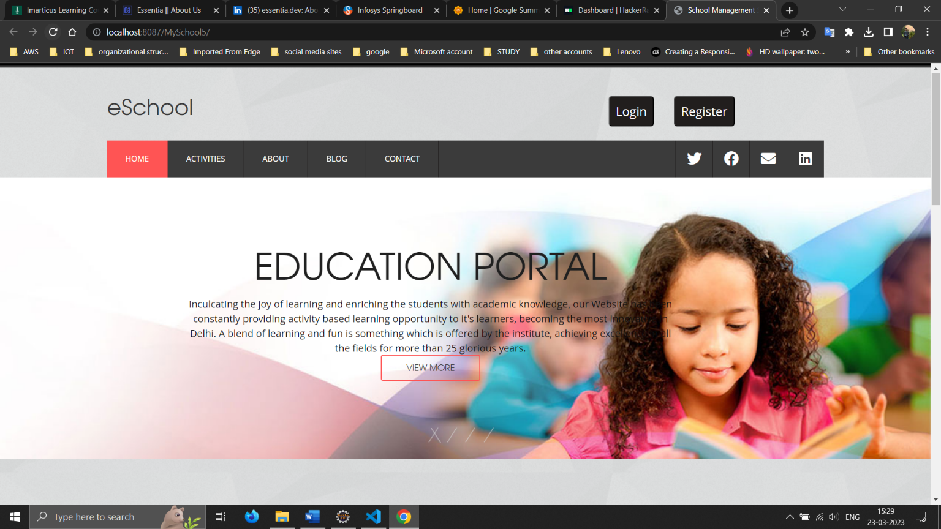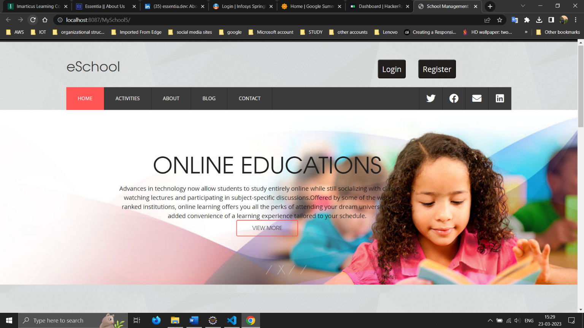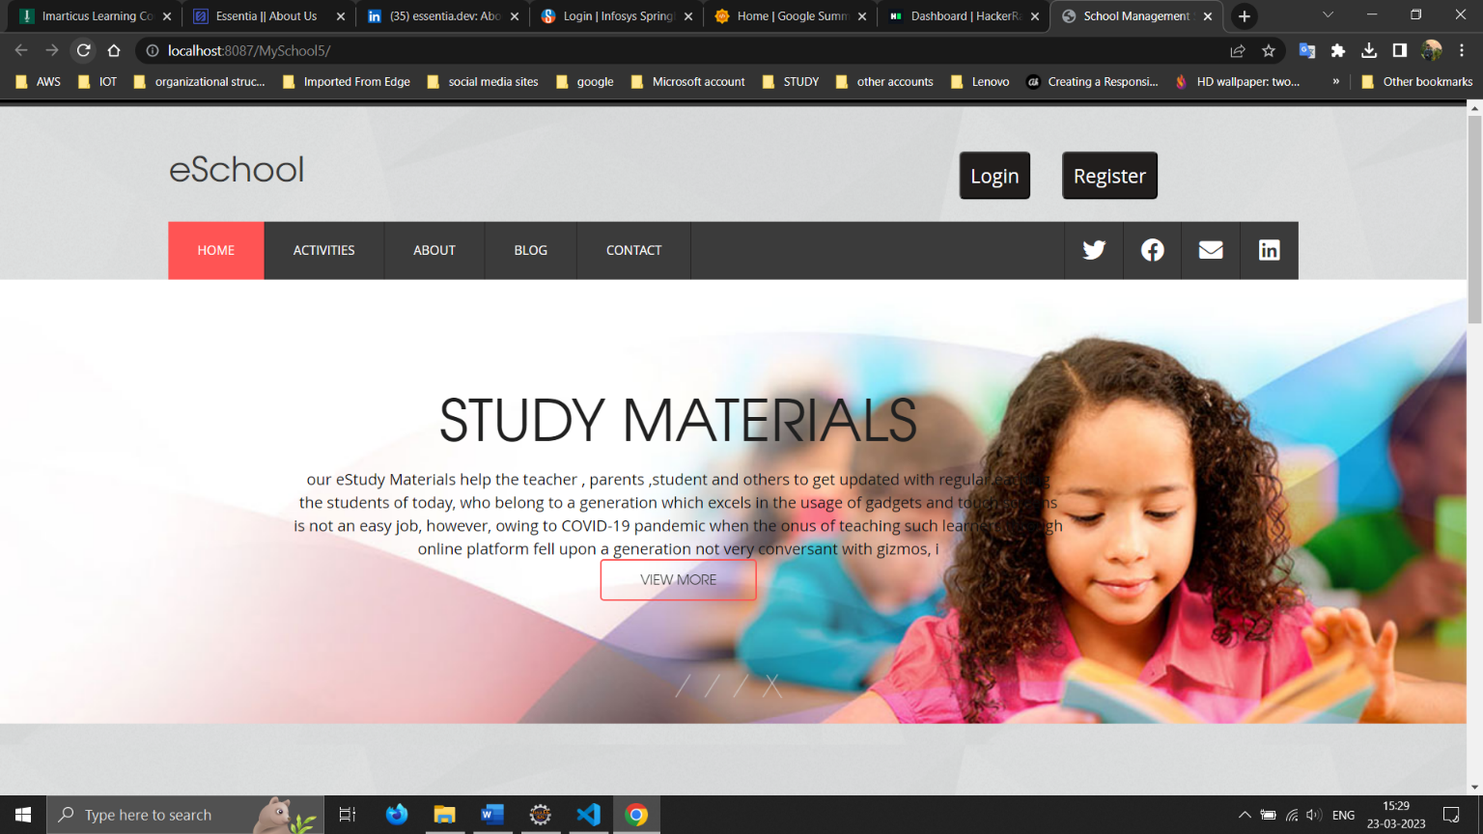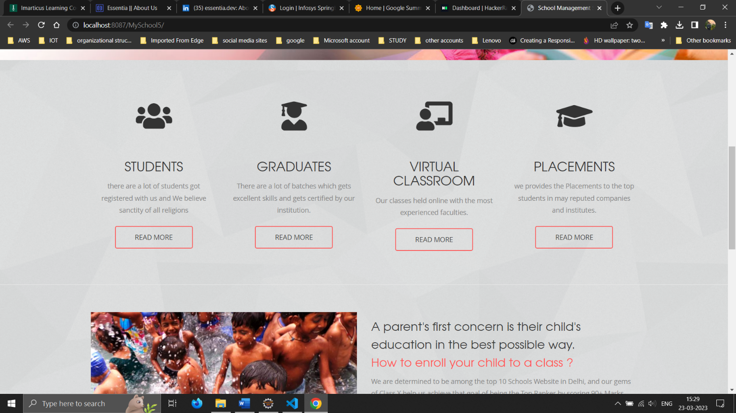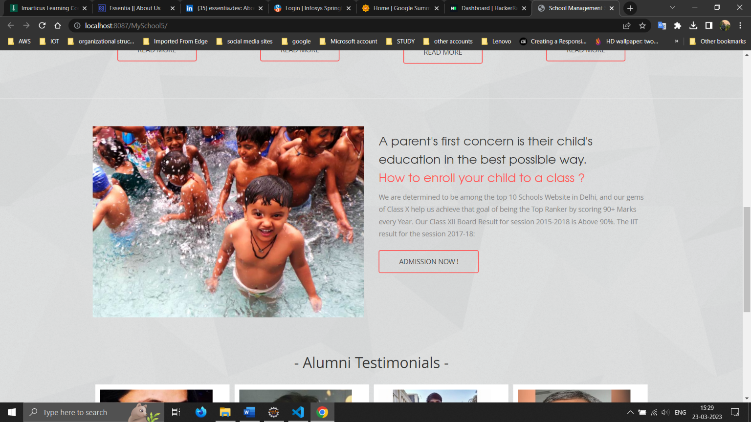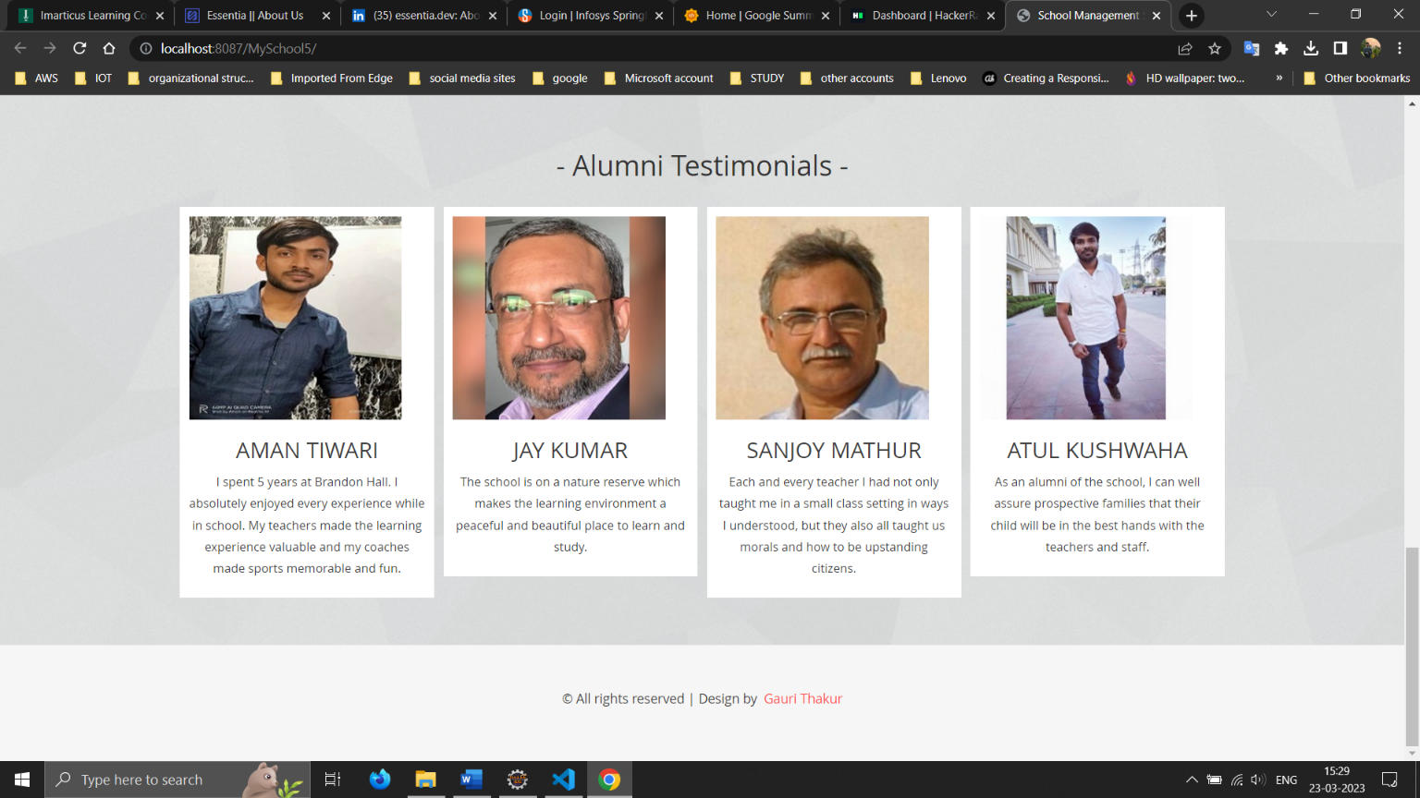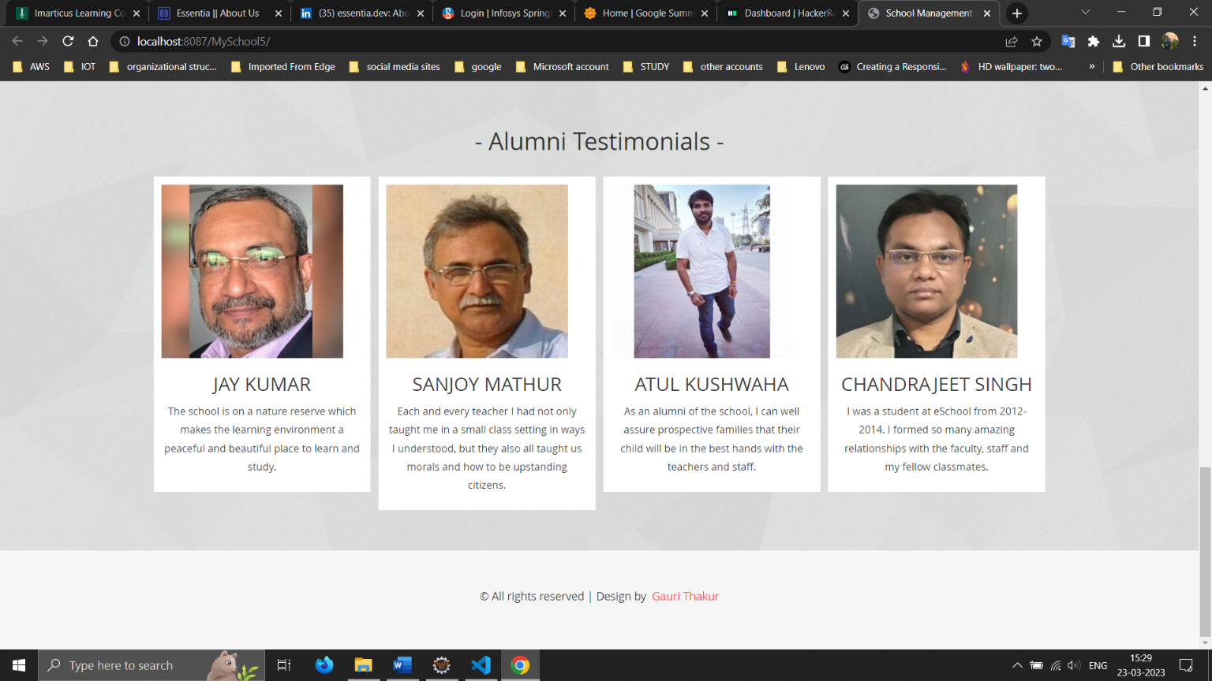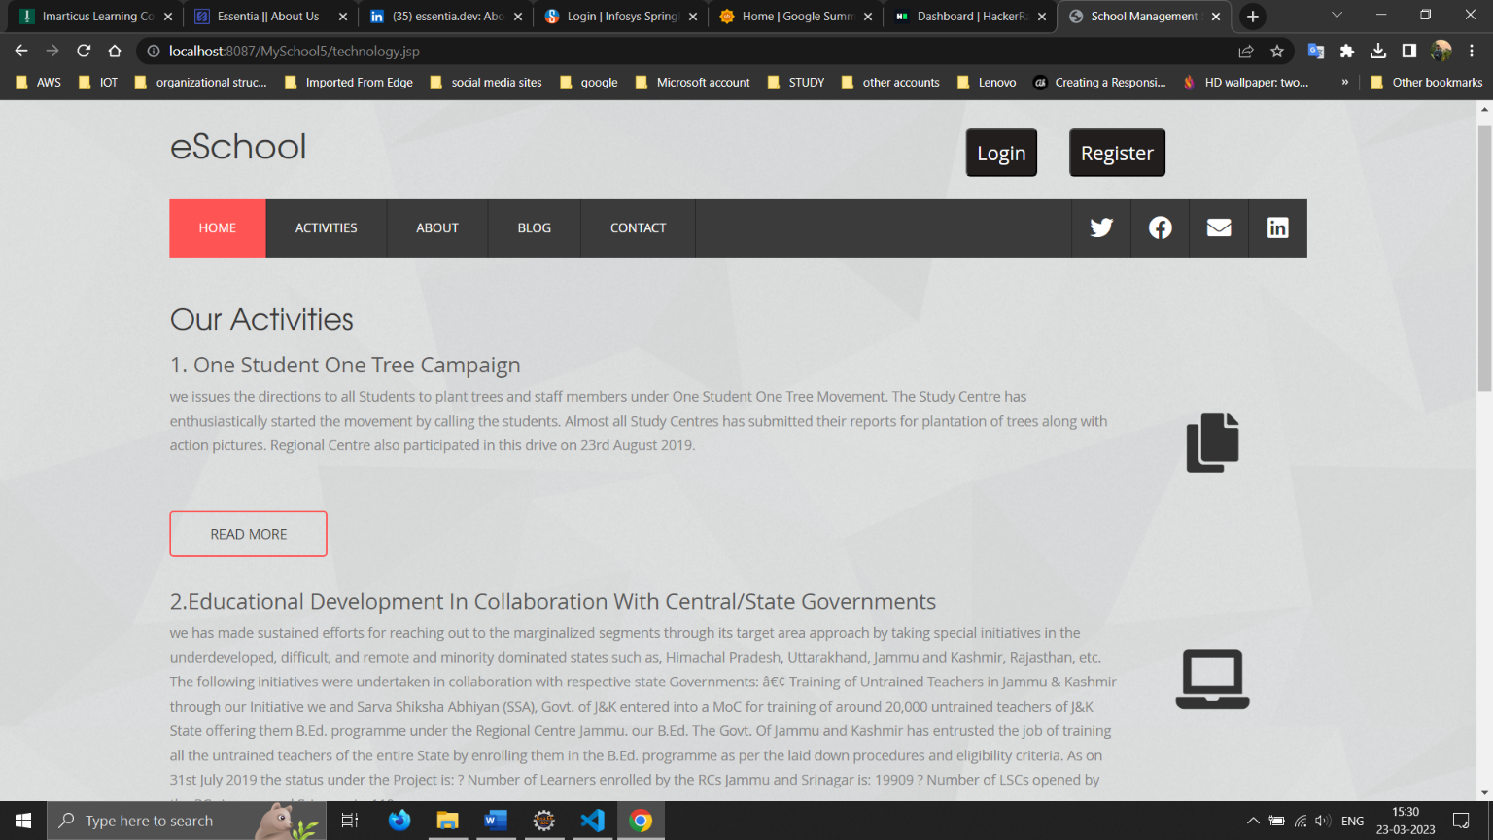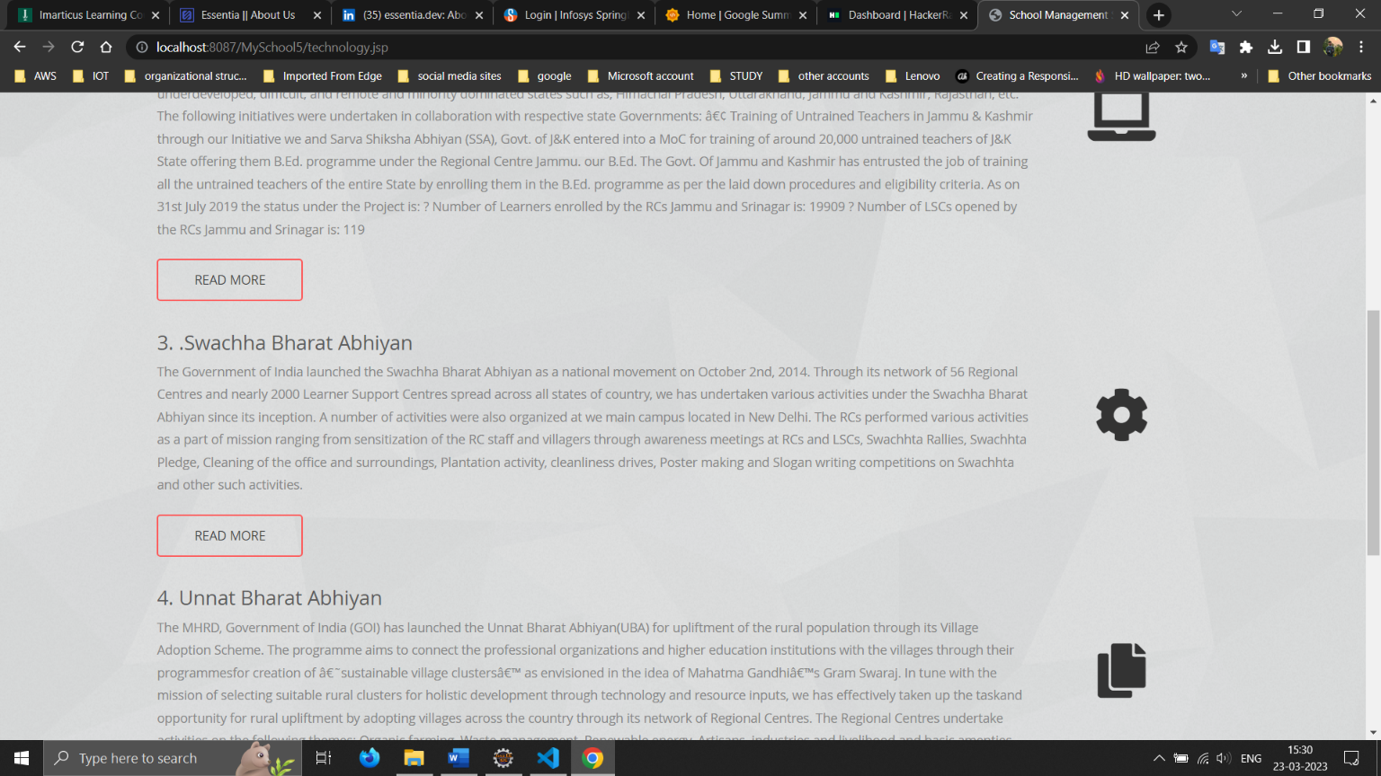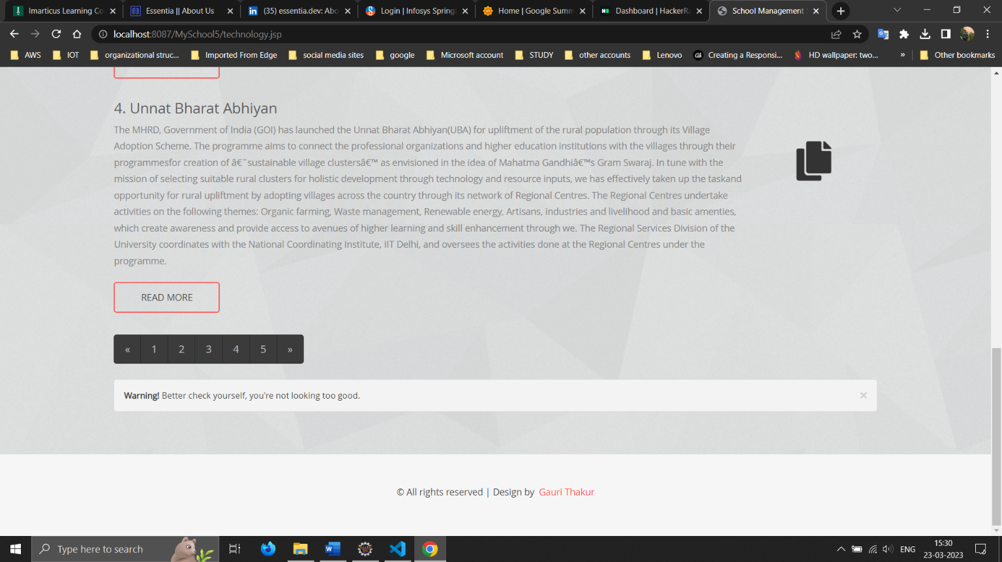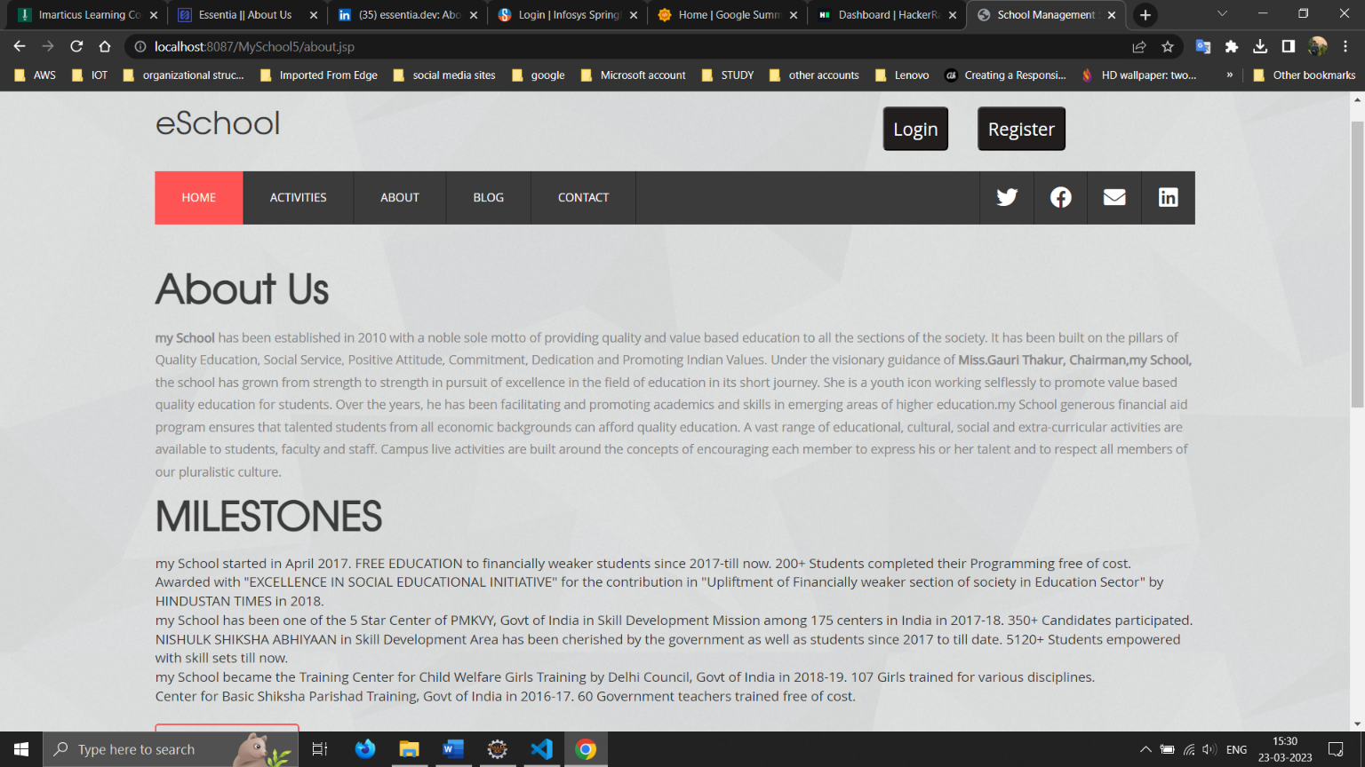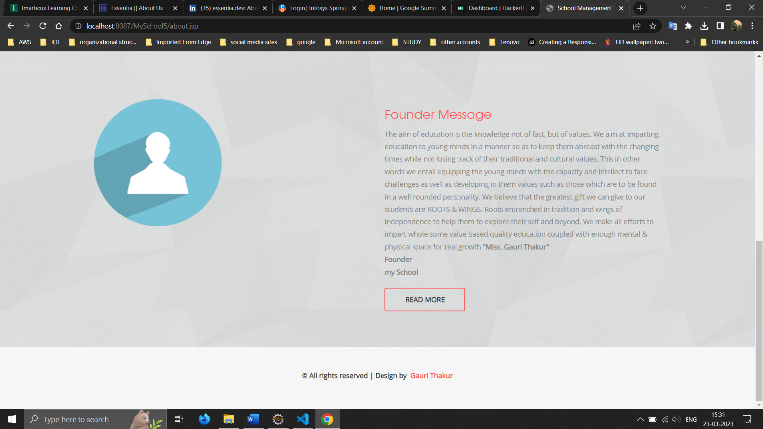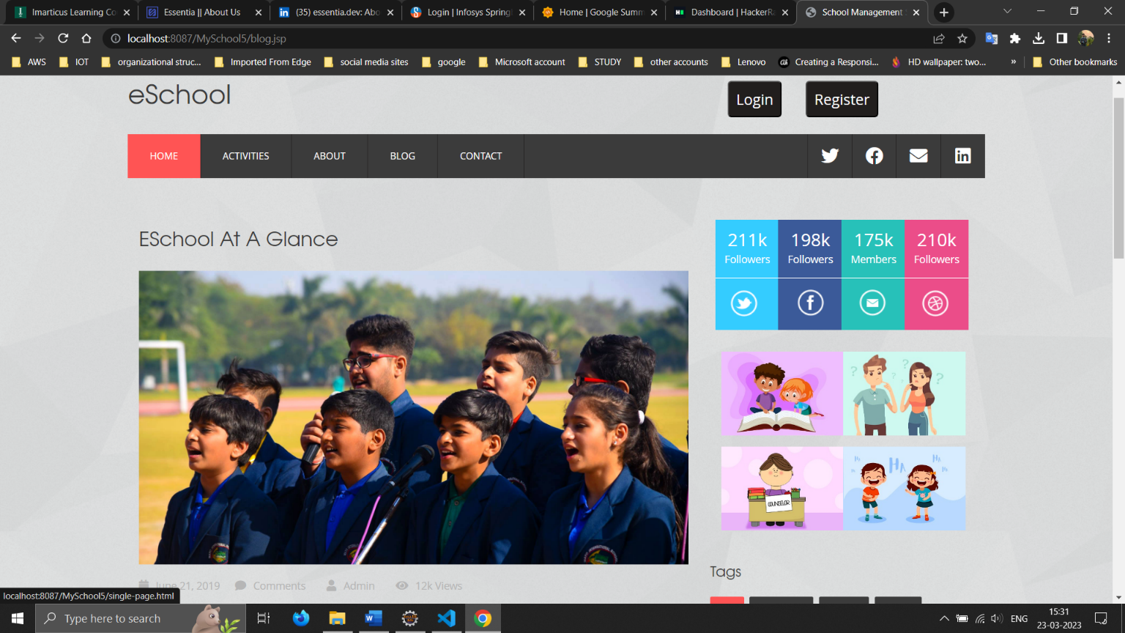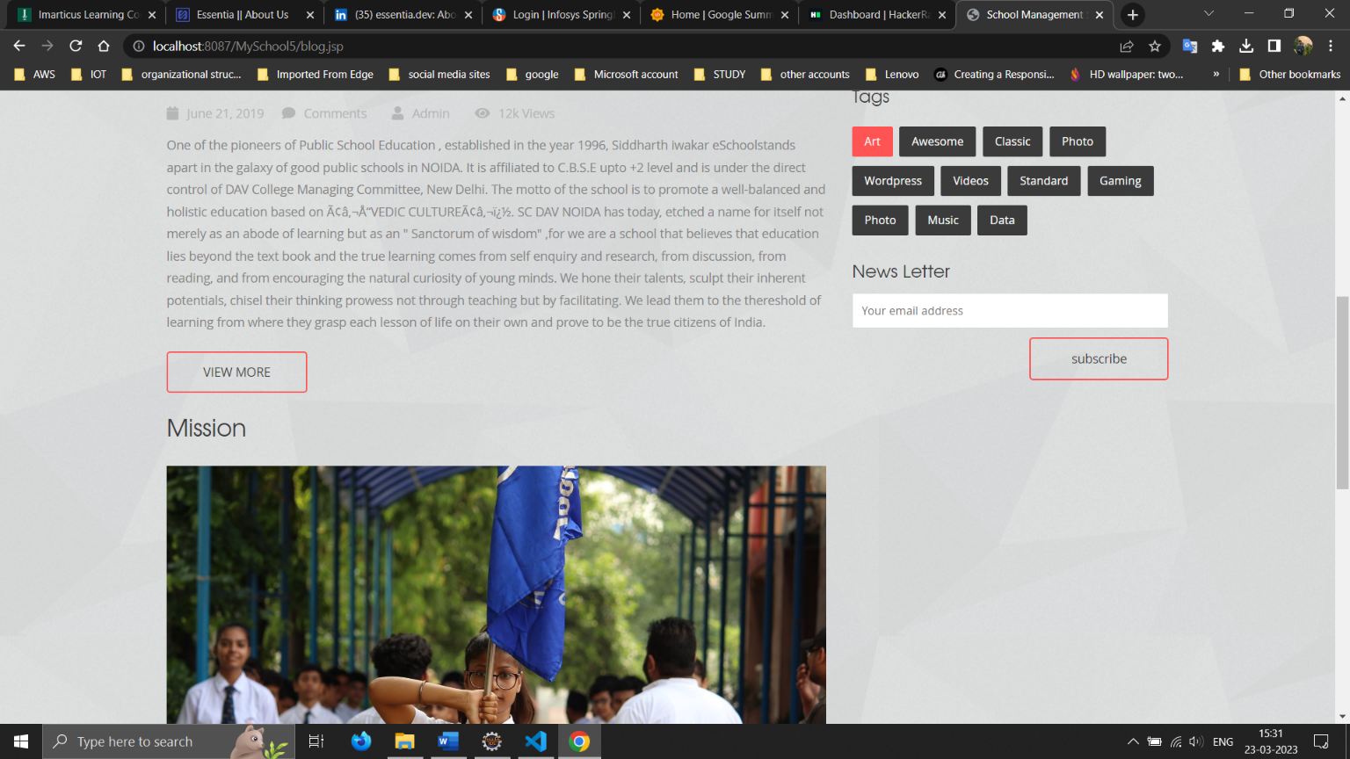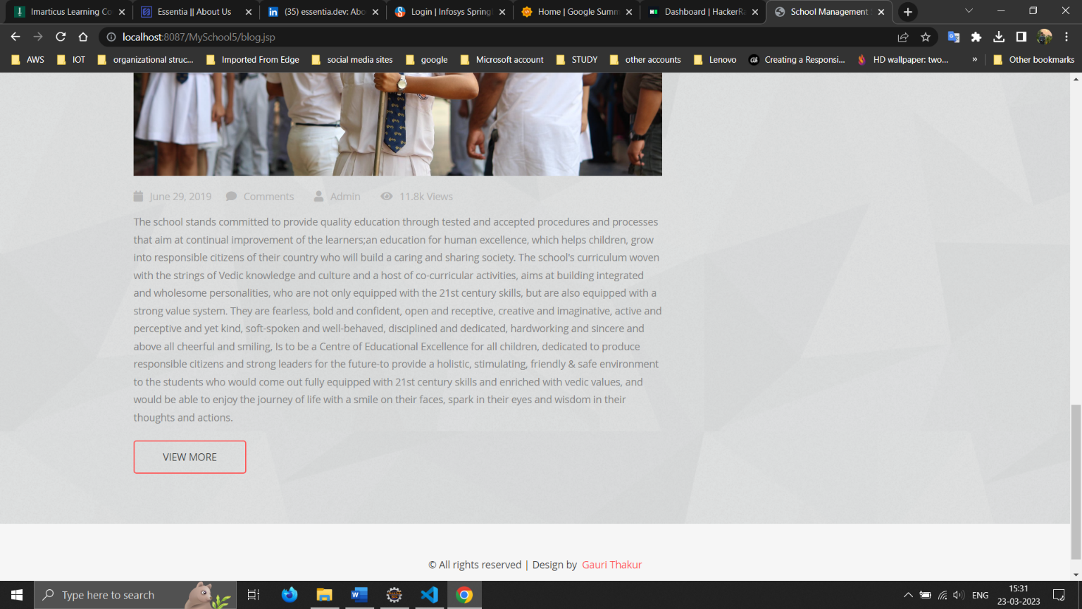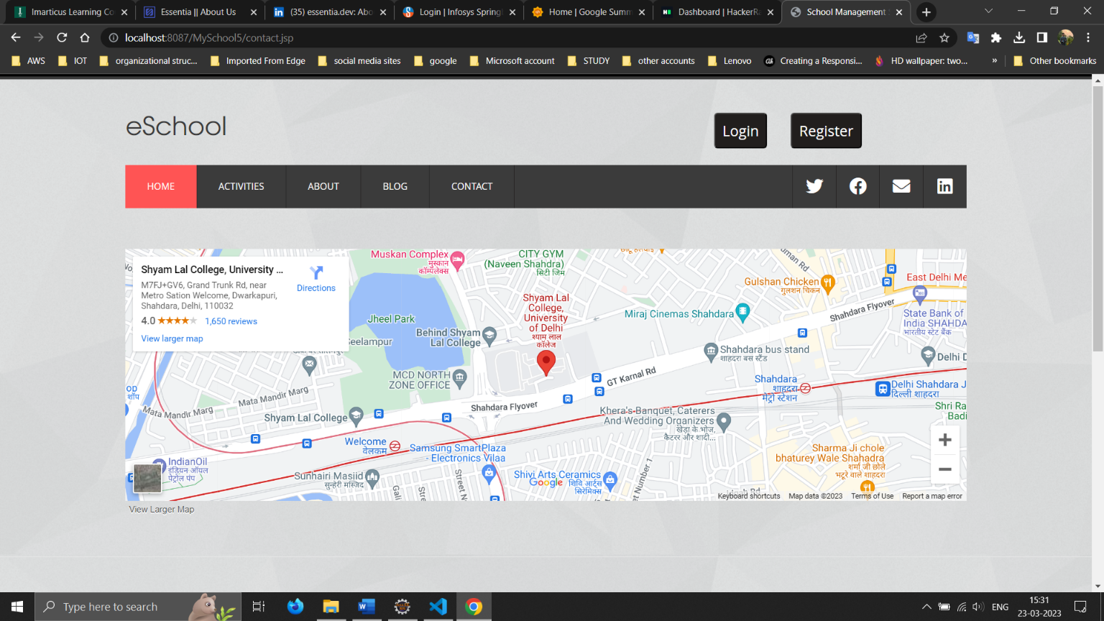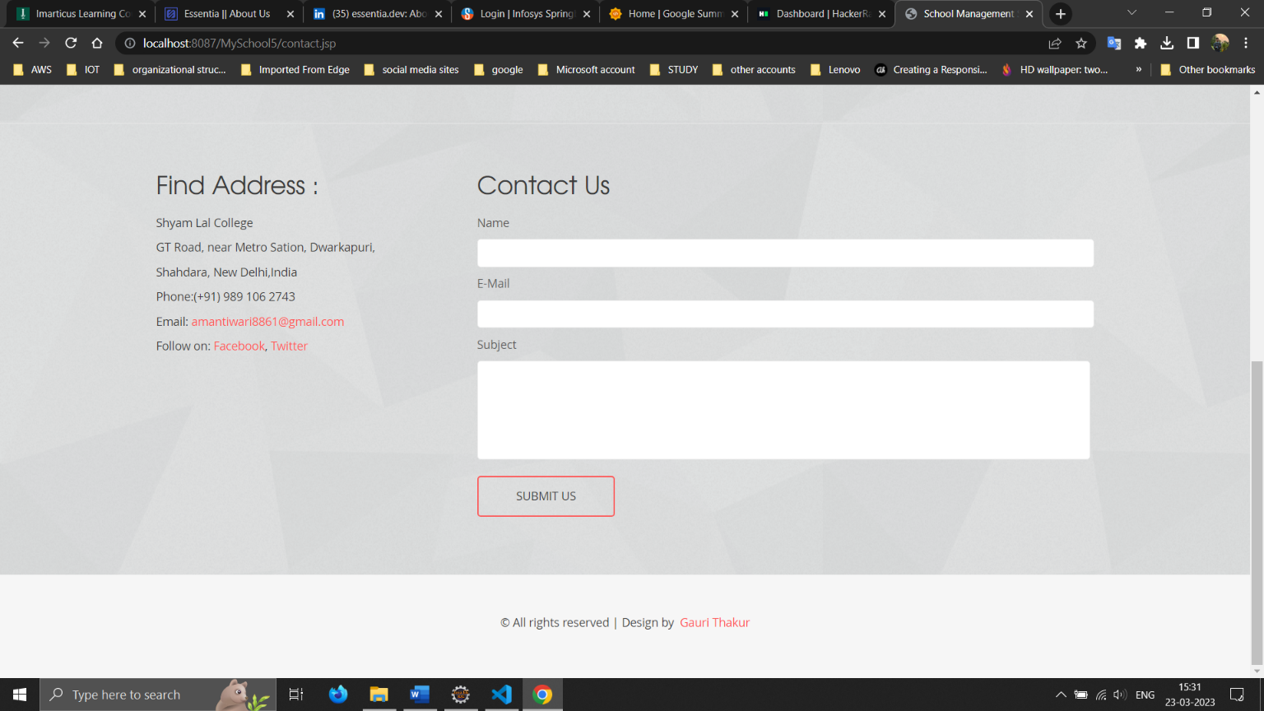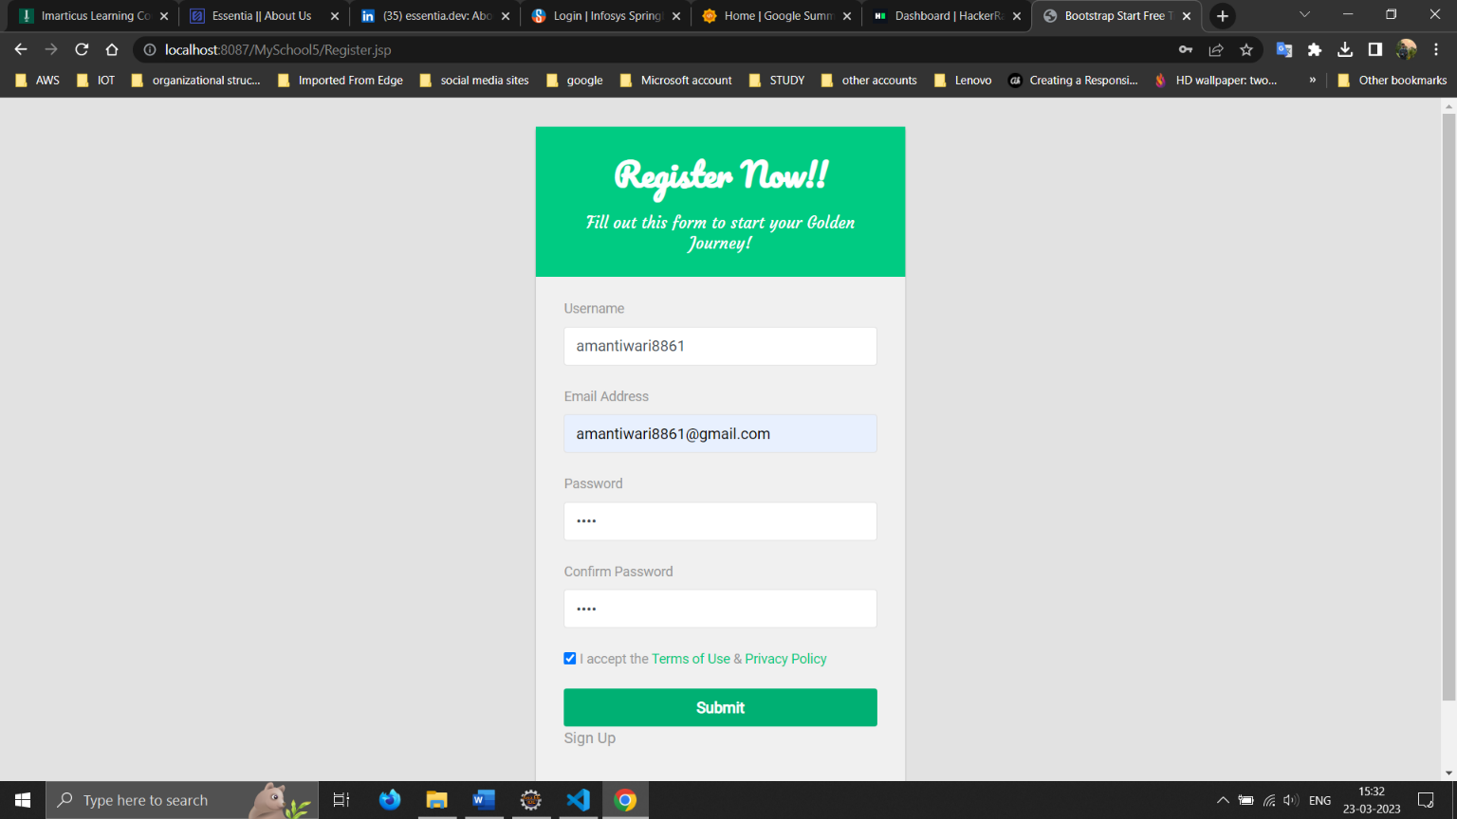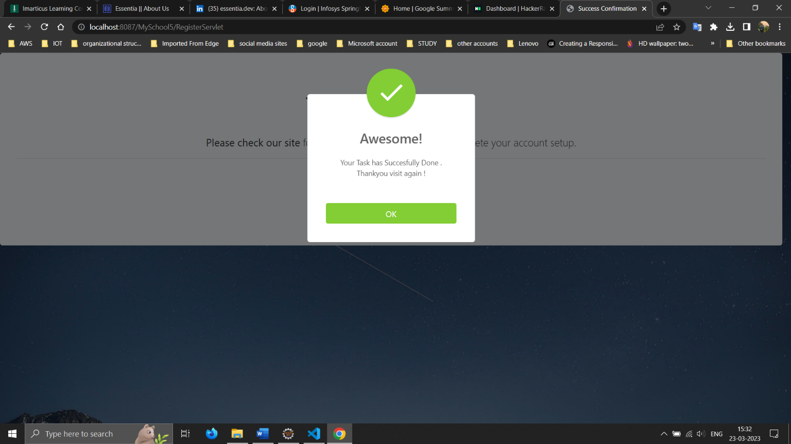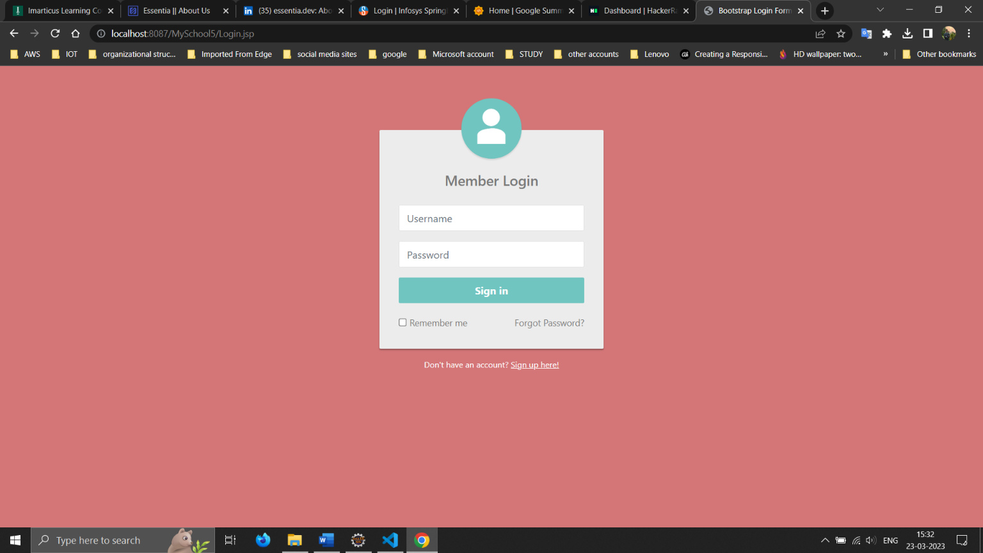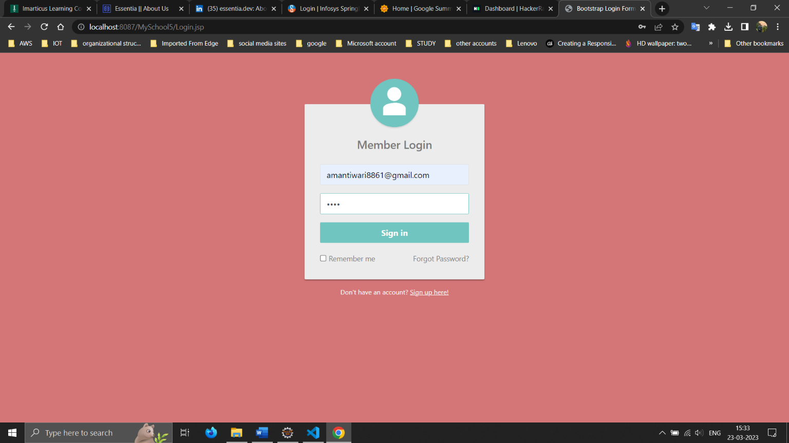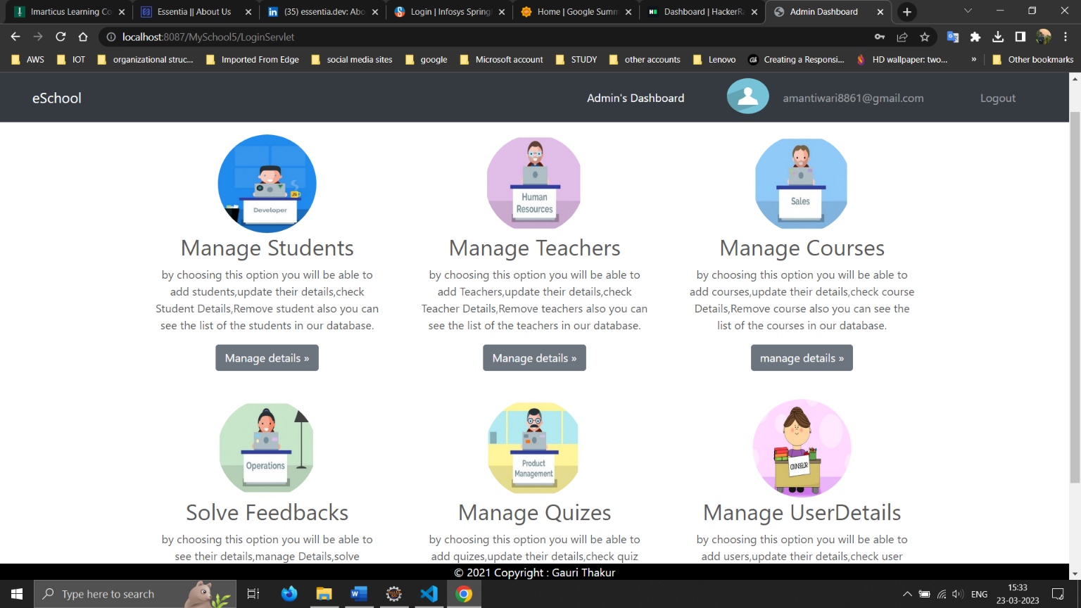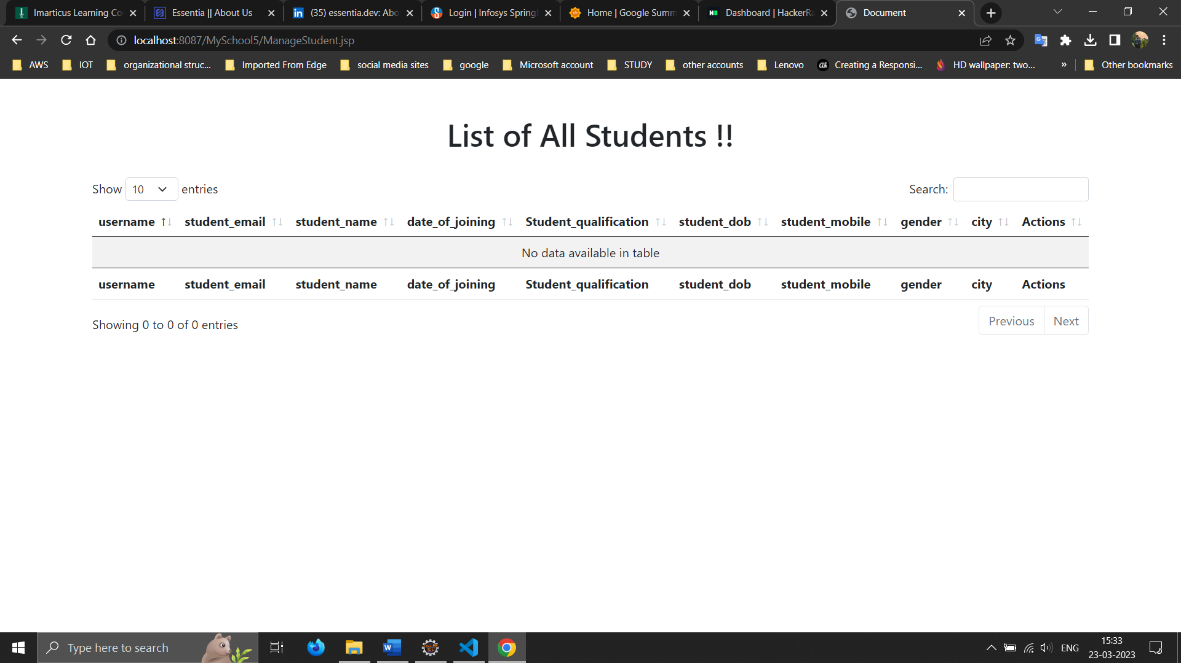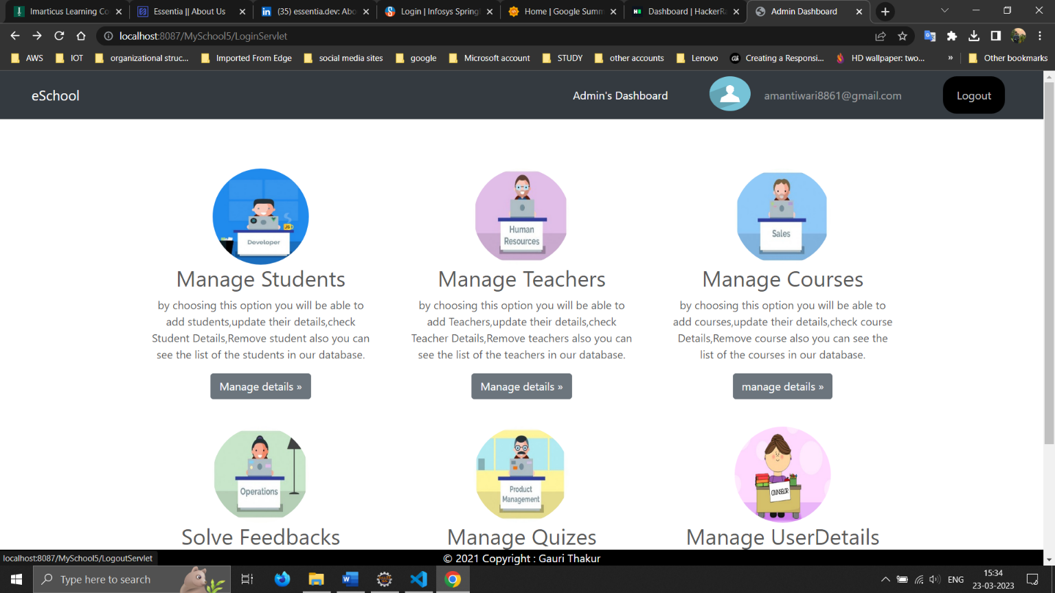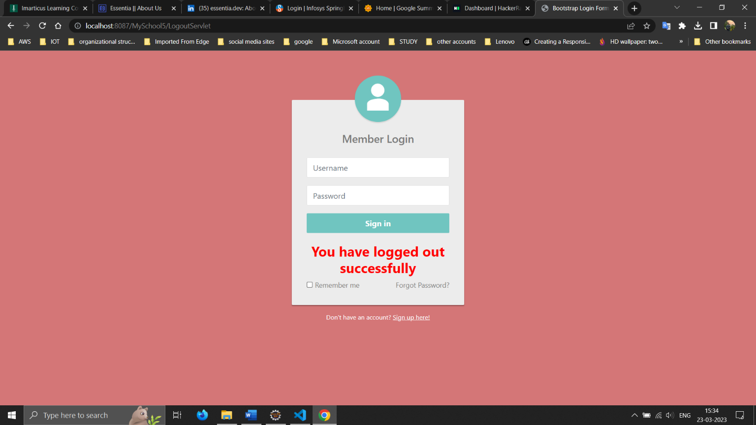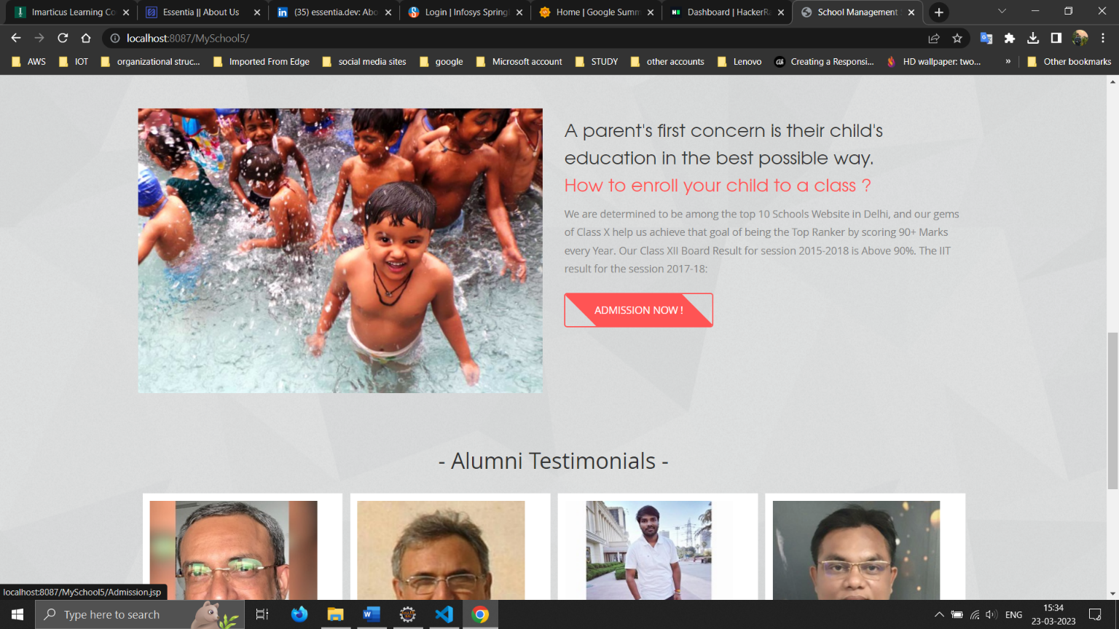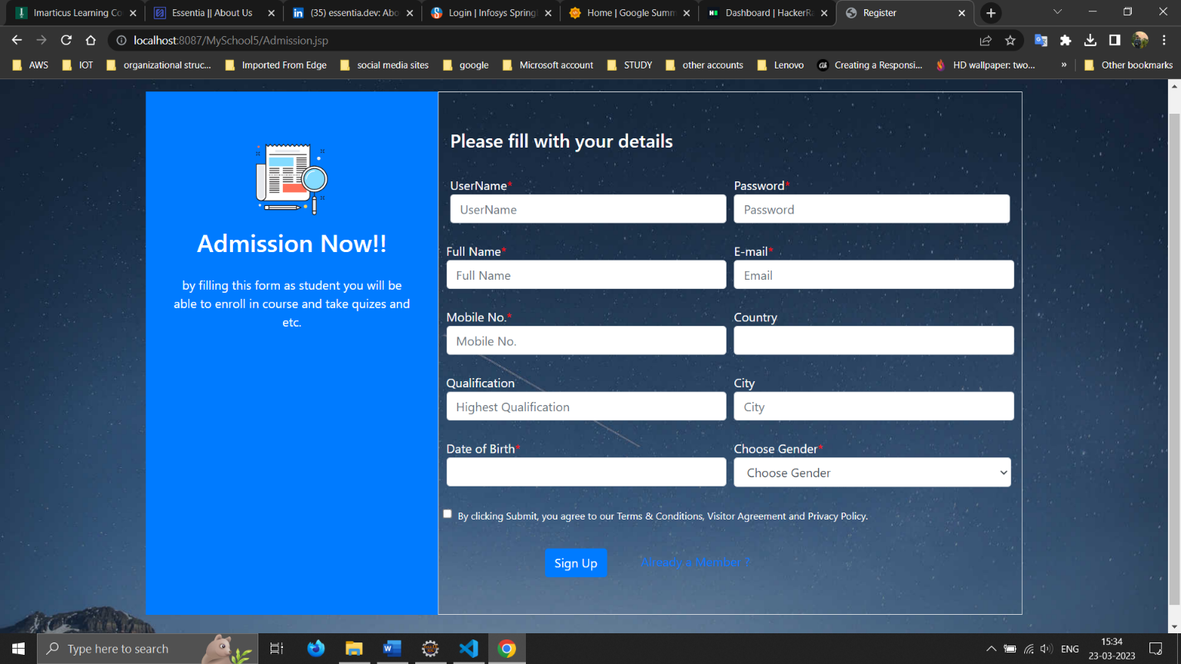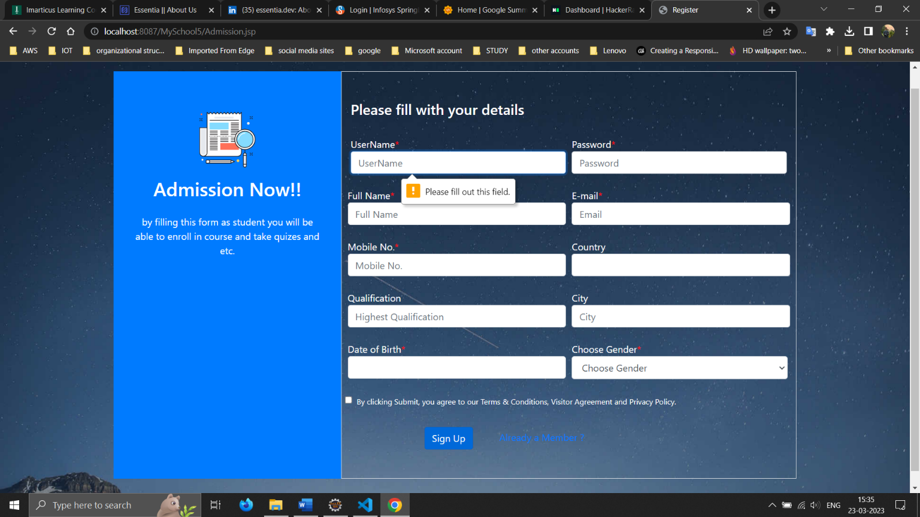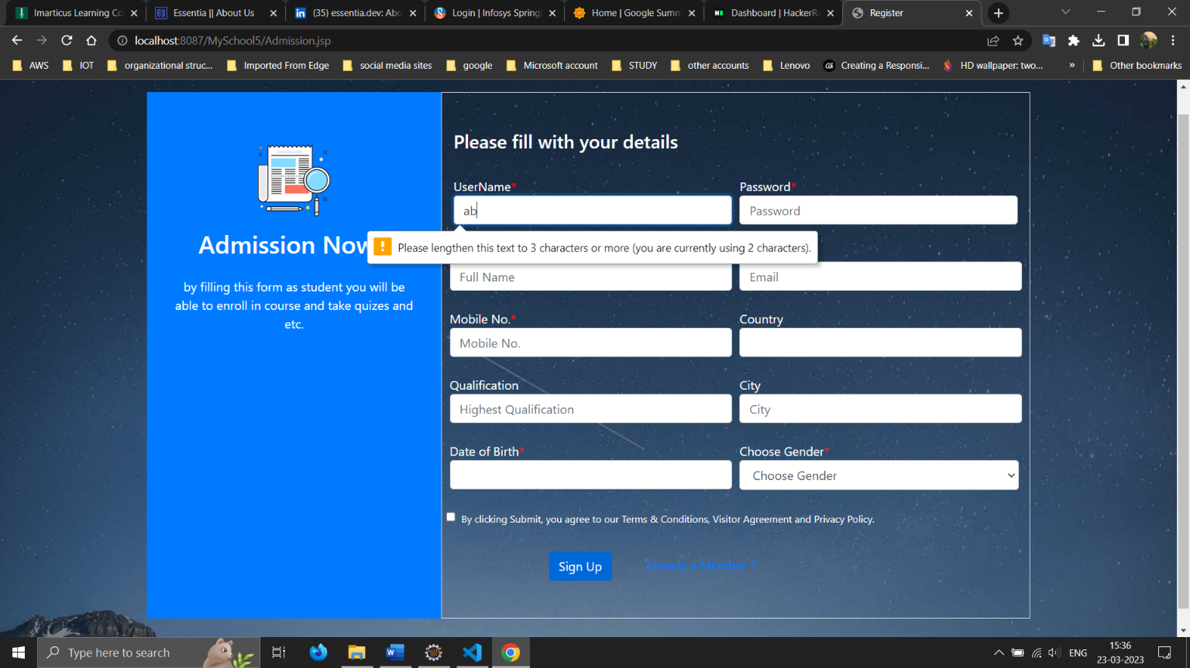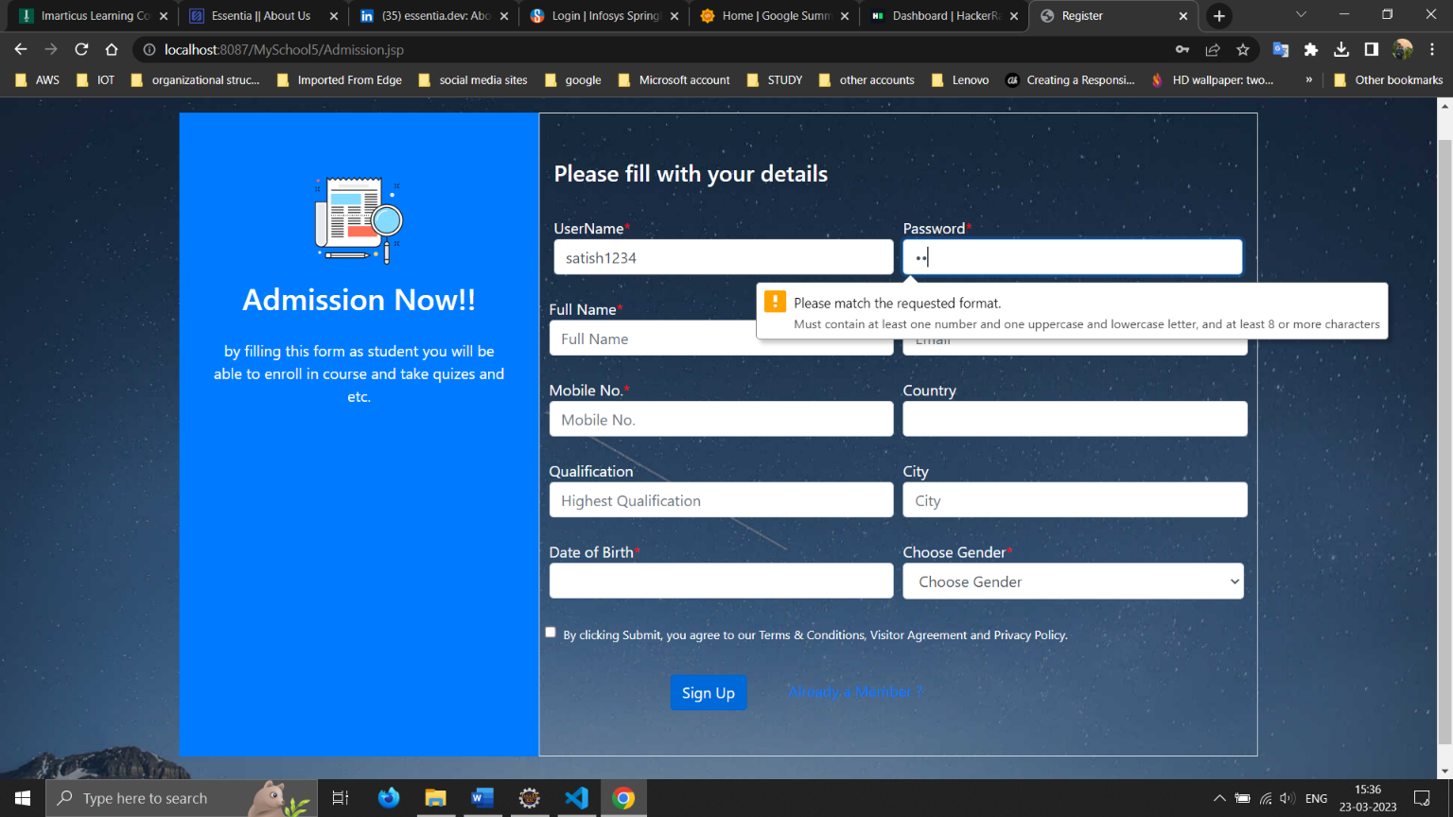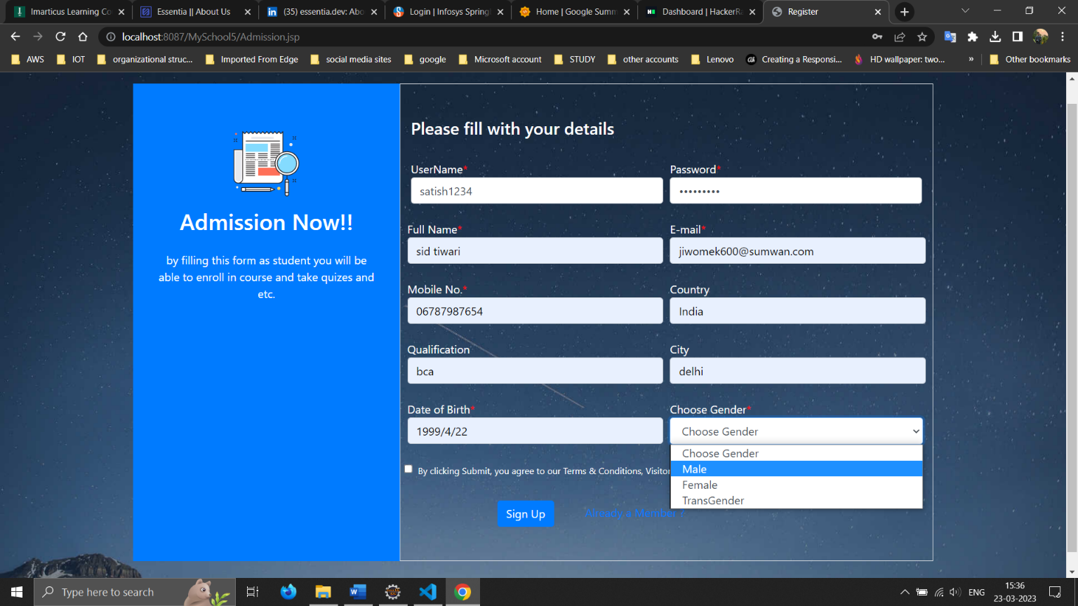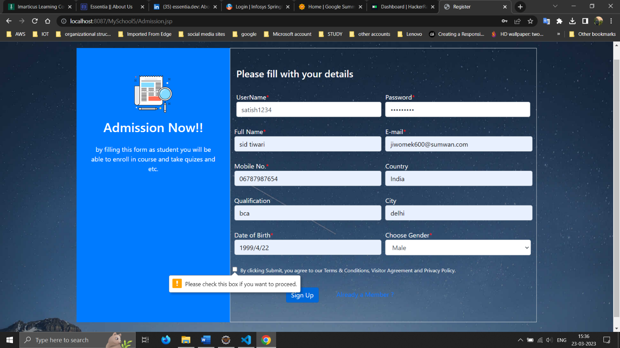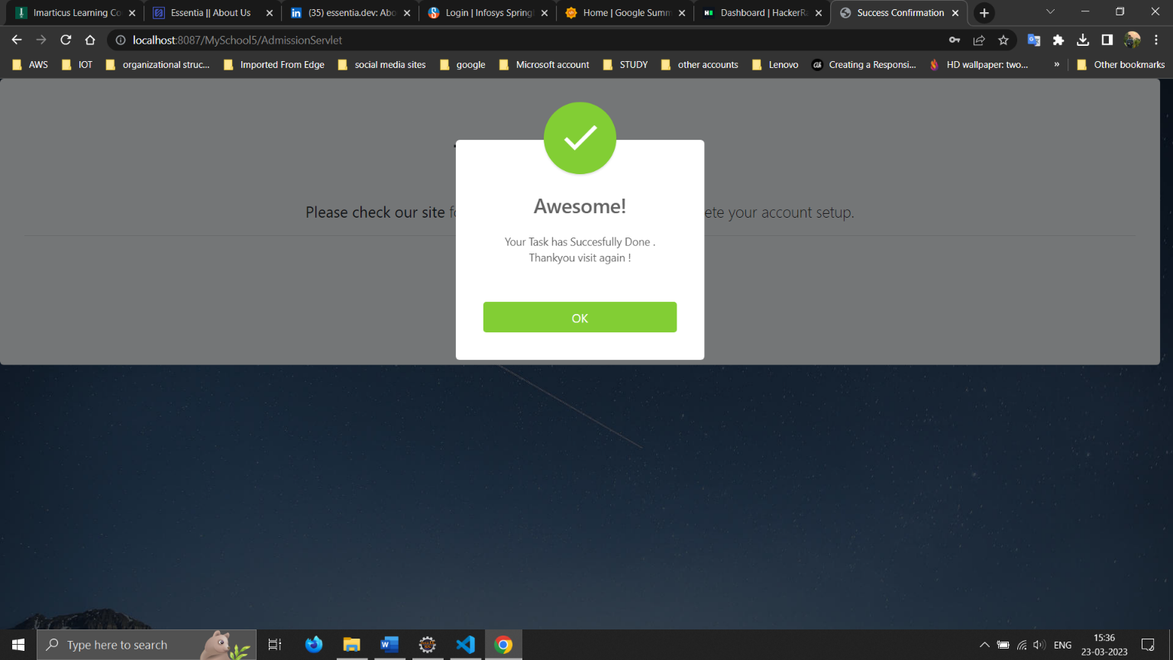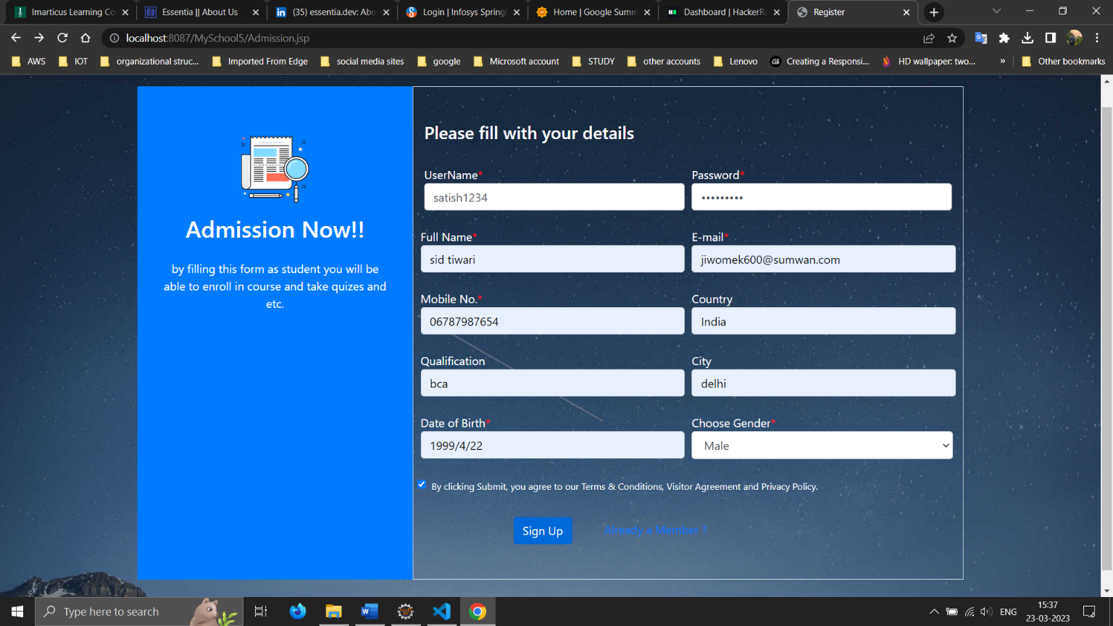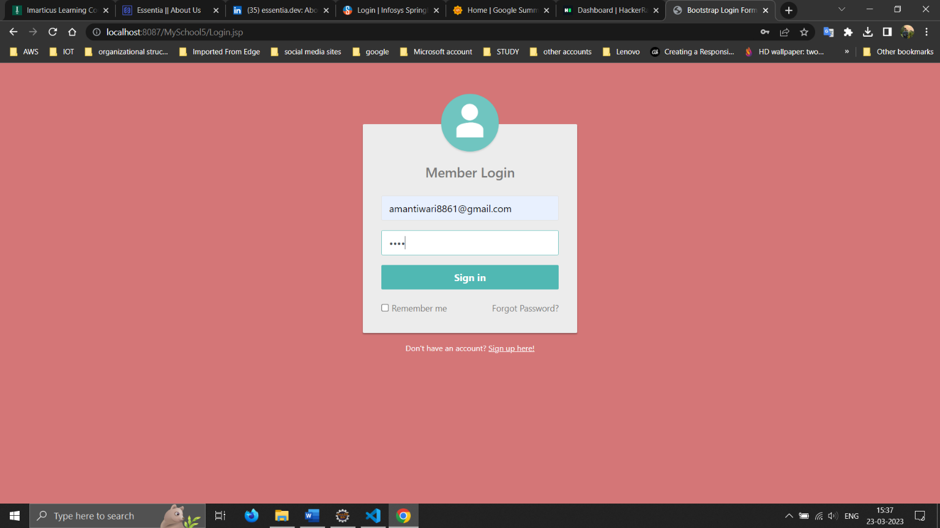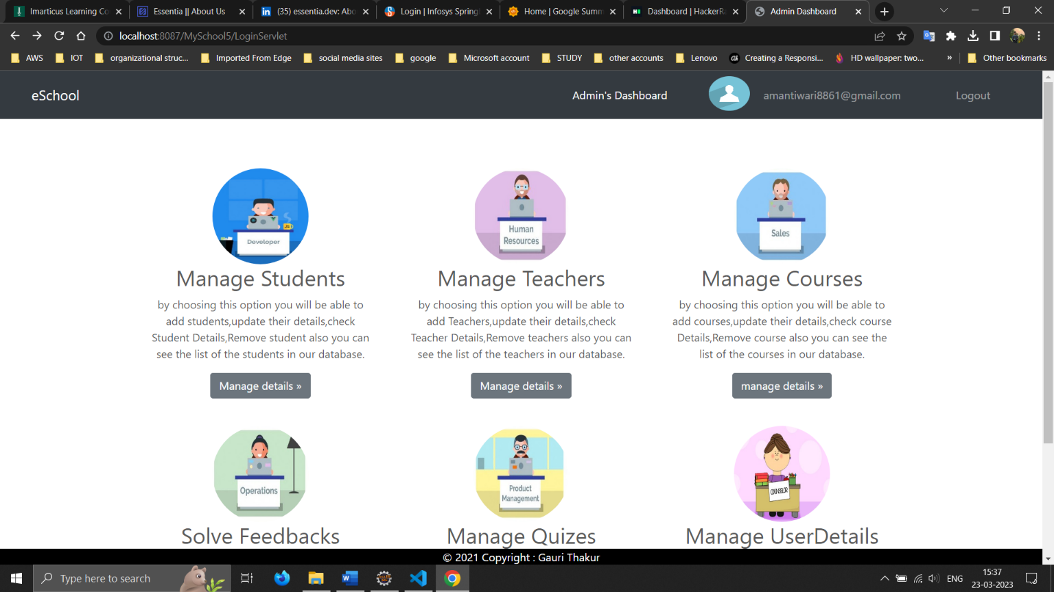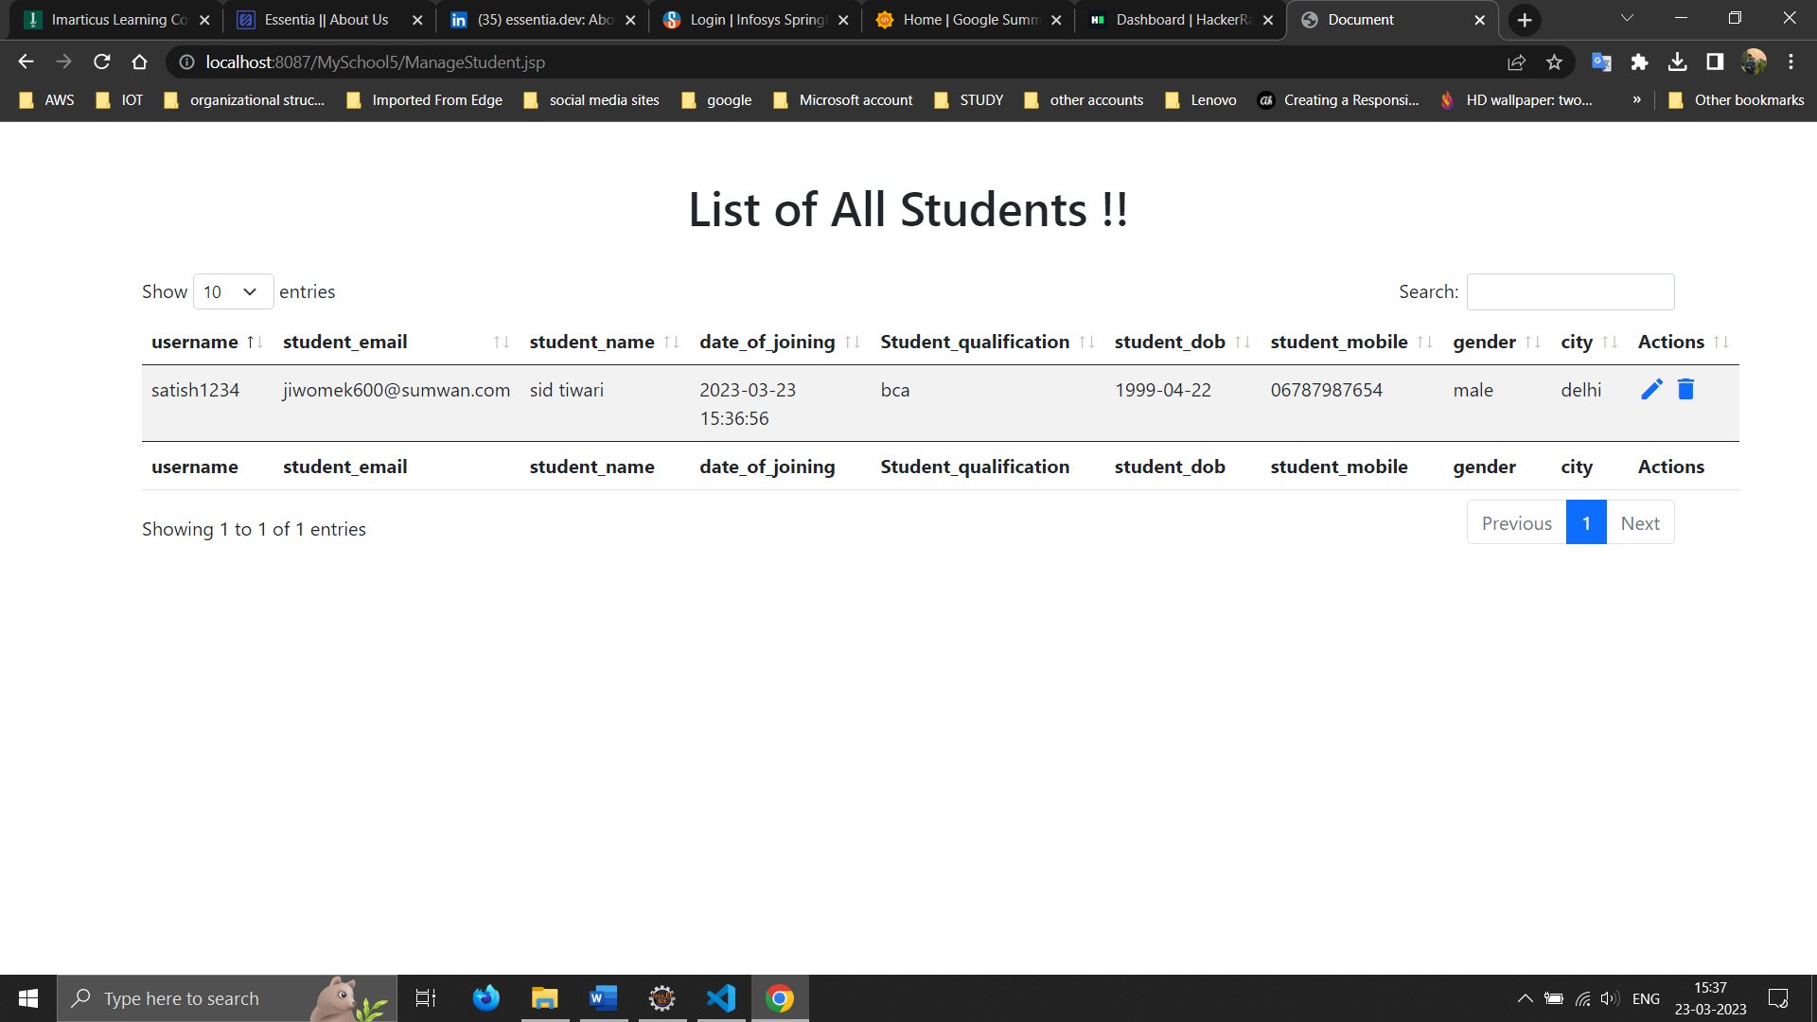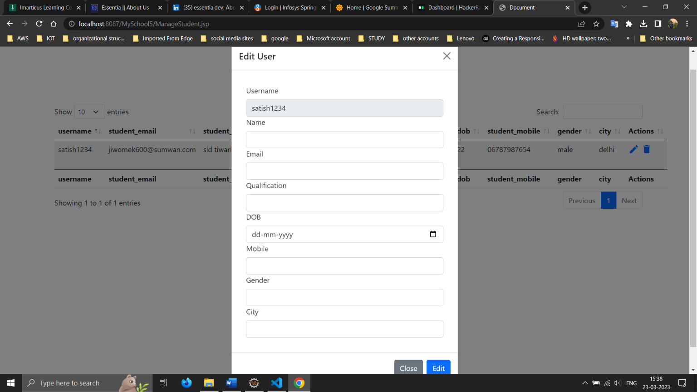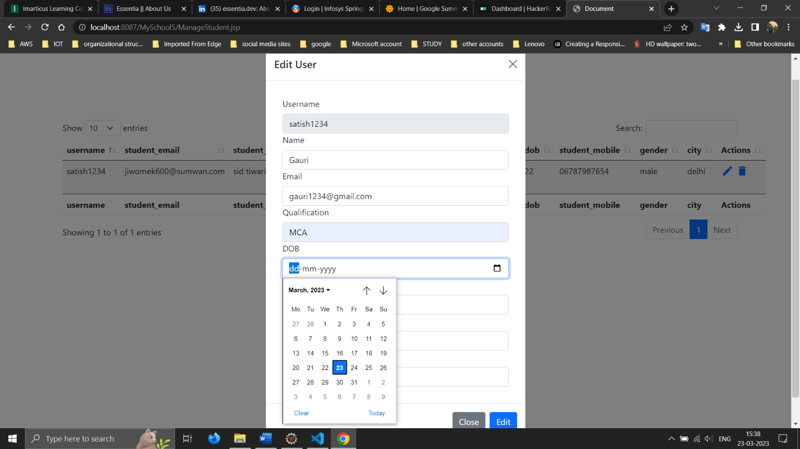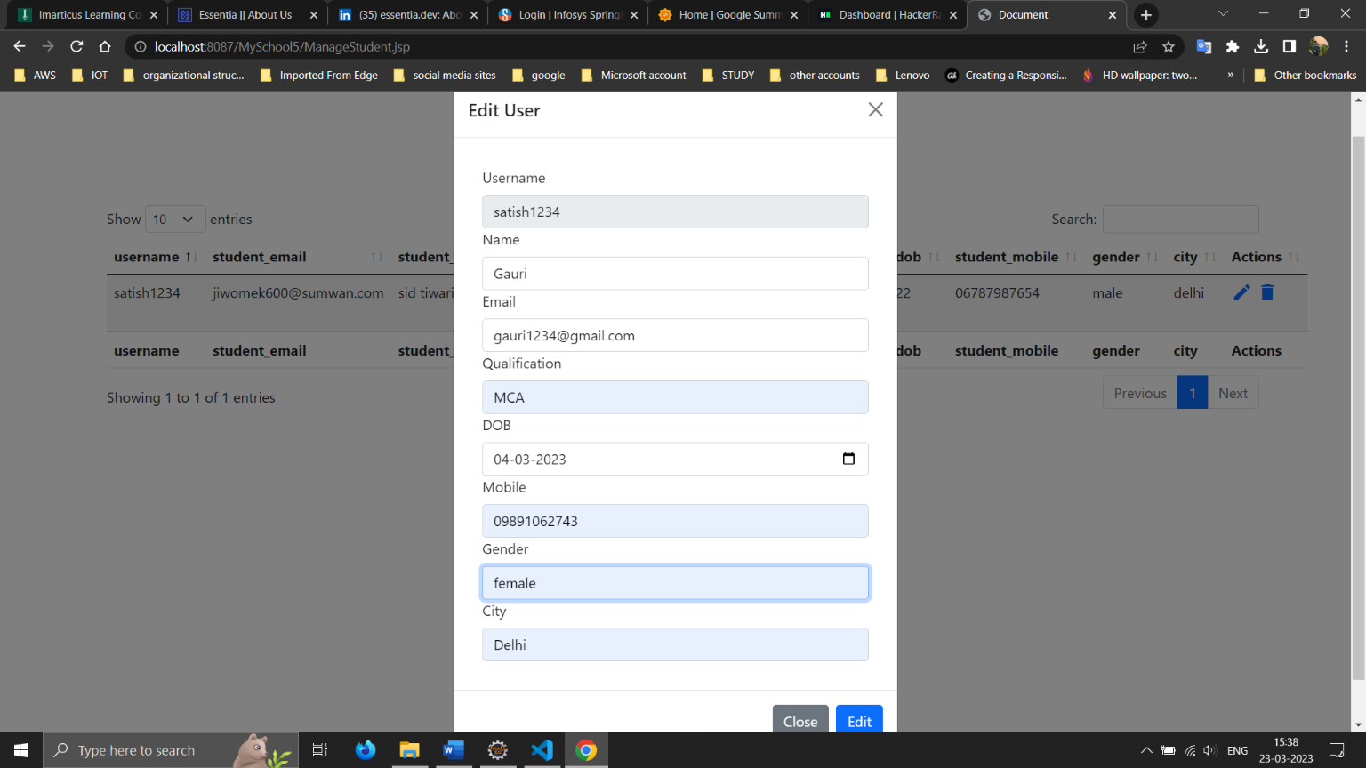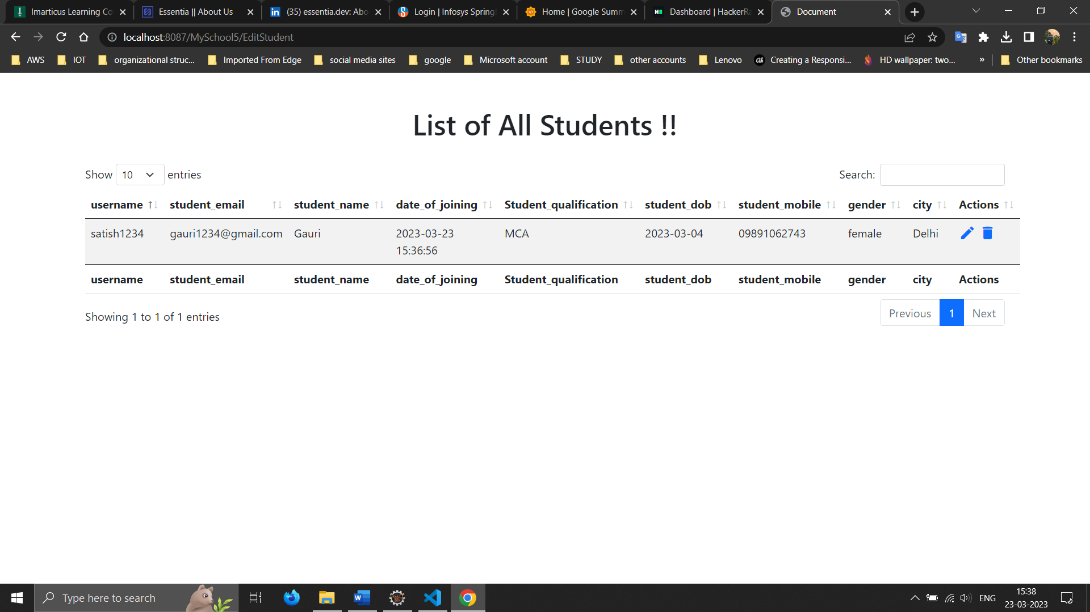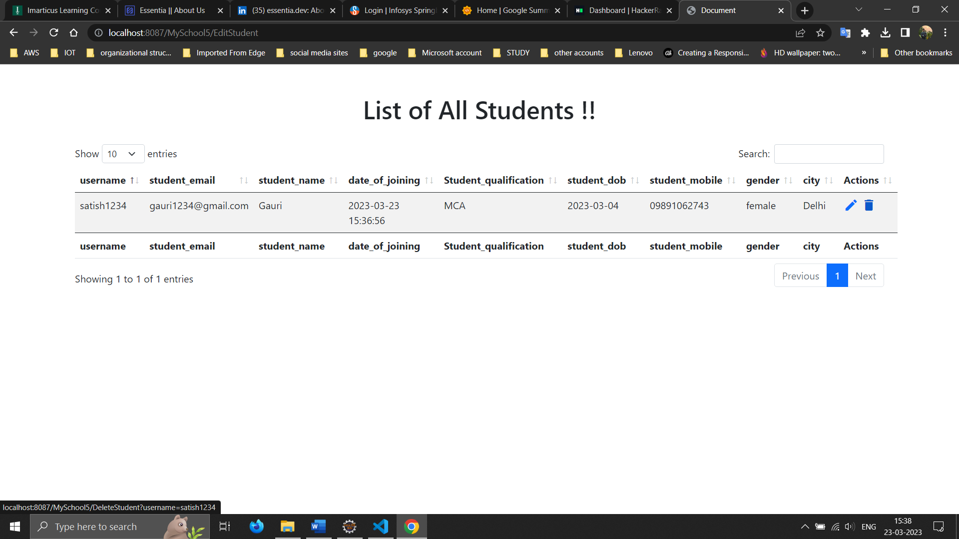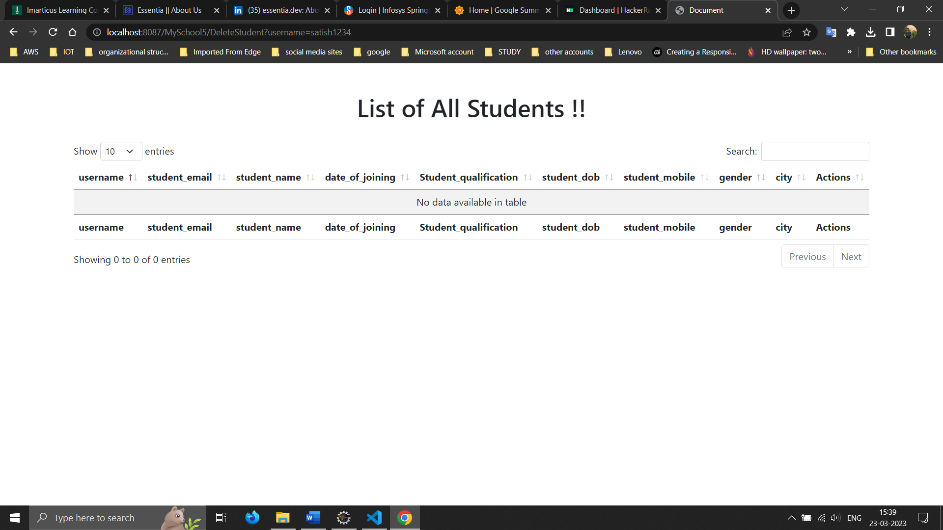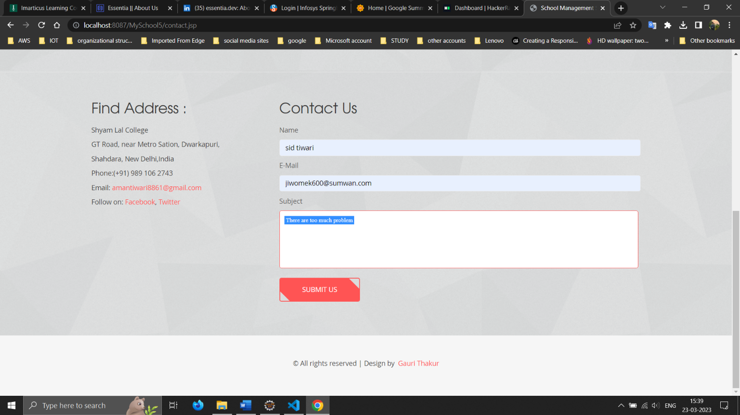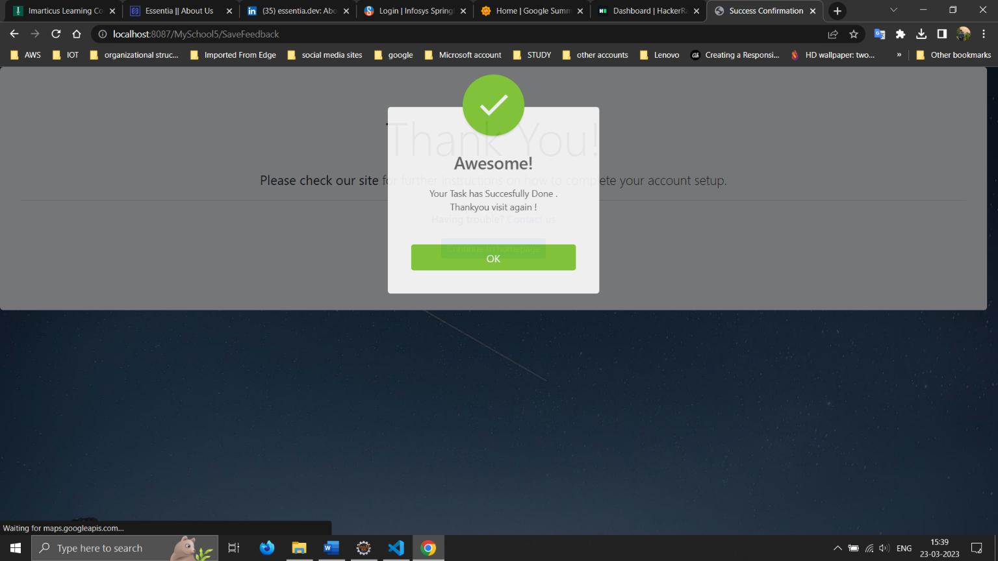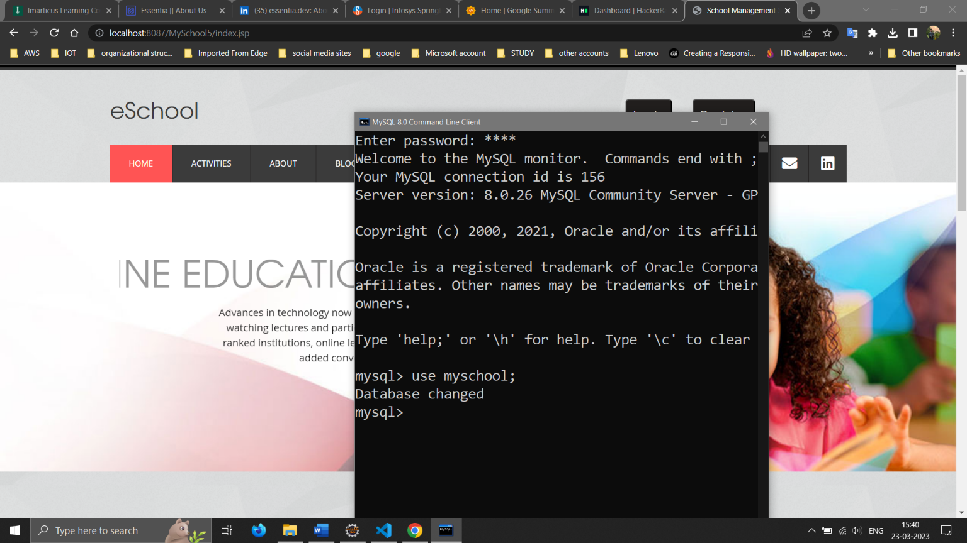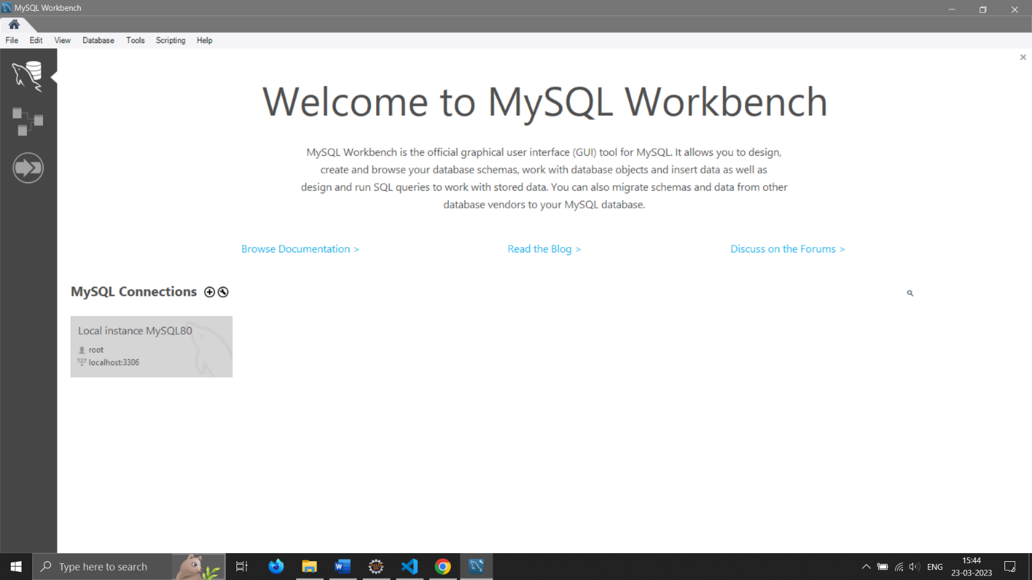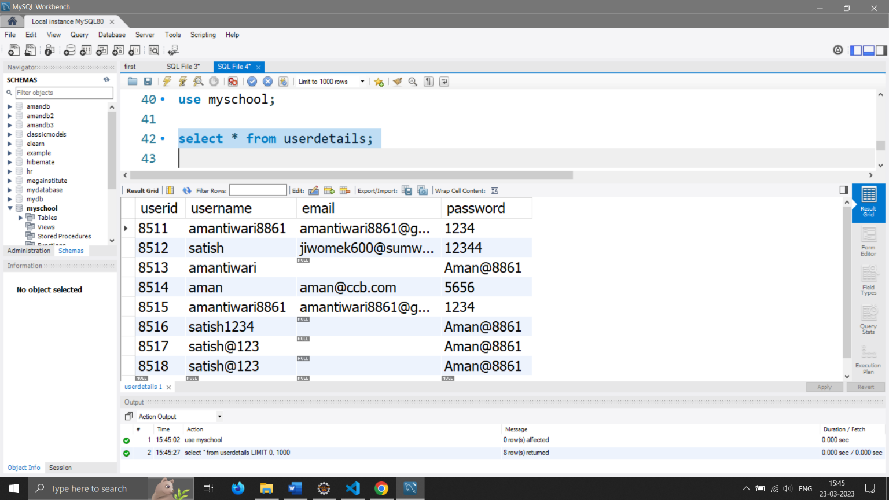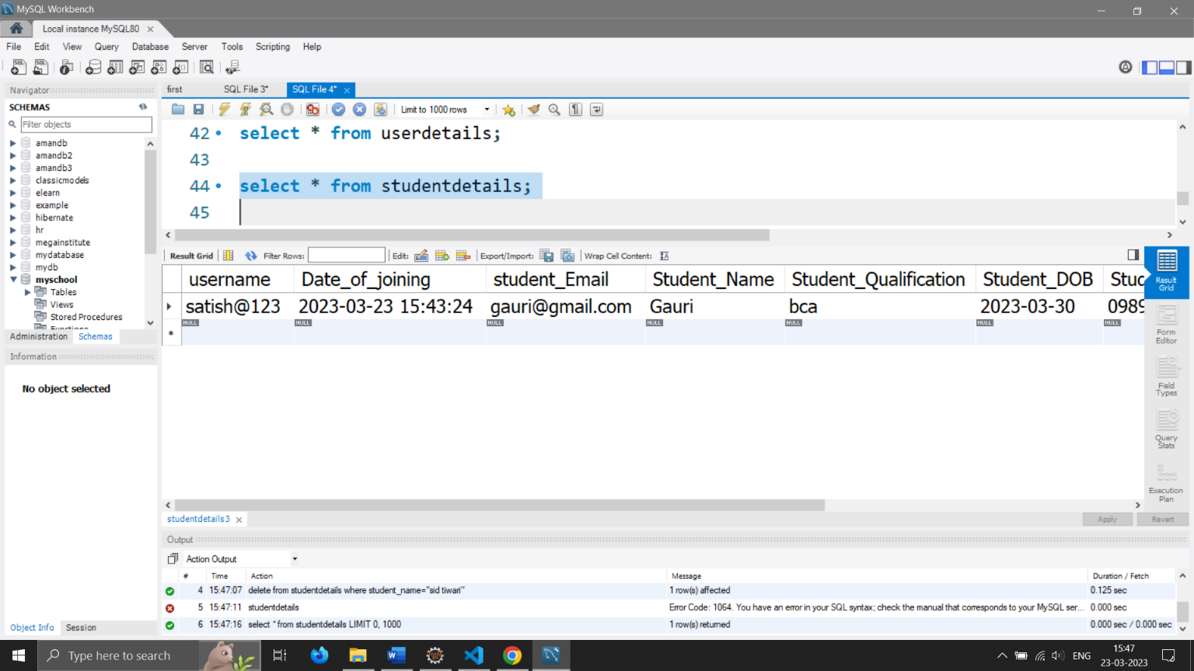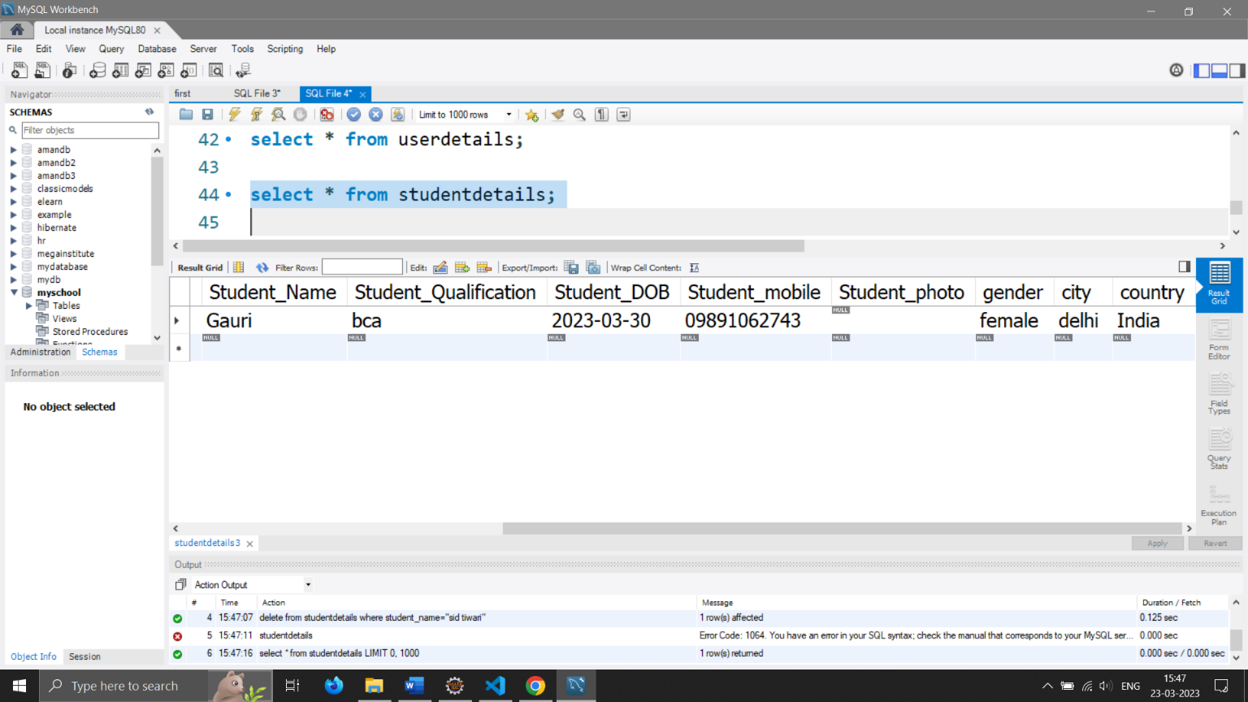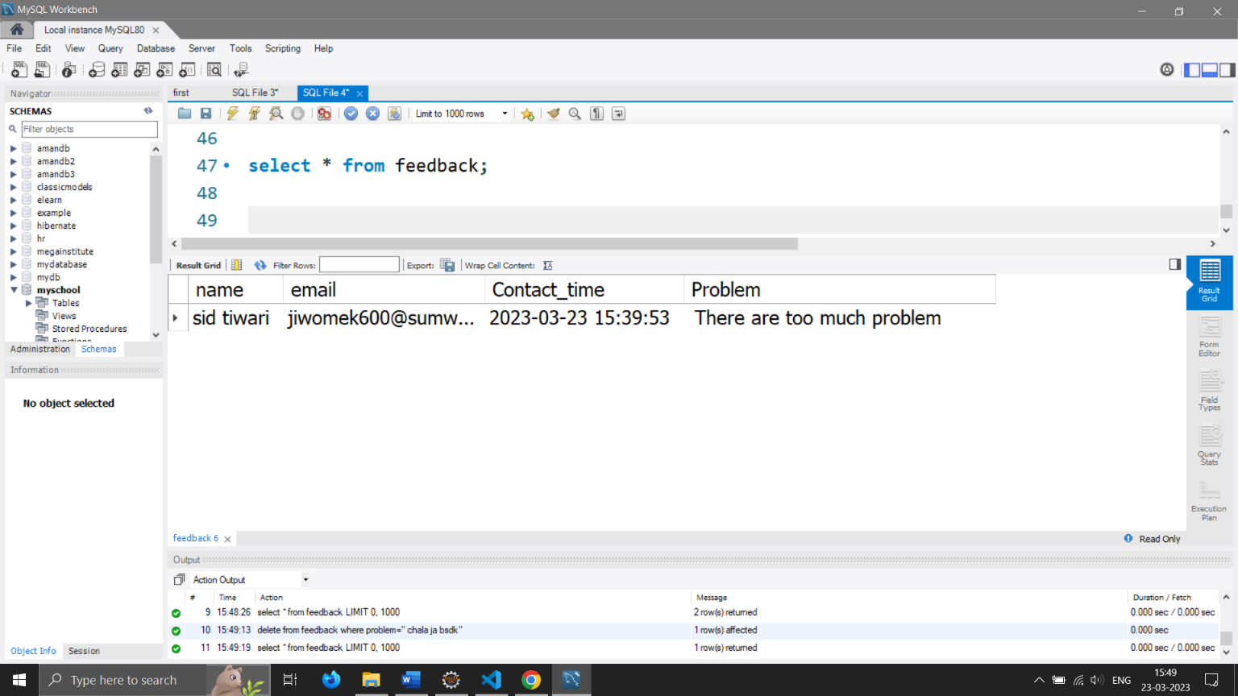

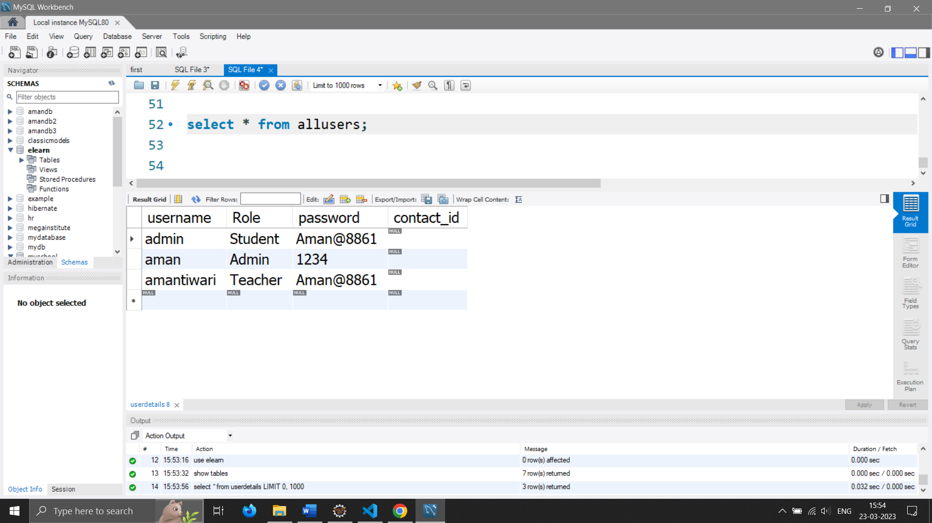

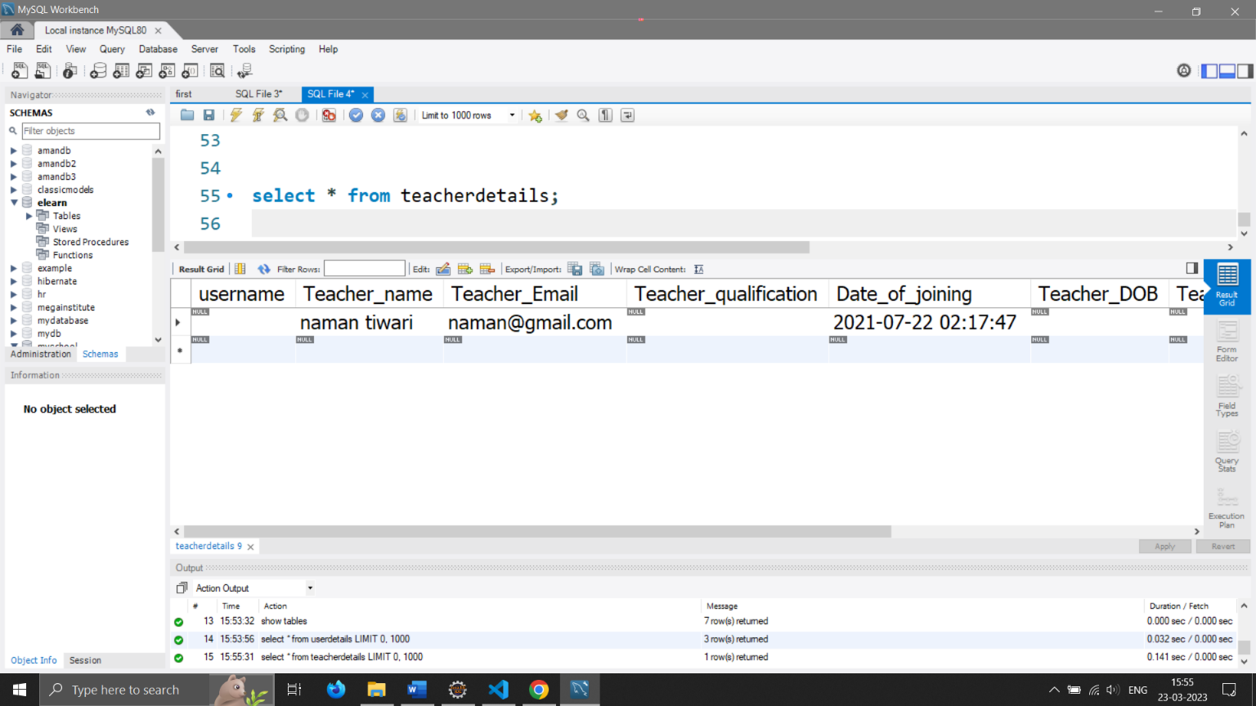

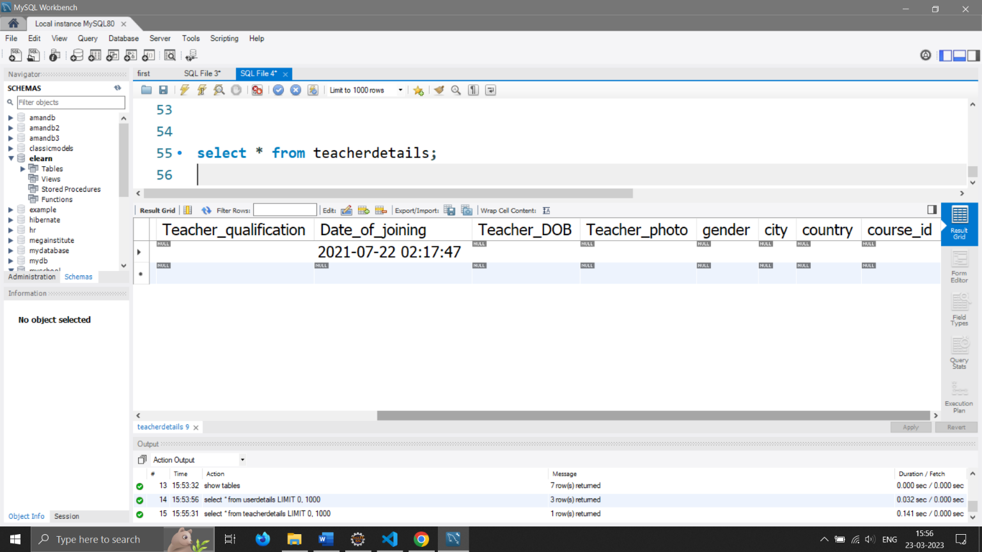

**10.IMPLEMENTATION OF SECURITY**

As computers and other digital devices have become essential to business and commerce, they have also increasingly become a target for attacks. In order for a company or an individual to use a computing device with confidence, they must first be assured that the device is not compromised in any way and that all communications will be secure. In this chapter, we will review the fundamental concepts of information System s security and discuss some of the measures that can be taken to mitigate security threats. We will begin with an overview focusing on how organizations can stay secure. Several different measures that a company can take to improve security will be discussed. We will then follow up by reviewing security precautions that individuals can take in order to secure their personal computing environment.

**The Information Security Triad: Confidentiality, Integrity, Availability (CIA)**

• **Confidentiality**

When protecting information, we want to be able to restrict access to those who are allowed to see it; everyone else should be disallowed from learning anything about its contents. This is the essence of confidentiality. For example, federal law requires that universities restrict access to private student information. The university must be sure that only those who are authorized have access to view the grade records.

• **Integrity**

Integrity is the assurance that the information being accessed has not been altered and truly represents what is intended. Just as a person with integrity means what he or she says and can be trusted to consistently represent the truth, information integrity means information truly represents its intended meaning. Information can lose its integrity through malicious intent, such as when someone who is not authorized makes a change to intentionally misrepresent something. An example of this would be when a hacker is hired to go into the university’s System and change a grade.

Integrity can also be lost unintentionally, such as when a computer power surge corrupts a file or someone authorized to make a change accidentally deletes a file or enters incorrect information.

• **Availability**

Information availability is the third part of the CIA triad. Availability means that information can be accessed and modified by anyone authorized to do so in an appropriate timeframe. Depending on the type of information, appropriate timeframe can mean different things. For example, a stock trader needs information to be available immediately, while a sales person may be happy to get sales numbers for the day in a report the next morning. Companies such as Amazon.com will require their servers to be available twenty-four hours a day, seven days a week. Other companies may not suffer if their web servers are down for a few minutes once in a while.

* **Tools for Information Security**

In order to ensure the confidentiality, integrity, and availability of information, organizations can choose from a variety of tools. Each of these tools can be utilized as part of an overall information-security policy, which will be discussed in the next section.

* **Authentication**

The most common way to identify someone is through their physical appearance, but how do we identify someone sitting behind a computer screen or at the ATM? Tools for authentication are used to ensure that the person accessing the information is, indeed, who they present themselves to be.

Authentication can be accomplished by identifying someone through one or more of three factors: something they know, something they have, or something they are. For example, the most common form of authentication today is the user ID and password. In this case, the authentication is done by confirming something that the user knows (their ID and password). But this form of authentication is easy to compromise (see sidebar) and stronger forms of authentication are sometimes needed. Identifying someone only by something they have, such as a key or a card, can also be problematic. When that identifying token is lost or stolen, the identity can be easily stolen. The final factor, something you are, is much harder to compromise. This factor identifies a user through the use of a physical characteristic, such as an eye-scan or fingerprint. Identifying someone through their physical characteristics is called biometrics.

A more secure way to authenticate a user is to do multi-factor authentication. By combining two or more of the factors listed above, it becomes much more difficult for someone to misrepresent themselves.

• **Access Control**

Once a user has been authenticated, the next step is to ensure that they can only access the information resources that are appropriate. This is done through the use of access control. Access control determines which users are authorized to read, modify, add, and/or delete information. Several different access control models exist. Here we will discuss two: the access control list (ACL) and role-based access control (RBAC).

For each information resource that an organization wishes to manage, a list of users who have the ability to take specific actions can be created. This is an access control list, or ACL. For each user, specific capabilities are assigned, such as read, write, delete, or add. Only users with those capabilities are allowed to perform those functions. If a user is not on the list, they have no ability to even know that the information resource exists.

ACLs are simple to understand and maintain. However, they have several drawbacks. The primary drawback is that each information resource is managed separately, so if a security administrator wanted to add or remove a user to a large set of information resources, it would be quite difficult. And as the number of users and resources increase, ACLs become harder to maintain. This has led to an improved method of access control, called role-based access control, or RBAC. With RBAC, instead of giving specific users access rights to an information resource, users are assigned to roles and then those roles are assigned the access. This allows the administrators to manage users and roles separately, simplifying administration and, by extension, improving security.

• **Encryption**

Many times, an organization needs to transmit information over the Internet or transfer it on external media such as a CD or flash drive. In these cases, even with proper authentication and access control, it is possible for an unauthorized person to get access to the data. Encryption is a process of encoding data upon its transmission or storage so that only authorized individuals can read it. This encoding is accomplished by a computer program, which encodes the plain text that needs to be transmitted; then the recipient receives the cipher text and decodes it (decryption). In order for this to work, the sender and receiver need to agree on the method of encoding so that both parties can communicate properly. Both parties share the encryption key, enabling them to encode and decode each other’s messages. This is called symmetric key encryption. This type of encryption is problematic because the key is available in two different places.

An alternative to symmetric key encryption is public key encryption. In public key encryption, two keys are used: a public key and a private key. To send an encrypted message, you obtain the public key, encode the message, and send it. The recipient then uses the private key to decode it. The public key can be given to anyone who wishes to send the recipient a message. Each user simply needs one private key and one public key in order to secure messages. The private key is necessary in order to decrypt something sent with the public key.

**11.LIMITATION OF PROJECT**

While school management systems can bring many benefits to educational institutions, there are also some limitations that need to be considered:

1. Technical Issues: School management systems can be prone to technical issues, such as system crashes or software bugs, which can cause disruption to the daily operations of the institution.
2. Implementation Costs: Implementing a school management system can be expensive, requiring significant investment in software, hardware, and IT support.
3. Data Security: With the increase in cyber threats, data security is a significant concern for educational institutions. School management systems can be vulnerable to hacking or data breaches, which can compromise sensitive student and staff information.
4. User Training: School management systems require staff to be trained in their use, which can be time-consuming and costly. Without proper training, staff may not be able to utilize the system effectively.
5. Lack of Customization: Some school management systems may have limited customization options, which can limit their ability to meet the specific needs of a particular institution.
6. Limited Accessibility: School management systems may not be accessible to all students and parents, particularly those who do not have access to technology or reliable internet connectivity.

It's important for educational institutions to consider these limitations when deciding whether to adopt a school management system, and to work with vendors and IT experts to ensure that any system chosen is secure, cost-effective, and well-suited to the needs of the institution.

**12.FUTURE APLICATION OF THE PROJECT**

A student management system is a software tool used to manage student data and academic records. It is widely used in educational institutions to streamline administrative tasks, track student progress, and improve communication between teachers, students, and parents. Here are some potential future applications of student management systems:

1. Predictive Analytics: With the help of machine learning algorithms, student management systems can analyze past academic performance data and predict future outcomes. This can help educators identify struggling students early on and provide them with the necessary support.
2. Personalized Learning: Student management systems can track student progress and recommend personalized learning pathways based on their individual needs and strengths. This can help students learn at their own pace and improve their overall academic performance.
3. Integration with Virtual Learning Environments: As more educational institutions adopt virtual learning environments, student management systems can be integrated with these platforms to track student progress and provide real-time feedback to students and educators.
4. Enhanced Parent-Teacher Communication: Student management systems can facilitate better communication between parents and teachers by providing real-time access to student progress reports, attendance records, and other important information. This can help parents stay informed and involved in their child's education.

13.BIBLIOGRAPHY

**Websites**

* <https://www.mysqltutorial.org/>
* <https://www.tutorialspoint.com/>
* <https://javatpoint.com/>
* <https://W3schools.com/>
* <https://edureka.co/>

**Books**

* HTML & CSS: Design and Build Web Sites
* Head First SQL: Your Brain on SQL
* SQL Bible, 2nd Edition (Paperback)
* Core java by E-balaguruswamy